PC13 – Final version of provisions following Third Interim Decision (amended for NPStds)

Definitions of Terms
Bulk solid material means materials consisting of, or including, fragments that could be discharged as dust or particulates. These materials include but are not limited to: gravel, quarried rock, fertiliser, coal, cement, flour, rock aggregate, grains, compost, palm kernel extract, tapioca, and woodchip (but do not include logs, salt, or other materials not in bulk form, such as materials contained in a bag, container or similar)
Handling of logs means conveying, transferring, loading, unloading, storage, and debarking of logs, and ancillary activities within the Mount Maunganui Airshed, but does not include fumigation.
Mount Maunganui Airshed means the area of Mount Maunganui and Tauranga specified by the Minister for the Environment as a separate airshed, by notice in the New Zealand Gazette on 31 October 2019.
Port company is as defined by the Port Companies Act 1988.
Port Industry Area is the area shown within the red polygon in Figure 1 of AIRSCHED3
Port Operational Area is the area shown within the black polygon in Figure 1 in AIRSCHED3
SQEP (for the purposes of the Air Quality chapter only) means a Suitably Qualified and Experienced independent Person who has professional qualification, training, skills, and experience relating to discharges to air, and can give authoritative assessment, advice and analysis on performance relating to the subject matter using relevant national and international standards and guidelines.
Subject site means the property except where otherwise mapped in AIRSCHED3.

Policies

New Policy AREA2-P1 (AQ P11) – Existing activities permitted for an Interim period
AREA2-P1 – Handling of bulk solid materials and logs as existing activities in the Mount Maunganui Airshed for an interim period
Provide for discharges of PM10 and other particulates to air within the Mount Maunganui Airshed from bulk solid material handling and handling of logs for an interim period, by requiring that the discharge of PM10 from any subject site must be minimised to reduce adverse effects on air quality in the Mount Maunganui Airshed to the greatest extent reasonably practicable through application of an Interim Permitted Activity Rule (AREA2-R1) defaulting to a discretionary activity, and to:
- reduce PM10 and other particulate discharges from the activities in a way that contributes to achieving Objectives AIR-O1, AIR-O2 and AIR-O3 and Policies AIR-P3(b) and AIR-P4(b); and
- generally ensure that the PM10 mitigation measures in place on the subject site must be no less effective than the mitigation measures in place and operating efficiently (and not on a trial basis) at any date prior to or on 12 February 2024.

New Policy AREA2—P2 (AQ P12) – Iterative management
AREA2-P2 – Iterative management of air quality within the Mount Maunganui Airshed
Activities which discharge PM₁₀ and other particulates to air within the Mount Maunganui Airshed, other than those in compliance with Interim Permitted Activity Rule AREA2-R1, must be managed by implementing an iterative management approach to:
- recognise that the Mount Maunganui Airshed is a Polluted Airshed as defined in Regulation 17(4)(a) of the National Environmental Standards for Air Quality (Polluted Airshed); and
- improve air quality and ensure the Mount Maunganui Airshed stops being a Polluted Airshed as soon as reasonably practicable, including by managing cumulative effects; and
- ensure that once the Mount Maunganui Airshed stops being a Polluted Airshed, the discharge of contaminants at a rate or volume that may cause an exceedance or breach of the ambient air quality standards of the National Environmental Standards for Air Quality is avoided; and
- safeguard the life supporting capacity of the air and protect human health within the Mount Maunganui Airshed, and
- avoid, remedy or mitigate adverse effects on cultural values, amenity values, and the environment.
The iterative management process will or may include, but not necessarily be limited to:
- requiring each subject site within the Mount Maunganui Airshed to minimise discharges of PM₁₀ to air to the greatest extent reasonably practicable and at the time of resource consent applications to take account of the effectiveness of mitigation measures and operating procedures implemented in accordance with the Interim Permitted Activity Rule AREA2-R1; and
- assessing changes in Mount Maunganui Airshed-wide air quality based on monitoring results to 31 December 2025, to determine the extent to which compliance with the National Environmental Standards for Air Quality and the annual guideline value in the Health-based Guideline Values of the Ambient Air Quality Guidelines 2002 (or its amendment or replacement) is likely to be achieved based on the Mount Maunganui Airshed-wide mitigation measures implemented to that time; and
- setting resource consent conditions based on (f) and (g) that can be expected to ensure compliance as soon as reasonably practicable; and
- making provision for the review of consent conditions as necessary to ensure compliance with the National Environmental Standards for Air Quality is achieved as soon as reasonably practicable and the annual guideline value in the Health-based Guideline Values of the Ambient Air Quality Guidelines 2002 (or its amendment or replacement) is met.

Method

New Method AREA2-M1 (AQ M1) – Assessment of monitoring results
AREA2-M1 – Assessment of Mount Maunganui Airshed monitoring results
Regional Council will assess the Mount Maunganui Airshed-wide air quality based on monitoring results at no greater than two-yearly intervals until compliance with the ambient air quality standard for PM₁₀ is achieved.

Rule outside Mount Maunganui Airshed

Rule AIR-R28 (AQ R22): Handling of bulk solid materials outside the MMA
AIR-R28 Handling of bulk solid materials –Discretionary
Unless otherwise permitted by AIR-R10, the discharge of contaminants to air from the handling of bulk solid materials outside the Mount Maunganui Airshed where:
    - the rate of bulk solid material handling exceeds 20 tonnes in any hour, and the discharge occurs less than 100 metres from any sensitive area,
OR
    - the rate of bulk solid material handling exceeds 50 tonnes in any hour,
is a discretionary activity.

Rules inside Mount Maunganui Airshed

Rule AREA2-R1 (AQ 22A) Interim Permitted Activity Rule (IPAR) for Existing Activities in the MMA
AREA2-R1 Handling of bulk solid materials and logs within the Mount Maunganui Airshed until 12 February 2027 – Permitted

Within the Mount Maunganui Airshed, unless otherwise permitted by AIR-R2, AIR-R15 or AIR-R10, or managed by AIR-FUME-R20, the discharge of contaminants to air from:
- the handling of logs on or within a subject site where:
- the area used for the handling of logs exceeds 1 hectare;
OR
- the handling of bulk solid materials on or within a subject site where:
- The rate of bulk solid materials handling exceeds 20 tonnes in any hour and the discharge occurs less than 100 metres from any sensitive area, or
- The rate of bulk solid materials handling exceeds 50 tonnes in any hour,
is a permitted activity until:
- 12 February 2027; or
- Where a resource consent application for the discharge proposed under Rule AIR-R16 or AREA2-R2 has been accepted by the Regional Council under s 88 of the Resource Management Act 1991 (or its replacement) prior to 12 February 2027, then the relevant date shall be:
  - The date the resource consent commences under s116 of the Resource Management Act 1991 (or its replacement); or
  - the date all appeals are determined, if the resource consent is declined.
Provided that the following standards are complied with:
- General standards applying to all discharges of PM₁₀
- The discharge of PM₁₀ must be the same or similar in character and the same or less in scale and intensity than that occurring in the 12 months ending on 28 November 2019, as estimated in accordance with all standards of this rule; and
- The discharge of PM₁₀ from the handling of logs or handling of bulk solid materials must be on the same subject site as the existing discharge as at 1 October 2020 and must have been occurring in the 12 months ending on 28 November 2019; and
- The discharge must not have been discontinued for a continuous period of more than 6 months since 28 November 2019; and
- The discharge does not cause any offensive or objectionable effect beyond the boundary of the subject site; and
- Subject to standard (1)(ka) and standard (2) (where relevant), the annual product volumes or tonnages of logs and bulk solid materials handled must be the same or less than in the 12 months ending on 31 July 2019; and
- In addition to mitigation measures required by standards (g) to (x) the PM₁₀ mitigation measures in place on the subject site must be no less effective than the mitigation measures in place and operating efficiently (and not on a trial basis) at any date prior to or on 12 February 2024. In the event of any trial mitigation subsequently being shown to form part of the best practicable option to reduce emissions of PM₁₀ to air in the Mount Maunganui Airshed, it must be included as an amendment to the Dust Management Plan; and
In addition to standards (1)(a) to (f), the following standards apply to PM₁₀ emissions from log handling activities within the MMA, both inside and outside the Port Industry Area
- The locations in which logs are stored and handled must be the same as they were in the 12 months ending on 31 July 2019 and the area must be the same or less than the area in which they were stored and handled in the 12 months ending on 31 July 2019; and
- The average volume/tonnage or average percentage of logs (whichever is higher) loaded via trailers at the point of vessel loading in any 12-month period must be the same or greater than the corresponding average volume or tonnage and average percentage in the 12 months ending on 31 July 2019; and
- The average volume/tonnage or average percentage (whichever is higher) of fully debarked logs delivered to site and at the point of loading onto vessels must be the same or greater than the corresponding average volume or tonnage and average percentage in the 12 months ending on 31 July 2019; and
- Measures to control dust, including PM₁₀, and to control the movement of vehicles contributing to the resuspension of dust must be the same or better than the measures in place in the 12 months ending on 31 July 2019; and
- There must be no change in the number and location of berths used for loading logs onto vessels compared to the 12-months ending on 31 July 2019.
(ka)
    - The annual product volume of logs that is trailer-loaded must be greater than that occurring in the 12 months ending on 31 July 2019;
    - Notwithstanding Standard (1)(e), for the 12 months ending 31 July 2023 and 12 months ending 31 July 2024, the annual product volume of logs may exceed that occurring in the 12 months ending 31 July 2019 only on the following basis:
      - the increase in annual product volume of logs above that occurring in the 12 months ending on 31 July 2019 must have resulted from exceptional circumstances relating to Cyclone Gabrielle; and
      - any increase in annual produce volume of logs must only be trailer-loaded; and
      - the annual volume of bunk-loaded logs must be reduced by four times the trailer-loaded volume in (ii); and
      - the annual product volume of logs does not exceed 7.5 million tonnes.
For the purpose of this clause:
Exceptional circumstances means a significant increase in wind-throw within forests directly affected by Cyclone Gabrielle.
Trailer-loaded means a trailer system is used to transport the logs from the log stacks to the berth and to load the vessel from the trailer directly.
Bunk-loaded means logs are loaded into a bunk at the berth and from there loaded onto the vessel.
In addition to standards 1(a) to (f), the following standards apply to PM₁₀ emissions from the unloading of bulk solid materials and handling inside the Port Operational Area
- The annual volume or tonnage of bulk solid materials unloaded and handled from vessels must be the same or less than the maximum annual volume or tonnage unloaded for the 12 months ending on 31 July 2019; and
- The nature and character of bulk solid materials handled must be the same or similar to those handled in the 12-months ending on 31 July 2019, taking into account density, free moisture content, hygroscopic nature and particle size distribution which could result in increased emissions of PM₁₀; and
- The number of hoppers used for unloading bulk solid materials from vessels must be the same or less than those used in the 12-month period ending on 31 July 2019; and
- Dust (including PM₁₀) control measures incorporated in the hoppers used for unloading bulk solid materials from vessels must be the same or greater than those incorporated in the 12-months ending on 31 July 2019; and
- Only slow-release grabs must be used for unloading bulk solid materials from ships after 3 March 2022; and
- All trucks used for transporting bulk solid materials must be always covered, except when being loaded or unloaded, to avoid the escape of dust during transport as far as reasonably practicable; and
- There must be no change in the number and location of berths used for unloading bulk solid materials from vessels compared to the 12-months ending on 31 July 2019.
In addition to standards 1(a) to (f), the following standards apply to PM₁₀ emissions from bulk solid materials handling or storage facilities outside the Port Operational Area, except as provided in (2)
- The annual volume or tonnage of bulk solid materials handled or stored on the subject site must be the same or less than the maximum annual volume or tonnage handled or stored in the12 months ending on 31 July 2019; and
- The annual volume or tonnage of bulk solid materials handled or stored outside any building enclosure on the subject site must be the same or less than the maximum annual volume or tonnage handled or stored in the 12 months ending on 31 July 2019; and
- The nature and character of bulk solid materials handled or stored must be the same or similar to those handled or stored in the 12-months ending on 31 July 2019, taking into account density, free moisture content, hygroscopic nature and particle size distribution which could result in increased emissions of PM₁₀; and
- The combined maximum daily truck numbers arriving at and departing from the subject site must be the same or less than the maximum daily number in the 12-months ending on 31 July 2019; and
- All trucks used for transporting bulk solid materials must be always covered, except when being loaded or unloaded, to avoid the escape of dust during transport as far as reasonably practicable; and
- The maximum processing capacity on the subject site must be the same or less than the maximum capacity available in the 12-months ending on 31 July 2019; and
- Dust containment measures in place on the subject site must be the same or better than those in place in the 12-months ending on 31 July 2019, including the extent to which sealing building openings and the installation of dust extraction and filtering equipment are incorporated, as examples.
- Circumstances in which standards (s), (t), (v) and (x) may not apply to bulk solid materials handling activities outside the Port Operational Area
Standards (s), (t), (v) and (x) may not apply if it can be demonstrated by robust, peer-reviewed methodology carried out by a SQEP that dust containment measures on the subject site are sufficient to avoid any adverse effects of PM₁₀ emissions from the site on sensitive areas.
- Dust management plan
- For discharges associated with activities located outside the Port Industry Area, the owner or occupier of the subject site where the activity is carried out must engage a SQEP who has visited the subject site to prepare a dust management plan in accordance with the requirements of AIRSCHED2.
- For discharges associated with activities located within the Port Industry Area
- the port company must engage a SQEP who has visited the Port Industry Area to prepare a dust management plan in accordance with the requirements of AIRSCHED2.
- The discharge is identified and managed by the dust management plan; and
- The dust management plan must specify procedures that must be followed and specify who must carry out those procedures, when handling bulk solid materials or handling of logs within the Port Industry Area.
- The dust management plan required by (3)(a) or 3(b) must be:
- peer reviewed by another SQEP prior to submission to the Regional Council; and
- revised to address the peer review comments prior to submission to Regional Council, or where the comments are not addressed to the satisfaction of the peer reviewer, the reasons must be stated; and
- provided to the Regional Council within six months of this rule becoming operative, together with the peer review required by (3)(c)) (i); or for the Port Industry Area, provided to the Regional Council and Ngāi te Rangi within six months of this rule becoming operative, together with the peer review required by (3)(c)(i); and
- reviewed by a SQEP at least once every calendar year and any updated version of the dust management plan provided to the Regional Council and to Ngāi te Rangi for the Port Industry Area, within one month of its review.
- The dust management plan required by (3)(a) or 3(b) must always remain on site, capital works required to minimise PM₁₀ emissions must be completed as soon as practicable and the dust management plan must be complied with at all times by all persons undertaking the bulk solid materials handling or handling of logs activity as soon as practicable following the dust management plan being finalised under (3)(c)(ii),(3)(c)(iv) or (3)(e).
- In the event of an exceedance of the trigger level in Part A Clause (7)of AIRSCHED2 and following an investigation as required by Part B Clause (11) of AIRSCHED2, the dust management plan must be amended by a SQEP to include actions to avoid or minimise future exceedances of the trigger level and resubmitted to Regional Council, and to Ngāi te Rangi for the Port Industry Area, within one month of its amendment.
- To demonstrate compliance with standards, the DMP must:
- Set out the baseline in the 12-months ending on 28 November 2019 unless a different compliance date is set out above against which compliance with each standard is to be measured; and
- Demonstrate how each standard is or will be met; and
- Describe any additional measures that will be implemented during the term of the IPAR to reduce PM₁₀ emissions from the subject site to the greatest extent reasonably practicable until objective AIR-O2 of PC13 is met and the annual guideline value in the Health-based Guideline Values of the Ambient Air Quality Guidelines 2002 (or its amendment or replacement) is met; and
- Demonstrate that the proposal will minimise PM₁₀ emissions to the greatest extent reasonably practicable until Objective AIR-O2 of PC13 is met and the annual guideline value in the Health-based Guideline Values of the Ambient Air Quality Guidelines 2002 (or its amendment or replacement) is met within the term of the IPAR, or within a defined period thereafter, after describing and evaluating all reasonably practical options that have been implemented or could be implemented to reduce PM₁₀ emissions from the subject site, together with their estimated costs and the estimated likely and range of PM₁₀ reductions they would achieve.
- The DMP must require that records are kept of:
- The number and significance of complaints received; and.
- Any exceedances of the PM₁₀ Standard attributable to the subject site, abatement notices and enforcement action taken from 12 February 2024.

Advice note – If an activity does not comply with the standards of Rule AREA2-R1 the discharge is a discretionary activity under AIR-R16.

Rule AREA2-R2 (AQ 22B) Restricted Discretionary for Existing Activities in the MMA
AREA2-R2: Handling of bulk solid materials and handling of logs on expiry of Rule AREA2-R1 – Restricted Discretionary
Within the Mount Maunganui Airshed, unless otherwise permitted by AIR-R2, AIR-R15, or AIR-R10, or managed by AIR-FUME-R20, the discharge of contaminants to air from:
(A) Handling of logs where:
- the area used for the handling of logs exceeds 1 hectare
OR
(B) Handling of bulk solid materials on a subject site where:
- the rate of bulk solid materials handling exceeds 20 tonnes in any hour, and the discharge occurs less than 100 metres from any sensitive area, or
- the rate of bulk solid materials handling exceeds 50 tonnes in any hour,
is a restricted discretionary activity subject to the following standards:
- Dust management plans must be developed and implemented as soon as practicable after consent is granted for all discharges of PM₁₀ to air, both inside and outside the Port Industry Area;
- For discharges associated with activities within the Port Industry Area:
- At least one of the consent applicants is a port company;
- There is a dust management plan to manage the discharges of contaminants collectively within the Port Industry Area subject site; and
- The dust management plan specifies procedures that must be followed and by whom for the handling of logs or handling of bulk solid materials within the Port Industry Area; and
Where standards (1) or (2) are not met, the discharge is a discretionary activity under AIR-R16.
- The Regional Council restricts its discretion to the following matters:
- consideration of effects on human health, including by considering the proximity of the subject site to sensitive areas, including any areas where people are likely to be present 24-hours a day;
- consideration of cultural effects, taking into account the extent to which consultation with representatives of Whareroa Marae has occurred and been taken into account, including:
- effects on the health of whanau at Whareroa Marae;
- recognising and providing for the relationship, culture, traditions and taonga of Ngāi Te Rangi within the Mount Maunganui Airshed;
- the extent to which the exercise of kaitiakitanga by Ngāi Te Rangi is provided for; and
- adverse effects on air quality values identified in the relevant iwi and hapū resource management plans;
- consideration of:
  - air quality effects including but not limited to, cumulative effects, reduced visibility, and amenity effects;
  - The effect of the prevailing weather conditions, including rainfall, wind speed and wind direction
  - methods to reduce PM₁₀ discharges to minimise adverse effects on human health and the mauri of air to the greatest extent reasonably practicable until Objective AIR-O2 is met ;
  - subsequently, if necessary to ensure compliance with the PM₁₀ Standard in the National Environmental Standards for Air Quality and any applicable ambient annual average air quality guidelines to reduce the discharge of PM₁₀ to air in accordance with the iterative management approach outlined in Policy AREA2-P2;
- the contents of the dust management plan including:
  - the extent to which best practice technology and operating procedures and PM₁₀ discharge mitigation options are incorporated in the dust management plan;
  - other methods available to further reduce PM₁₀ emissions and the reasons why they are not included in the dust management plan;
- the extent by which any increase in PM₁₀ emissions that could result from an increase in volume of product throughput or change in product character has been compensated for by improved mitigation measures compared to those in place before the increase occurs;
- the extent of any exceedances of trigger levels included in AIRSHED2 of Rule AREA2-R1
- the extent to which the amount and rate of PM₁₀ discharge is the same or less than those occurring under the standards of Rule AREA2-R1;
- The operational requirements and locational constraints relevant to the discharge and/or activity.
- The history of complaints, abatement notices and enforcement orders at the subject site and methods of dealing with them;
- The lapse period, term of consent, and review of consent conditions;
- The collection, recording, monitoring and provision of information related to the exercise of the resource consent.

For the avoidance of doubt
- For activities within the Port Industry Area, where a discharge is not identified and managed by the dust management plan, that individual discharge will be non-compliant with standard (1) and will require resource consent under general discretionary rule AIR-R16. For the further avoidance of doubt, this does not mean that all discharges within the Port Industry Area require resource consent under general discretionary rule AIR-R16.
- Any discharge authorised by a certificate of compliance must cease on the grant of a resource consent for the same discharge to air under this Rule.

Rule AREA2-R3 (AQ R22C) Notification of affected persons
AREA2-R3: Notification
Any application for resource consent to discharge contaminants into the Mount Maunganui Airshed under Rule AREA2-2 or AIR-R16 will be subject to the normal tests for notification under the relevant sections of the Resource Management Act 1991. When deciding who is an affected person in relation to any activity for the purposes of s95E of the Resource Management Act 1991 the Council will give specific consideration to the people of Whareroa Marae and Ngāi Te Rangi.

Schedules

AIRSCHED2 – Dust Management Plan requirements for AREA2-R1
AIRSCHED2 – Dust Management Plans for the Mount Maunganui Airshed
These requirements apply to dust management plans prepared under Rule AREA2-R1 and can be used as a guide for dust management plans prepared under Rule AREA2-R2.
Part A: Contents
A dust management plan must be prepared for each subject site and contain:
  - Title
  - A purpose to ensure that the discharge of PM₁₀ into the Mount Maunganui Airshed is minimised to the greatest extent reasonably practicable to contribute to meeting the objectives of the AIR chapter without undue delay, to meet the general standards of Rule AREA2-R1 standards (1)(a) to (1)(f) and to be consistent with Policy AIR-P3 to achieve improvements in air quality.
  - A map that includes a scale, a north point, the location of the subject site, distance to all sensitive areas, including any isolated dwellings within the industrial area and predominant wind directions at the subject site.
  - Process description and method of operation including:
- A detailed description of the subject site, activity, and discharges to air;
- A description of the potential sources of dust emissions;
- Any locational or operating constraints relevant to the management of handling of bulk solid materials and/or handling of logs; and
- the type(s), volume(s) and frequency of handling of bulk solid materials or handling of logs at the subject site.
  - Methods of mitigation and standard operating procedures for the subject site which must include details of dust emission reduction processes and practices including:
- for all activities:
  - Product movement paths, storage, and processing areas including conveyance systems, and whether these are indoors or outdoors;
  - Use of dust suppression (e.g. sprinkler/fog/misting) systems;
  - Use of wind speed limits relating to the subject site when operations must cease;
  - Vehicle speed limits and vehicle unloading procedures to minimise dust;
  - Site sweeping/vacuuming and containment protocols including hours of operation and sweeping frequency;
  - Inventory of mitigation measures in place on or about 28 November 2019;
  - Inventory of current mitigation measures, including equipment, materials and procedures;
  - Proposed further mitigation measures, including equipment, materials and procedures
  - Frequency of equipment maintenance programmes; and
  - Contingency procedures.
- for bulk solid materials only:
  - Exclusion or buffer areas within the subject site where no outdoor storage is permitted;
  - Use of covers or containment systems for outdoor storage areas;
  - For enclosed operations, emission pathways and general containment provisions , the extent of air extraction and treatment systems installed and their performance specifications; and
  - Materials spill management response protocols
  - A monitoring programme which must:
- Be designed by a SQEP to monitor ambient PM₁₀ concentrations in accordance with relevant good practice;
- Include a description of types and locations of devices for PM₁₀ and meteorological conditions monitoring;
- Provide data that allows for a technically robust comparison with the trigger values in Part A clause (7);
- Be continuous monitoring with a minimum of ten-minute resolution;
- Be telemetered with alarms;
- Be installed, commissioned, operated, serviced, and maintained in accordance with the manufacturer’s instructions and any appropriate standards;
- Have as a minimum one monitor funded by the owner or occupier of the subject site;
- Produce validated data in accordance with the Good Practice Guide for Air Quality Monitoring and Data Management, including the valid data requirements of 75% for averaging and 95% for data capture;
- Specify monitors compliant with either NESAQ Schedule 2 or equivalency as demonstrated through AS 3580.9.17-2018 or EN 12341:2014;
- Require that all monitoring data collected must be provided to the Regional Council as follows:
- Raw monthly data to be provided via electronic access to the Regional Council by the 5th day of the following month;
- Validated quarterly data to be provided via electronic access to the Regional Council on 1 February, 1 May, 1 August, and 1 November of every year; and
- Any exceedance of the trigger values set out in Part A clause(7) must be notified to the Regional Council in writing within 5 working days of the exceedance.
- Requires records to be kept, including documentation of maintenance and control parameters.
  - The following PM₁₀ trigger values for use in Part B and IPAR standard(3)(e):
- 150 micrograms per cubic metre (calculated as a rolling 1-hour average concentration under Schedule 1 NESAQ) recorded by the monitoring devices in the monitoring programme set out in clause 6;
OR
- 65 micrograms per cubic metre (calculated as a rolling 12-hour average) recorded by the monitoring devices in the monitoring programme set out in clause 6.
  - Complaints procedures must include:
- The name of the contact person and contact details for complaints from the community;
- Complaints procedures for staff;
- Maintenance of a complaints/incidents register that includes any actions undertaken to respond to the complaint, including further dust control measures;
- A complaint response protocol, including methods for recording of any on-site activity, including type and approximate volume of material being handled, dust mitigation measures in place at the time, and wind conditions at the time of complaint; and procedures for investigating and remedying the cause of complaint and providing response to complainant;
- A protocol for determining further mitigation measures that may be required on site;
- Timeframes for communication to the Regional Council and complainant; and
- Reporting requirements that include the complaints/incidents register which must be submitted to the Regional Council at least once per calendar year.
  - Staff training procedures must include:
- Components of the dust management plan that staff are to be trained in;
- Methods used to train staff;
- Frequency of staff training; and
- How and where staff training records are to be kept.
  - System review and reporting procedures must include:
- The process for reviewing the overall dust management system performance;
- Types and frequency of reports not otherwise provided to the Regional Council such as site/process/equipment upgrades; and
- External audits and ISO certification (optional).
Part B: Investigation and Reporting
- In the event that either of the trigger values set out in Part A Clause (7) are exceeded, then an investigation must be undertaken as soon as reasonably practicable by, or under the direction of, a SQEP to:
- Determine the cause of and reasons for the trigger value being exceeded;
- Identify corrective actions required to minimise the potential for the trigger value being exceeded in the future; and
- Set out the timeframes for implementation of the identified corrective actions;
- The investigation results and findings must be documented by the SQEP in an Investigation Report;
- The Investigation Report in (b) must be provided to the Regional Council within two months of the trigger value being exceeded;
- The owner of the subject site and/or the parties responsible for the activity/operation that caused the exceedance of the trigger values must implement the corrective actions within the timeframes identified by the SQEP in the Investigation Report and must provide written confirmation to the Regional Council within 5 working days of completion of the actions.
- An annual report prepared by a SQEP must be provided to the Regional Council and to Ngāi te Rangi for the Port Industry Area, on 30 June of every year containing the following:
- A summary of the year’s monitoring data;
- Details of investigations into all exceedances of the trigger value;
- Steps taken to implement corrective actions;
- Ongoing actions to reduce discharges of contaminants from the site; and
- Changes/modifications to the air quality monitoring programme; and
- For the Port Industry Area, the port company must hold and must invite Ngāi te Rangi and operators identified within the dust management plan to an annual meeting with Ngāi te Rangi to share the results of the annual report required by (e).
Explanatory note 1
For the purposes of Part A (4)(d) as it applies to the type(s), volume(s) and frequency of handling of logs:
- Types refers to barked or debarked; and
- Volume and frequency refers to annual export throughput.
Explanatory note 2
Examples of process improvements include: targets for debarking logs; and targets for improvement in technology (e.g. improved hopper design) and methodology (e.g. trailer-style loading in preference to bunk loading).
Explanatory note 3
- For Standard Operating Procedures, not all elements apply to log handling.

AIRSCHED3 – Subject Site Exceptions
AIRSCHED3: Definitions of Port of Tauranga and De Havilland Way subject sites
  - Port of Tauranga
The Port Industry Area (the red polygon in Figure 1.) forms one subject site.
The rationale for the location of the proposed boundary is that effects on air quality, namely discharge of particulate to air, occurring in this area as a result of numerous bulk solids material handling and log handling activities would not be readily differentiated from one another, and therefore should be managed as a single subject site not numerous sites.
There are some complexities and nuances with the ownership and control of certain areas encompassed with the red polygon;
At 12 February 2024 POTL does not regulate the handling of bulk solids materials or logs with its procedures in some areas within the Port Industry Area and does not currently maintain any operational control of activities within those areas.

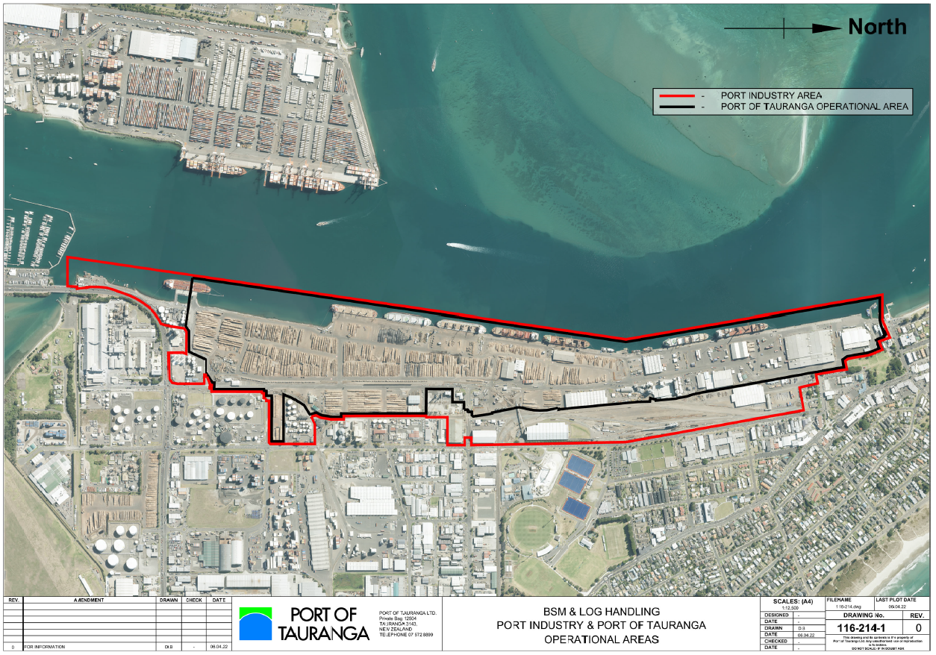
Figure 1: Aerial Image Showing the Extent of the Port of Tauranga “subject site” – Port Operational Area (shown by the black polygon) and Port Industry Area (shown by the red polygon)

  - 101 Aerodrome Road
The subject site shall be the leasehold area of 3.1417 hectares as defined as Lot 1 DP 403092 and described in Record of Title 410120. The Record of Title shows the owner of the lease as MM Group 3 Limited with the lease extending to 30 April 2049 and there is a fencing covenant relating to the lease. Refer to Figure 2 and Figure 3.
The leasehold area is part of a larger site of 54.4858 hectares owned by Tauranga City Council (Whareroa 2A2B1 Block) as described in Record of Title SA2B/115. That land extends from 101 Aerodrome Road (this being the leasehold area), across De Havilland Way (not legal road reserve), to the 11 hangars that are shown in Figure 2, and part of the runway of Tauranga Airport, and the southern boundary being the Tauranga Harbour.
Within 101 Aerodrome Road there are several warehouse buildings that may be occupied by different tenants and supporting a range of activities within the site. In the past the site has often had a mix of activities, including handling of different bulk solid materials and different operators. Since this is a large site with a mix of separate activities within it, it is appropriately considered as a subject site in the same way as the Port of Tauranga and managed through a single Dust Management Plan.
The leasehold area is a legally defined area that is certain, and that this is the fenced area for all activities within 101 Aerodrome Road. It is acknowledged that that the concrete walls of the buildings in the south-west corner of the subject site form the boundary at that location without the need for a physical fence since there are no openings (windows, or doors) along these walls.
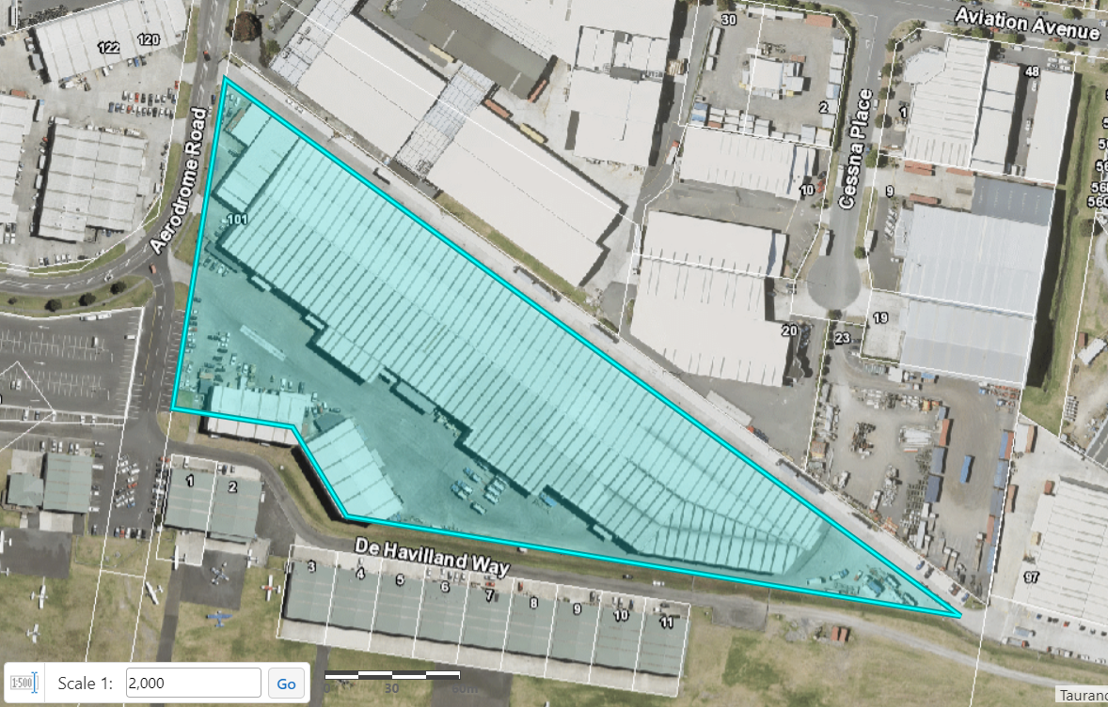
Figure 2: Aerial image showing cadastral boundary of 101 Aerodrome Road Lease Area.
N
Source: MAPI - Tauranga City Council
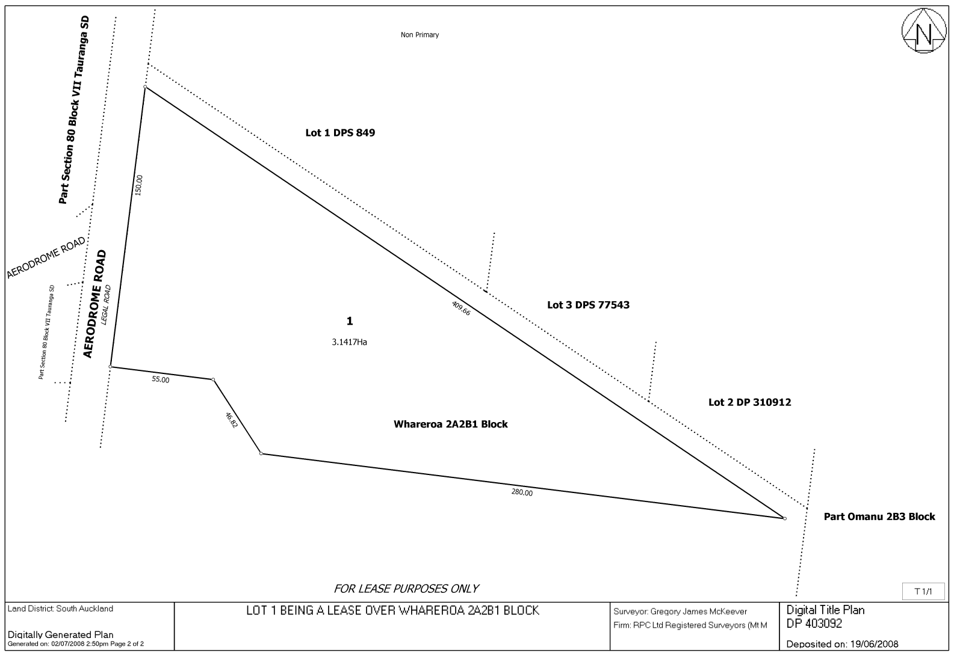
Figure 3: Lease Plan

Source: Record of Title 410120, Land Record Search (linz.govt.nz)

Bay of Plenty Regional Airshed Notice 2019

