Master Dust Management Plan
Name of Company:
Address of company:
Address of company:

Objectives
- No exceedance of the National Environmental Standard for PM₁₀ due to dust from this site.
- To ensure that there is no dust beyond the boundary of the site caused by discharges or activities from the site which is objectionable or causing a nuisance.

Key contacts
Site contact:  Name of site contact  (Position at company)  Phone XX XXX XXXX  Mobile XXX XXX XXX  Email  XX.XXX@XXXXX.co.nz | Site backup contact:  Name of backup contact  (Position at company)  DDI XX XXX XXXX  Mobile XXX XXX XXX  Email  XX.XXX@XXXXX.co.nz | BOPRC contact:  Name of BOPRC contact  (Position at BOPRC)  DDI 0800 884 881 x XXXX  Mobile XXX XXX XXX  Email  XX.XXX@boprc.govt.nz

Site activity
[This is a brief description of site activities noting all sources, and potential sources, of dust. If the company has a resource consent, this section should note the number of consent.]
[Text here]
Example requirements of a dust management plan. Depends on the site – pick and mix as required.

General
- No part of the process shall be operated without the associated emission control equipment being fully operational and functioning correctly.
- All pipework, ducting and control equipment shall be maintained in good condition, free from leaks and shall draw sufficient negative pressure to ensure that fugitive emissions are kept to a practicable minimum.
- Sweep up any sawdust spilled inside and outside processing buildings at least weekly. This includes:
- Sawmill No. 1
- Sawmill No. 2
- Finishing Line Building
- Kilns
- Boiler
- Chip bin
- Sweep up any sawdust spilled from conveyor lines and transfer points at least weekly.
- Maintain, in good condition, all covers for conveyor lines.
- Ensure sufficient water is available on site for dust control.
- Any dust blown off the property onto the road must be swept up immediately.

Plant - Boiler
- Boiler fuel is to be stored so that it is kept clean and dry (i.e. protected from wind and rain).
- Operate boiler and regulate fuel to maximise efficiency and minimise discharges of particulate as follows:
- Oxygen [e.g.] 5%-8%
- Post combustion temperature around [e.g.] 500°C
- The cyclones shall be kept free from blockage.
- Boiler to be tuned every two years.
- Last tune-up [insert date here]
- Next due [insert date here]

Plant - Baghouse
- Visually check the Baghouse Performance once per shift
- Pressure drop should be [e.g.] < 10 mm
- Inspect the condition of the filter socks annually and launder and/or change as required

Waste sawdust and boiler fuel stock piles
- Install, and maintain in good condition windbreak screens on waste sawdust pile in front of Sawmill No. 1 by [insert date here].
- Install, and maintain in good condition, windbreak screens on waste sawdust pile in front of Sawmill No. 2 by [insert date here].
- Extend, and maintain in good condition, windbreak screens on hog fuel overflow stockpile (eastern corner of site) by [insert date here].
- Cover bark bin by [insert date here].

Stockpiles
- Stockpiles should be contained in the designated stockpile bunds.
- Limit the height and slope of stockpiles to reduce wind entrainment (ideally less than 3 m in height).
- Any stockpiles not contained in bunds must be located so as to maximise wind shelter and cleared/used as soon as possible.
- Active stockpiles must be dampened down with water or covered if stockpiles are of fine materials.
- Grass and/or dampen inactive stockpiles if they are producing visible dust emissions.

Vehicles
When trying to control dust - a speed limit is essential for all sites, both sealed and unsealed. However, a limit is only as good as its enforcement and this is usually beyond Bay of Plenty Regional Council (BOPRC) control.
Courier vans are known to cause problems and can be forced to slow down by the use of judder bars.
- All vehicles onsite, including those entering and leaving the site are limited to a speed of [e.g.] 10 km/hr.
- Vehicle speed signs must be displayed at the site entrance and at least three other places onsite. Signage must be clearly visible at all times.
- Limit load size to avoid spillage.
- Any spillage from loading must be cleaned up immediately.
- Vehicles carrying fine loads must be covered before entering and before leaving the site.
- Alternatively, dampen any loads that may generate dust (e.g. topsoil) prior to moving (e.g. when entering site, moving around on site, when leaving site).
- Procedures for chip loading (including the requirement to immediately clean up any spills), load height, load covering and the site speed limit must be strictly enforced through site induction for all drivers and contractual requirements with trucking companies.

Sealed areas
- Use water cart to repeatedly dampen down dust on all trafficked areas during dry, windy weather. Water cart to issue a fine spray of water to dampen down dust (as opposed to wetting surfaces).
- Reduce dust generation from sealed areas by washing or sweeping daily, or more frequently if needed, during dry, windy weather. This includes:
- All kerbs and channels
- Main yard
- All storage yards (logs, dried, treated and cut timber)
- Workshop
- Sweep tar sealed area regularly (typically every twelve weeks, or more frequently if road sweeper available).
- Repair cobbles as soon as practicable to prevent further degradation.
- Patch areas of broken seal as soon as practicable to prevent further degradation.

Unsealed areas
- Cobble/seal heavily trafficked areas by [insert date here] including:
- Treated timber storage yard
- Unsealed access road around weighbridge
- Use water cart to dampen down dust on all unsealed areas during dry, windy weather. Water cart to issue a fine spray of water to dampen down dust (as opposed to wetting surfaces).
- Grass over any unused, unsealed areas.

Agreement
- Implement this plan. Agree that this plan will be binding from the date signed in Section 5.
- Attend, or delegate to another member of staff, any group meetings held with BOPRC.
- Ensure all staff on site are familiar with the existence and contents of this plan.
- Inform the BOPRC contact person when the site contact or back up contact changes.
- Hand over responsibilities of the plan to the new site contact (or back up contact) for continuity.
- Site contact or backup contact to be available in the event of dust issues from this site.
This plan is agreed between the site operator and Bay of Plenty Regional Council (BOPRC). Compliance with this dust management plan is generally considered suitable to ensure compliance with the dust rules of Bay of Plenty Regional Air Plan Rule 17 and Section 5.6.5(c)(4).

Site authorised signatory  PRINT NAME:  DATE: | BOPRC authorised signatory  PRINT NAME:  DATE:

Site audit
The Bay of Plenty Regional Council may conduct an audit of the site against the requirements of this plan. The auditor may, or may not, inform the site operator before conducting the audit.
Site audited by:

PRINT NAME: DATE:

Plan review
The Bay of Plenty Regional Council may review the conditions of this plan to assess the need for revision or amendment.
Plan reviewed by:

PRINT NAME: DATE:

Record keeping
The operator is to keep records demonstrating activities in accordance with this plan.
This section is optional. Ideally it would be helpful to have an auditable trail. However, we dropped this requirement from the majority of dust management plans in Ngāpuna because it just wasn’t being done and was too hard to enforce.
Dust Control Examples – Depending on budget and requirements of each site – pick and mix options from below.

Permanent seal

Asphalt
Whilst moderately expensive, asphalt is hard wearing and suitable for many heavy industrial applications. It is excellent for eliminating dust emissions and easy to sweep and keep clean.
It is important to repair broken areas of seal to avoid further degradation.
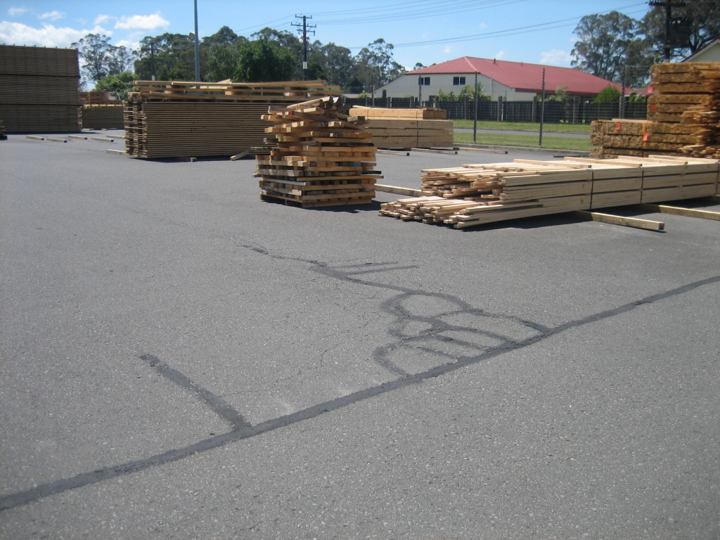
Patched asphalt, Claymark, 30 Nov 2011

Cobbles
Cobblestones (also referred to as industrial pavers) are both practical and cost effective for heavy industrial applications such as log yards. A paper by Allan McKerchar, Civil Engineering Tokoroa (cet@xtra.co.nz) outlining his experience at Kinleith notes:
- In a hardworking woodyard environment with 30 tonne Wagner Log Loaders, 100 mm cobblestones were wearing at a rate of 3 mm a year. Asphalt in the same location was wearing at a rate of 20 mm per month. In some areas (where rear jockey wheels of Wagner Log Loader turns) 150 mm strips were wearing through in six months.
- Cobblestones impervious to chemical or hydraulic fluid attack.
- Cobbles can be replaced relatively easily if the sub-base subsides.
The following companies in Ngāpuna employ cobbled surfaces:
- McAlpines
- Tachikawa
- TD Haulage
- Vaughan Road Panel Beaters
We have noted that the cobbled log yard at McAlpines in Rotorua, laid in 2002, was in excellent condition as at May 2013. Cobbles are easy to sweep and keep clean.
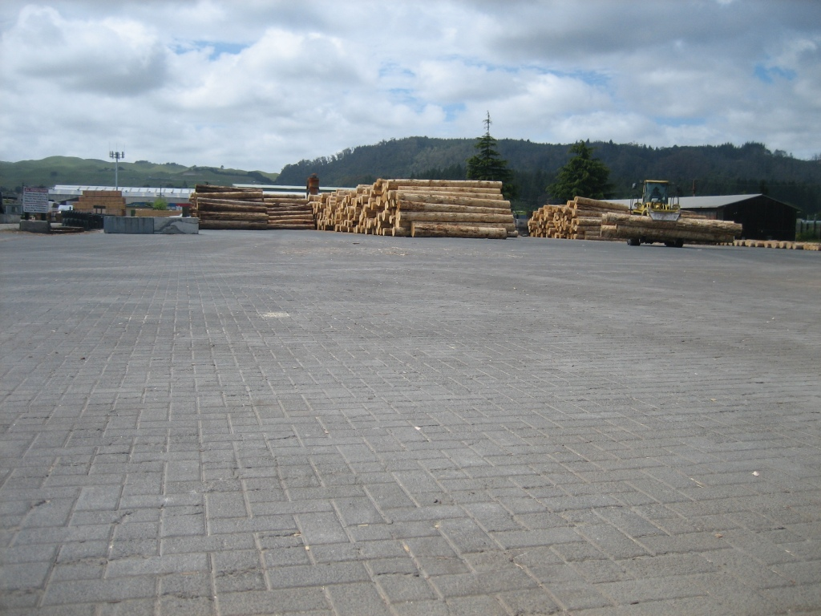
McAlpines log yard, 28 Nov 2011 (laid in 2002)

Concrete
Another option for sites with heavy traffic is reinforced concrete. John Rowbotham (owner JR Autospray which services tracked vehicles) recommends reinforced concrete as an appropriate surface for such vehicles. Other sites in Ngāpuna employing reinforced concrete for heavy vehicles include:
- Claas Harvest
- Claymark
- Gough Gough and Hamer
- Truckstops
- Transdiesel
Tracked vehicles will require rubber mats (or tyres) to be laid to avoid the surface being broken. Concrete is relatively easy to sweep and keep clean.
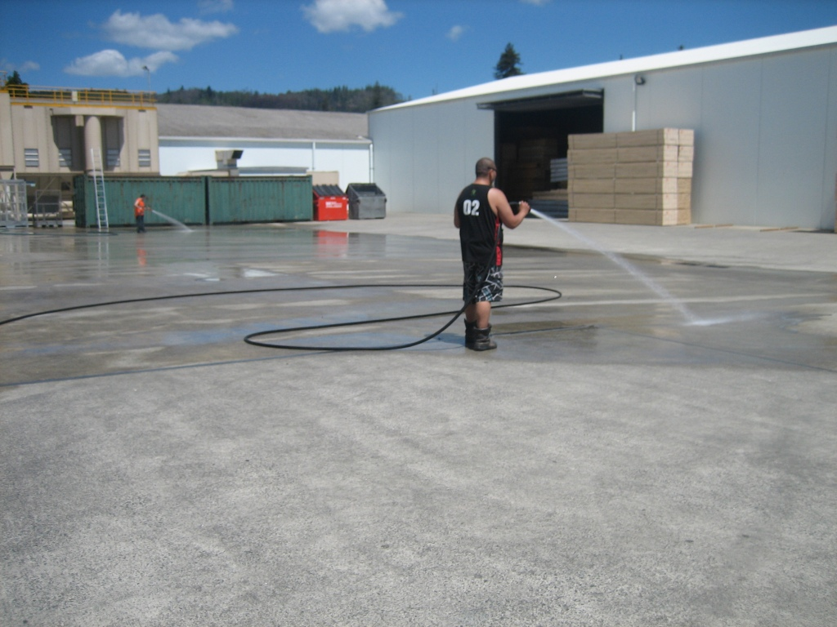
Claymark, 30 Nov 2011

Metal or chip
Metal is a term used in New Zealand to describe aggregate which is laid on a road to provide a durable surface.
Mike Lamberts (forestry truck haulage) in Rotorua, laid about 20 cm of metal on their large site in Ngāpuna in 2012. It worked well to reduce dust emissions but requires relaying after only one year. This site has a large number of trucks moving over it every day.
A metal surface cannot be swept to remove dust.
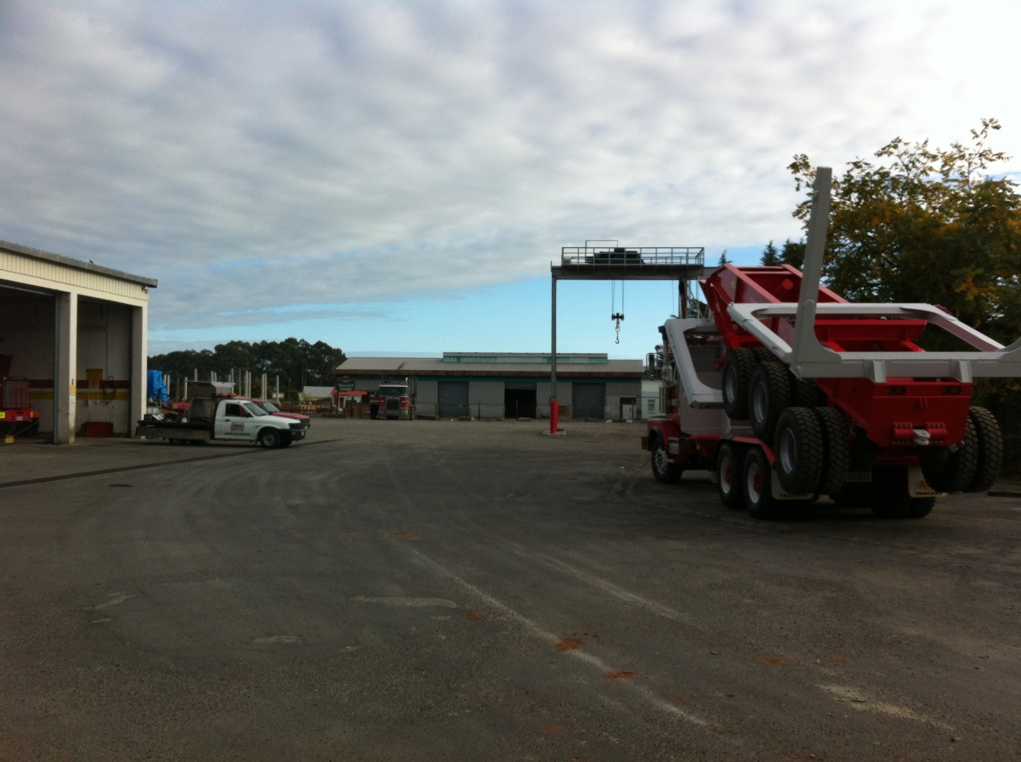
Mike Lamberts metalled site, 2 May 2013

Chip seal is a thin layer of stones set in tar. It is a cheaper alternative to asphalt. Rotorua Forest Haulage also have chip sealed their truck depot (refer photo below). This site is in good condition but will similarly require replacement at some stage.
Chip seal cannot be swept to remove dust.
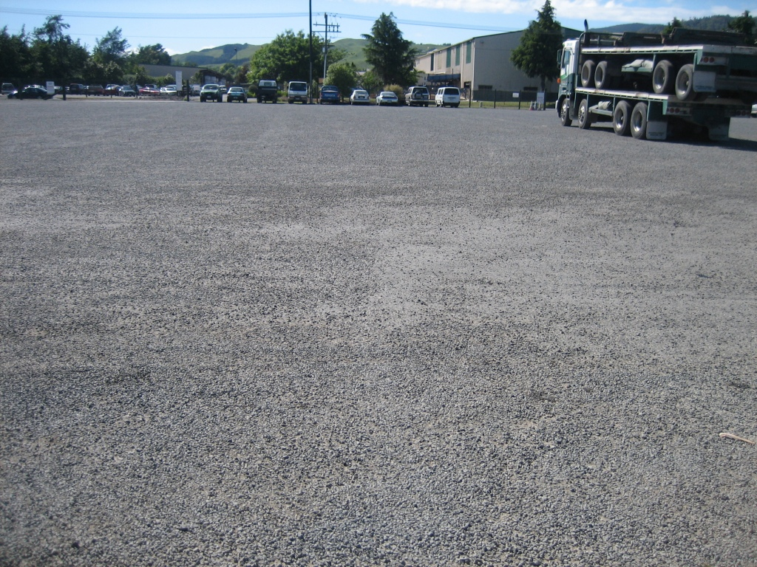
Rotorua Forestry Haulage, 30 Nov 2011

Temporary seal
There are a number of products that can be applied to provide a temporary seal
(e.g. dustlock, dustdown, soiltac). Sometimes these also require pre-treatment
(e.g. grading, compaction) of the surface prior to application.
In our experience, these are variable in performance and relatively expensive. Whilst they may be good at reducing dust emissions initially, they often do not last – particularly in highly trafficked areas as is often the case in industrial applications. We advise caution.

Sweeping and vacuuming
Sweeping large open areas manually (i.e. with a broom) simply isn’t practical. Alternatives include brushes and/or vacuums on the front of bobcats, front end loaders and/or tractors (refer photos).
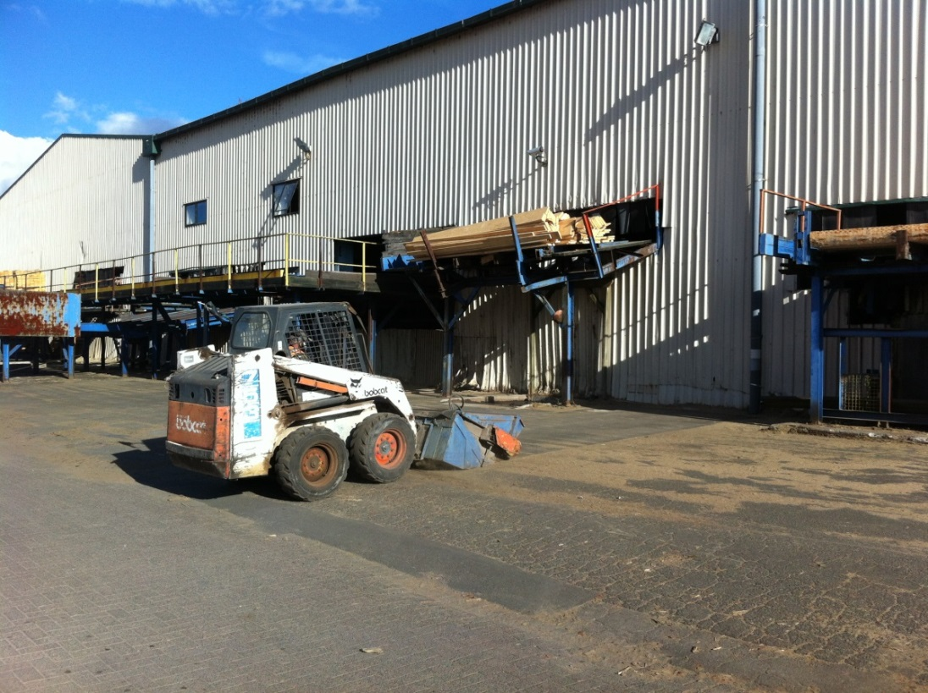
Bobcat vacuum sweep, Tachikawa, 1 May 2013
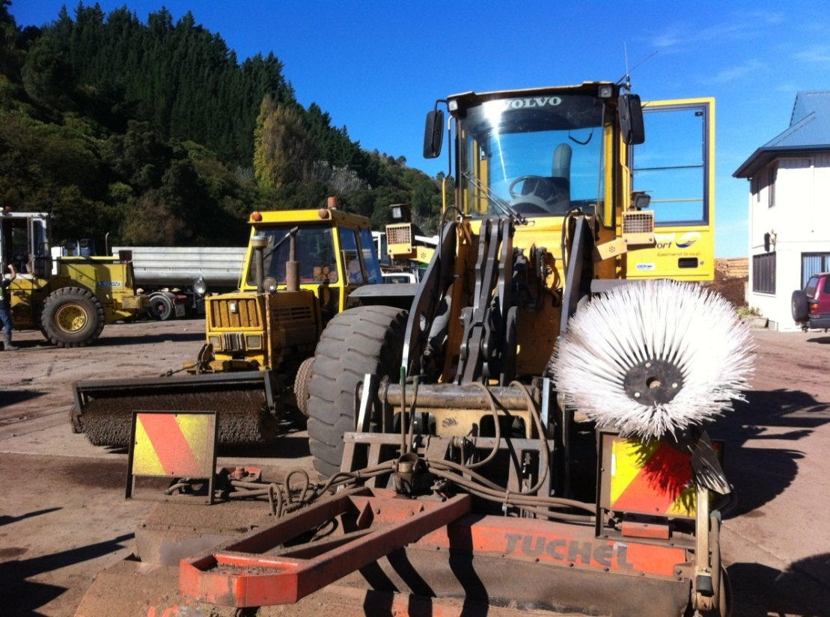
Tractor sweep and front end loader vacuum sweep, courtesy Eastland Port Ltd, 29 April 2013

Watering
Spraying a fine mist of water to dampen (as opposed to wetting) surfaces can be highly effective at controlling dust. However, it is only a temporary measure. Typical water requirements are up to 1 L/m²/hr (litre per square metre per hour).
Sprinklers needn’t be expensive - cheap, lawn sprinklers from Bunnings can do a passable job. Once fixed to a stand, these can be moved around to different parts of a site (refer photo).
Alternatively, rotating sprinklers can cover a moving 20 m arc and apply more water for fast relief. These can be fixed, or mobile (refer photos).

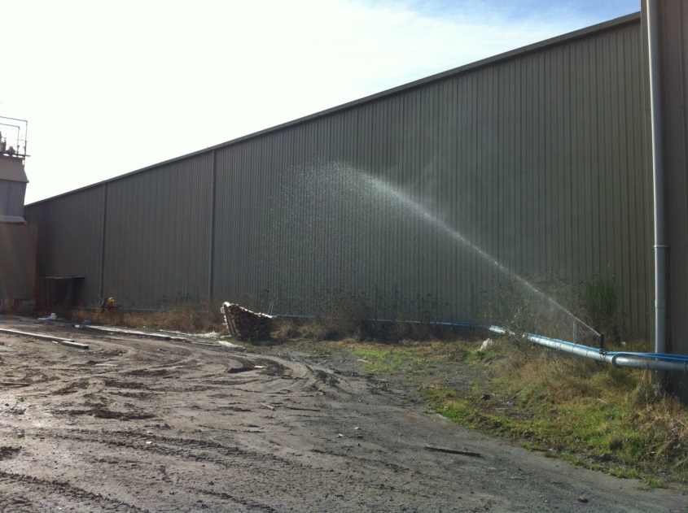
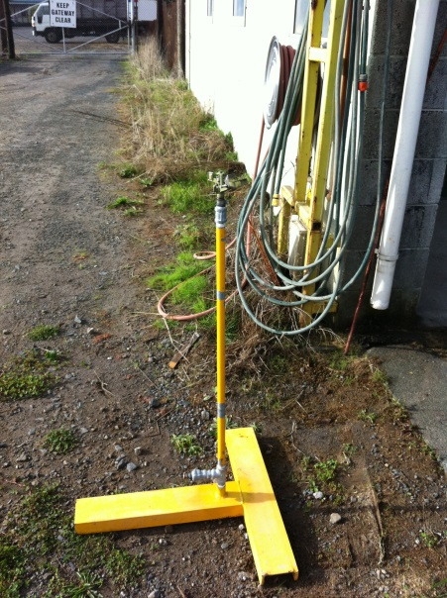 Fixed, rotating sprinkler
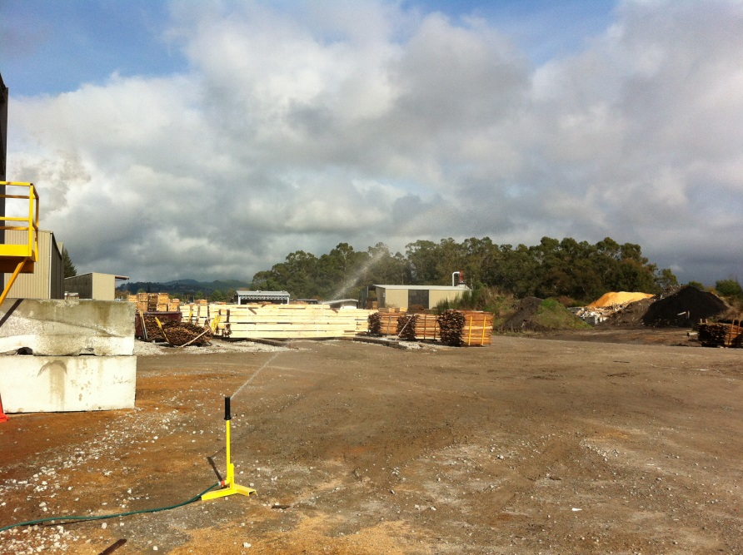
Bunnings sprinkler on stand

Mobile, rotating sprinkler

