IN THE MATTER of the Resource Management Act 1991 (RMA)
AND
IN THE MATTER of Proposed Change 6 (National Policy Statement on Urban Development) to the Bay of Plenty Regional Policy Statement

HEARING DIRECTION #1 FROM THE HEARING COMISSIONERS

- Pursuant to section 34A of the RMA, Bay of Plenty Regional Council (the Council) has appointed Commissioner Robert Scott (Chair), Commissioner Rawiri Faulkner, Councillor Jane Nees and Councillor Paula Thomson to hear submissions and make recommendations to the Strategy and Policy Committee on Proposed Change 6 (National Policy Statement on Urban Development) to the Bay of Plenty Regional Policy Statement.

- Following the hearing of submissions and evidence on Wednesday 21 and Thursday 22 June 2023, we adjourned the hearing to allow the Council officers to prepare a written reply to the evidence presented and to allow for a field trip to relevant areas within the Region referred to in evidence. Some submitters also offered to provide additional information in response to our questions.

- At this stage the Commissioners intend to undertake the field trip on 18 July 2023 and commence deliberations on 19 July 2023.

- We wish to thank the submitters for their co-operation and flexibility with the hearing schedule, the evidence presented to us and helpful answers to our questions.

- This direction confirms the timeline for the provision of further information and the field trip as follows:
  - Any additional information from submitters shall be provided by 4.00pm Friday 30 June 2023;
  - Council shall provide a written response to the evidence submitted at the hearing by 4.00pm 7 July 2023;
  - Commissioners will undertake a field trip on 18 July 2023.

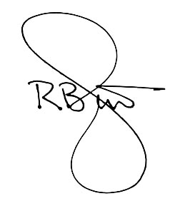
- Any enquiries regarding these Directions or related matters should be directed to the Council’s Hearings Advisor, Ms Claudia Cameron, by email at claudia.cameron@boprc.govt.nz

Robert Scott, Chairperson
26 June 2023

