Date: 10/11/2022
Prepared by: Mary Pappon
Senior Consents Planner

Application details
Application ID: RM22-0076 and RM22-0128
Applicant: Rainbow Mountain Renewable Energy Ltd
Metal Co Recyclers Limited
Application: To discharge contaminates to air on a temporary basis during the trial of an ATR pyrolysis plant; and
To discharge contaminates (mainly particulates) to air on from an Industrial Shredder and Destoner Cleaning Plant.
Location of activity: 216 State Highway 38, Waimangu

Introduction/Summary of proposal
Mitchell Daysh Limited (the consultant) on behalf of the Rainbow Mountain Renewable Energy (the applicant) has applied for resource consent to discharge contaminants to air resulting from the shredding of metal and the processing of automotive shredder residue (ASR) at their new site located at 216 State Highway 38, Waimangu (refer Figure 1). It is the applicant’s aim to establish a refuse material recycling plant at the site.
The applicant proposes to utilise an existing industrial shredder (currently located at their Te Puke site) to undertake the shredding of automobiles, domestic appliances, construction materials and light machinery at the site. Consent is sought for the discharge of contaminants to air (mainly fine particulates and dust) from the operation of the shredder. Application RM22-0128 seeks to authorise this discharge.
Following the shredding of automobiles, a mix of plastics, glass, rubber, and wood (referred to as ASR material) is produced. The applicant explains that this material is hard to recycle and is currently disposed of to landfill. The applicant proposes, through application RM22-0076, to undertake the recycling of this material, as a means of reducing waste to landfill. The process of recycling this ASR material involves loading the material into a pyrolysis plant and applying heat and pressure to break the material down. The ASR material will be heated to temperatures between 350 and 650 degrees Celsius (˚C) and will result in the production of oil, black powder and gas.
Application RM22-0076 seeks to authorise anaerobic-thermal-reduction (“ATR”) pyrolysis trials (using the pyrolysis plant) at the site. The purpose of the trials is to;
- ensure the plant operates as expected;
- gain a better understanding of how the pyrolysis plant will operate and to refine the operational aspects of the plant;
- better understand the chemical make-up of the discharge as a result of heating and pressurising the ASR material;
- refine the mix of ASR material to achieve a discharge that is free of particulate, free of carcinogenic and or mutagenic compounds and is low in temperature; and
- undertake testing and analysis to inform a long-term consent application and consented limits.

A consent term of 6 months is sought for application RM22-0076 (ATR Pyrolysis Plant Trial).
Application RM22-0128 seeks to authorise the discharge of contaminants to air (mainly particulates - dust) from the industrial shredder and destoner cleaning plant. For efficiency, the effects associated with both applications are considered in this report. A consent term of 20 years is sought.
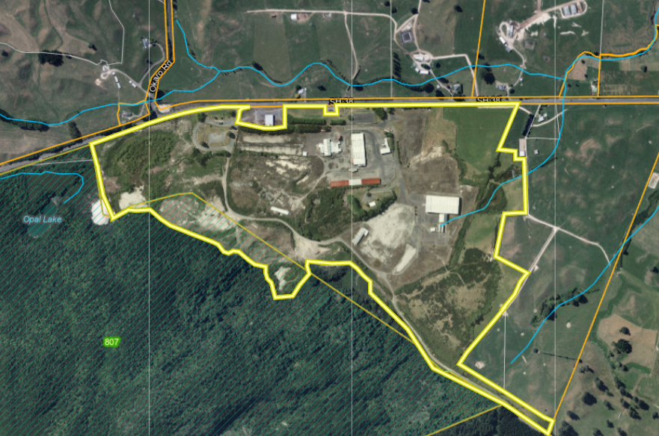
Figure 1: Site location (yellow), freshwater bodies (blue) and adjacent biodiversity area

System Description and Operation
The Industrial Shredder and Destoner Cleaning Plant
The shredder will be used to break down and separate a variety of discarded or end-of-life products (‘feedstock’). Primarily this will be automobiles, but may also be domestic appliances, construction materials and light machinery. The shredded material will be separated by the shredder into ferrous metals (steel), nonferrous metals and mixed/organic material.

The shredded metal will be transported off site and the mixed organic material (ASR material) will be processed in the pyrolysis plant using the ATR process (this process is explained further below).

Shredded material will be stockpiled on site. The base of the stockpile will be sealed with concrete, and it will be covered from rain with a permanent roof above. The shredder itself will be located on a concrete pad and will have a concrete enclosure built around it, following relocation from Te Puke, so as to capture the discharges to air from the shredding process. In addition to the discharge of dust and fine particles to air from the shredding process, there may be small amounts of oil vapour discharged as a result of heating (resulting from friction) of the scrap metal.

Prior to the ASR material being processed in the ATR Pyrolysis plant, as described below, the material will be cleaned in the destoner cleaning plant. This plant will be located within an enclosed building on site in close proximity to the shredder.

The Pyrolysis Plant
The pyrolysis plant will be located within an enclosed concrete pad (approximately 18 metres (m) x 24m) and will have an emission stack; 14 m above ground level. The plant will have a wet scrubber process to treat or encourage the settling out of fine particles prior to the discharge through the stack.
The ASR material is a random mixture of many plastics, natural and synthetic rubbers, glass, wood, dirt, and stones. Following the shredding of automobiles and subsequent sorting of this material, the ASR material will be directed to the pyrolysis plant for treatment. The ASR material directed to the plant will be ‘washed’ through an enclosed cleaning plant prior to entering the pyrolysis plant to remove unwanted material such as glass, metallics, stones and dirt, to ensure a higher quality end product is produced.
The ATR process will ‘thermally decompose’ the ASR material under heat and pressure, in the absence of oxygen. The ATR process operates in the range 350-650°C to create the primary vapour which travels, under convection induced flow, to simple water-cooled condensers. These condensers change the hot hydrocarbon (primary) vapours to condensate (oil) and non-condensable gas (syn-gas). The end products of ASR are liquid monomers (as an oil), carbon black (as a powder), and gas.
It is anticipated that the gas will be used as the primary source of heat energy to power the ATP plant and the oil and carbon black by-product will be transported off site (on-sold) for use as fuel at Oji Fibre’s processing plant or used as a bitumen additive at Allied Asphalt’s Rotorua Plant.
Oil will be stored in a storage tanker and the carbon black will be stored in sealed containers to be transported off site daily via trucks.

Planning framework
Resource consents are required under the ‘Pre-Operative’ Plan Change 13 (Air Quality) to the Bay of Plenty Regional Natural Resources Plan
- The discharge of contaminates to air from pyrolysis process is a discretionary activity under Rule AIR R15(22); and
- The discharge of contaminates to air from waste facilities (including resource recovery and recycling centres) is a discretionary activity under Rule AIR R15(24(b)).
It is recognised that the discharge of contaminated stormwater from the site requires consent under Rule DW R8 of the Regional Natural Resources Plan. This does not form part of this application, however, consent will be sought through a separate consent application process.
National Environmental Standards for Storing Tyres Outdoors 2021 (NESTO)
The company will not actively be seeking tyre material from vehicles, however, if this material is received, it will be stored in accordance with Regulation 11 and 12 of the NESTO. Specifically, storage of tyres will be less than 100 cubic metres (m³) in volume, will be less than 3 m in height, and will be more than 20 m away from any surface water body. Therefore, the storage of tyres at the site will be a permitted activity under the NES Tyres.
National Environmental Standard for Assessing and Managing Contaminants in Soil to Protect Human Health 2011 (NES:CS)
The site is listed on the HAIL register due to previous Timber Treatment activities on the site. However, given there will be no disturbance of soil / material associated with the proposal, and there is no change to land use at the site, the NES:CS does not apply. Rita Martin, Senior Compliance Officer, reviewed the application and agreed with the applicant’s opinion that no consent is required under the NES:CS.
As there is no disturbance on site as part of the proposal Rule DW R25 (disturb a contaminated site) of the Regional Natural Resources Plan also does not apply.
National Environmental Standards for Freshwater 2020 (NES-FM)
The proposed take is not within 100m of a natural wetland and does not require resource consent under the National Environmental Standards for Freshwater 2020.
Overall, the application is considered to be a discretionary activity.

Description of the existing environment
The site is located within a wider rural landscape at the foot of Rainbow Mountain, which is located immediately southwest. It is a highly modified industrial site that was previously used as a timber treatment yard and landfill. The site currently consists of a range of industrial style buildings, sealed and unsealed transport roads leading to various areas of the site.
The site is largely hidden from view from the adjacent State Highway (“SH”) 38, given it is elevated above street level due to the natural gradient of the surrounding environment, and is vegetated along its boundary. The site is currently fenced and is accessed via two gated entrances off SH38. The site is predominantly flat, with a gentle rise from SH38 towards the southern area of the site (the foot of Rainbow Mountain Scenic Reserve).
There are pockets of vegetation within the site; this includes a densely vegetated area around a stormwater pond on the western portion of the site close to SH38, a small area in the centre of the site, and densely vegetated areas on the southern boundary adjacent to the boundary shared with the Rainbow Mountain Scenic Reserve. The surrounding environment is predominantly rural in nature. Rural properties in the vicinity of the site are predominantly located adjacent to SH38, as depicted in Figure 2.

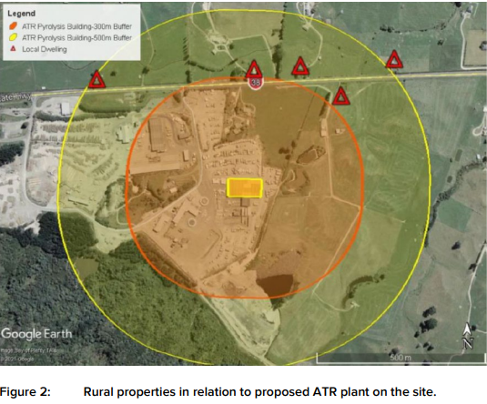
Figure 2: Rural properties (red triangles) in relation to the proposed ATR plant on the site (orange rectangle).

Notification/Non-Notification Recommendation and Decision

Sections 95A to 95F Resource Management Act 1991

Is public notification mandatory?
Step 1 – Has the applicant requested public notification (s95A(3)(a))?
☒ No - go to Step 2.
Step 2 – Is public notification required under s95C (s95A(3)(b))?
- Has further information (s92(1)) been requested or has the applicant been notified of the intention to commission a report (s92(2))?
☒ Yes – go to Step 2b.
- Did the applicant refuse the request, or fail to respond, or fail to provide the information by the deadline?
☒ No – Go to Step 3.

Is public notification precluded?
Step 3 – Are all activities in the application subject to one or more rules or national environmental standards that preclude public notification (s95A(5)(a))?
☒ No – Go to Step 4.
Step 4 – Is the application for a controlled activity (s95A(5)(b)(i)) only?
☒ No – Go to Step 5.

Is public notification required?
Step 5 – Does a rule or national environmental standards require public notification (s95A(8)(a))?
☒ No - go to Step 6.
Step 6 – Are adverse effects on the environment more than minor (s95A(8)(b))?
☒ No – (go to Step 7) I recommend the application is not publicly notified for the following reasons:
- Relevant objectives and policies in planning documents
The application provides an analysis of the relevant objectives and policies from the Regional Policy Statement (RPS) and Regional Natural Resources Plan (RNRP) at Section 4 of the application document. I consider that it identifies the relevant objectives and policies and although I do not repeat them here, these matters have been considered as part of the notification assessment. I refer to some, but not all, of the relevant objectives and policies in the assessment below.
- Assessment of adverse effects
  - Air Quality – Shredder

Feedstock in the form of automobiles, domestic appliances, construction materials and light machinery will be brought to the site for processing. The feedstock will be fed into the shredder and following shredding will be sorted to separate the material to be transported off site (ferrous metals) from the mixed / organic material (ASR material) which will be further processed in the ATR plant on site. During shredding, contaminants, in the form of particulate matter (dust) will be generated and discharged to air.

As outlined above the shredder will be located upon a concrete pad to contain and direct contaminated stormwater and it will be housed within a noise attenuation enclosure. While the enclosure’s primary purpose is to attenuate noise, it will also function to capture particulates from the operation of the shredder. In addition to this, the applicant has proposed to install a bag house and wet scrubber to capture large particles (baghouse) and enable the settling out of finer particles (wet scrubber).

Through the processing of the consent, the applicant was asked to undertake stack testing of the discharge from the shredder at the Te Puke site and use this information to inform an assessment of effects for the use of the shredder at the Rainbow Mountain site. The applicant took the measured discharge from the Te Puke site and input this information into the CALPUFF model to better understand the effects of the discharge at the Rainbow Mountain site. In undertaking the assessment, the applicant considered the effects on the nearest 16 residential receptors (shown below in Figure 3). Mr Nicholas Browne (Air Quality Specialist, Air Matters Ltd) undertook a review of this information on behalf of Bay of Plenty Regional Council (BOPRC), and while he commented that the information provided was not perfect (for example the applicant could have used three years of meteorological data rather than one), he commented that the “modelling indicates low ground level concentrations at the nearest sensitive receptors even considering a background concentration of particulate.” Mr Browne also commented that it would be appropriate to require regular stack testing alongside the imposition of a mass emission limit and concentration limit. The specific limits are discussed in section 3, below.

Based on the information provided, I consider that the potential effects associated with the discharge of particulate matter from the shredder is likely to be less than minor.

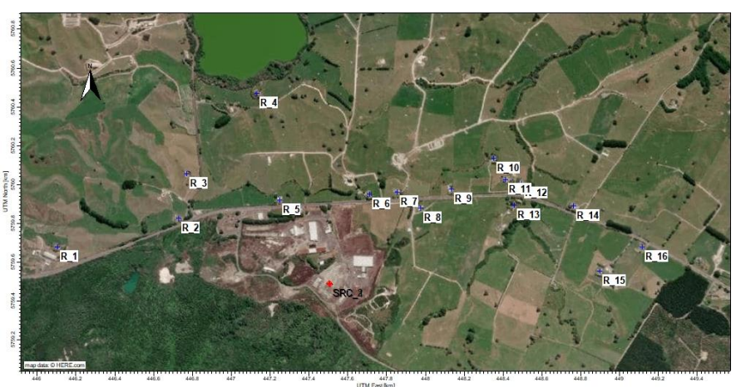
Figure 3: Location of sensitive receptors in proximity to the site.

2.2 Air Quality – Pyrolysis Plant

The applicant seeks a short-term trial (6 months) for the discharge from the pyrolysis plant to better understand the effects associated with using a pyrolysis plant to ‘thermally decompose’ the ASR material and to optimise the operating conditions of the plant. I understand that this type of activity does not currently occur in New Zealand and therefore there is not a lot of information available throughout New Zealand that could be directly applied to this application. Despite this, the applicant has undertaken an assessment of the effects of the activity, and this has been reviewed by Mr Browne.
Given the uncertainty around the effects associated with the pyrolysis plant, the applicant proposes to undertake a series of trials. Some of the trials undertaken will be ‘no load’ trials whereby the pyrolysis plant will be run without the ASR material within the plant. This is to calibrate the plant and make sure the plant is running safely and operating as expected prior to introducing ASR material. In addition to this a series of ‘in load’ tests will also be undertaken. During all trials, the plant will be monitored to see how it reacts and trials will be undertaken on a 24-hour basis from Monday – Friday. This monitoring and reporting will be particularly important during the ‘in load’ testing. The aim of the in-load trials is to introduce different types of ASR material (i.e. different plastics) to monitor how the ASR pyrolysis plant reacts to this material, to better understand the nature of the discharge (i.e. what contaminants are in the discharge) and what the concentrations of the contaminants in the discharge are.
Once the applicant has a good understanding of the nature and concentration of the discharge, they will then be able to translate that information into understanding what the effects of the discharge on the environment and human health might be on an ongoing basis. This information will be used to inform a long-term consent for the discharge.
While the applicant anticipates that only carbon dioxide (CO²) and water vapour will be discharged from the stack, regular monitoring will be undertaken to ensure this is the case. Through the review of the technical aspects, concern was raised regarding potential adverse effects associated with the discharge, especially as there is little information on how the plant operates and what contaminants would be discharged. Therefore, rather than restricting the number of trials that could be undertaken or the reporting requirements following the undertaking of trials, the applicant, through their response to our request for further information, proposed discharge limits that they would monitor against and comply with during the trials. These limits were proposed as a backstop to give Council assurance that potential adverse effects on the environment and human health would be avoided. The monitoring regime and suite of contaminants to monitor for have been revised from that which was initially proposed. The contaminants and associated limits are discussed in further detail in section 3 of this report.
The monitoring regime and suite of contaminants to be monitored for, has been assessed by Mr Browne. Mr Browne confirmed that the limits seem appropriate and that the relevant contaminants will be monitored. Mr Browne has commented that it is important that the applicant monitor the measured discharge from the stack as well as monitoring against the emissions limits imposed as conditions of consent. This will give us a good understanding of the actual discharge from the stack but will also ensure that the ‘backstop’ limits imposed to maintain human health standards during the trial are maintained. Consent conditions will require, that should the emissions limits be exceeded, the trial in progress will be completed and then a review process, to understand what caused or contributed to the exceedance(s), will commence. This will ensure that any exceedances are short term and are remedied before the next trial takes place. Sampling and testing required, will be submitted within 10 working days of the results being received.
Given that the proposal is for a trial and there will be the regular monitoring for the identified suite of contaminants and limits associated with the contaminants have been proposed and agreed to, the effects associated with undertaking the trial are considered to be less than minor.
2.3 Odour
There are several potential odour sources throughout the site which include:
Odour may be generated as oil is transferred from the tanks into trucks for transportation of site. The applicant proposes that the tank vents be fitted with carbon scrubbers to mitigate any potential odour effects. In addition to this the applicant proposes to undertake FIDOL assessments during the loadout process which will be formalised in the Management and Monitoring plans as a condition of consent.
The applicant has advised that the material stockpiled on site will not be of an odorous nature. However, as above the undertaking of regular FIDOL assessments will either confirm this or require the generation of odour to be rectified.
Odour may be generated during the ASR process. The applicant considers that this is unlikely due to the closed loop nature of the system. The applicant proposes to undertake FIDOL assessments during the trials to ensure these assumptions are correct and to remedy any discharges of offensive or objectionable odour from this activity. This will be addressed through the final Management and Monitoring plans as a condition of consent. A catch all consent condition will be imposed to ensure there are no offensive or objectionable discharges of odour beyond the boundary of the site. It is recommended that this is included on both the shredder consent and the ATR plant consent.
I consider that the potential adverse effects of odour beyond the boundary on neighbouring properties is likely to be less than minor.

Dust
There may be fugitive dust emissions from the site in addition to the dust specifically generated from the shredder. It is not anticipated that dust would be generated from, or as a result of, the stockpiling of the ASR material on site. ASR material will be stored in a semi-enclosed covered structure, and I understand that it is large enough to not be disturbed by wind. The applicant has proposed that they will maintain the site and undergo regular sweeping of the site to ensure this source of dust, is managed so that it does not discharge beyond the site boundary. The measures to manage dust are outlined in the draft management plan and will be finalised through conditions of consent. I consider the potential effects associated with the discharge of dust are likely to be less than minor.

Effects on Cultural Values
Information provided confirms that Maunga Kakaramea (Rainbow Mountain) is a significant site of cultural value particularly to Ngāti Tahu-Ngāti Whaoa. Through the consultation period there appears to be some confusion that earthworks will take place at the site. It is understood through the processing of this consent that no earthworks are proposed. There will be minor works undertaken to prepare the site for machinery (such as the shredder) and potentially new buildings. However, bulk earthworks do not form part of this application. Despite this, I consider that it is appropriate to enable the involvement of tāngata whenua with the proposal through the invitation of iwi representatives during site establishment and monitoring should they wish to be involved.

Below is a record of engagement with tāngata whenua of the subject area undertaken by the applicant regarding the development of the site including the use of the shredder and ATR plant. The applicant has had some success in understanding the potential adverse effects upon cultural values. However, in other instances they have not received a response to their engagement attempts.

Based on the technical reviews I am comfortable that the potential adverse effects associated with the discharges are likely to be less than minor and will not cause adverse effects within the site or beyond the boundary of the site.

Table 1: Summary of iwi engagement undertaken and outcomes of the engagement.

Iwi and hapū | Date of contact | Comments
Ngāti Tahu-Ngāti Whaoa  Ngāti Tahu-Ngāti Whaoa Rununga Trust-  Michelle Phillips, Environmental Resource Consents Officer | 29/09/2021 | Maunga Kakaramea and its surrounding lakes and waters are of the utmost significance to the iwi.  Requested that accidental discovery protocol is in consent conditions. Has stated that engagement will need to continue.
Ngāti Rangitihi | 08/04/2022 | No concerns with the proposal.
Tūhourangi  Tūhourangi Tribal Authority | 29/09/2022 | Supports the application on basis that relationship between both parties continues and the application does not cause adverse effects.
Ngāti Raukawa | 24/03/2022  27/05/2022  09/06/2022 | Phone call and emails sent over the period indicated.  No written response received.
Te Arawa Lakes Trust | 17/08/2021  15/06/2022  28/06/2022 | Three emails sent over this period to Jude at Te Tatau and with Melissa at Te Arawa Iwi.  Phone conversation with Melissa at Te Arawa Iwi.  No written response received.

Given the responses received or in some instances, the lack of response, I consider that the effects of the discharge on cultural values are likely to be less than minor. I have required through conditions of consent, that tangata whenua representatives are invited to the site during the trial being undertaken to better understand how the trial will happen and what the effects of the discharge are. This will help the iwi representatives, get a better understanding of the process and to allow for these comments to be incorporated into a long term consent, following the completion of the trial.

Adverse effects that have been disregarded (s95D)
No effects have been disregarded.

Conclusion
Having reviewed the application, further information provided, and the technical reviews of the information provided, I am comfortable that the potential adverse effects associated with the application are likely to be less than minor. The applicant has confirmed that the discharges from shredding activity and the pyrolysis plant will not give rise to adverse effects within the site or beyond the boundary of the site. Proposed limits for the ATR plant have been set to ensure the potential effects on the environment and human health are avoided. Therefore, I consider the potential adverse effects resulting from the discharges from the site are likely to be less than minor.

Special circumstances and public notification
Step 7 – Are there special circumstances which warrant public notification?
☒ No - There are no special circumstances. Go to Step 8.

Is limited notified mandatory?
Step 8 – Are there affected protected customary rights groups (s95B(2)(a)), customary marine title groups (s95G), or statutory acknowledgement group (s95B(3))?
☒ No – Go to Step 9.

Is limited notified precluded?
Step 9 – Are all activities in the application subject to one or more rules or national environmental standards that preclude limited notification (s95B(6)(a))?
☒ No – Go to Step 10.

Limited notification of other affected persons?
Step 10 – Are the adverse effects on a person minor or more than minor (but not less than minor) (s95B(8))?
☒ No – There are no affected owners/persons and/or the effects are less than minor. Go to Step 11.

Special circumstances and limited notification
Step 11 – Are there special circumstances which warrant limited notification?
☒ No – There are no special circumstances.

Recommendation
In accordance with the above assessment, I recommend that the application be processed non-notified, on the basis that the adverse effects are less than minor.
This recommendation is made by:
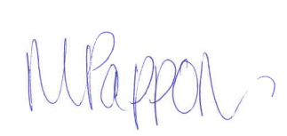
Mary Pappon
Senior Consents Planner Date: 16/11/2022

Decision under delegated authority
I agree with the recommendation that the application should be processed non-notified.
This decision is made under delegated authority by:
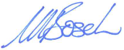
Marlene Bosch
Principal Advisor, Consents Date: 22/12/2022

Section 42A Officer’s Report for non-notified resource consent application, Resource Management Act 1991 (RMA)

Consultation
Consultation with tāngata whenua has been outlined in section 1.5 of my s95 notification recommendation report (above). My s95 notification recommending report confirmed that potential adverse effects upon cultural values was likely to be less than minor.
No other consultation was undertaken.

Consent Conditions

My s95 report recommendation report confirmed that the potential adverse effects associated with the discharge from the ATR Pyrolysis Plant and the industrial shredder were likely to be less than minor. Key components of the application are the imposition of conditions of consent to ensure that the actual or measured discharges occur in the same way and to the same extent that the assessed and modelled information provided in support of the application, anticipated.

Table 2 below identifies the matter that requires management and the conditions proposed to manage them and the associated effects.

Table 2: Matters or effects requiring control or management and proposed method of managing these.
Matters / effects requiring control or management | Conditions
Controls to manage dust generated during the carbon black size reduction and separation | Installation of a baghouse and wet scrubbers that will filter black carbon from the air stream.
Stack for the ATR Plant | Minimum exhaust height of at least 14 metres above ground level.  Minimum clearance of 3 metres above the top of the nearest structure on site.  Stack to have an unimpeded vertical discharge.
Emission limits and testing | Emission testing methods and frequency provided in the ATR Sampling and Monitoring Plan (S&MP) (see 5 below)  Location of the collection of the sampling parameters provided in the ATR S&MP (refer Figure 1).  Applicant has provided stack limits, testing method and frequency for the discharge in the ATR S&MP. These limits have been imposed as an appendix to the consent.  Maximum emission limits for the shredder:  0.03g/s for PM10.  10mg/m³ - max concentration for PM10.
Stack Testing | Regular stack testing will be required throughout the ATR Pyrolysis trials. Likely to be for a period of no less than 1 hour to determine consistency of emissions.  The applicant will be required to monitor the measured discharge and monitor the discharge against the consented limits and consider the effects of the discharge on the environment.  Annual stack testing from the shredder stack required. Information modelled in 2027 and 2031 to confirm ground level effects.
Management Plans | Draft Shredder Activities Site Management Plan (SASMP)  Final version of the SASMP to be submitted to the BOPRC for certification.  Operation of the shredder and associated stockpiles in accordance with the Final SASMP.  Update the environmental management plan to include specific criteria for wet scrubber including monitoring, operational levels for pH, temperature, and flow through the scrubber.  Treated as a ‘live’ document that will be updated as necessary.

Draft Emergency Management Plan (EMP)

Final version of the EMP to be submitted to the BOPRC for certification.

Treated as a ‘live’ document that will be updated as necessary.

Draft Site Management Plan (SMP) –

Operation ATR Plant

SMP should be updated to include:

How complaints are dealt with,

Process description updated especially for the ATR process,

Method of control to be updated especially for the ATR process;

Monitoring updated to include “who, where, how and what” details;

Update roles / responsibilities,

Update the dust / particulate aspects of the SMP with specific details around dust / particulate management.

Applicant to manage the site and discharge activities in accordance with the SMP.

Applicant to manage the emission control equipment in accordance with the manufacturer’s instructions and recommendations.

Final version of the SMP to be certified by BOPRC.

Treated as a ‘live’ document that will be updated as necessary

ATR Plant Sampling and Monitoring Plan (S&MP)

The applicant provided a draft sampling and monitoring plan (S&MP) for review. This was updated and finalised prior to consent being granted, so does not require certification as a condition of consent.

Monitoring and sampling to be undertaken in accordance with the Sampling and Management Plan (S&MP).

Treated as a ‘live’ document that will be updated as necessary.
Odour | Storage tank vents to be fitted with carbon scrubbers to mitigate potential odour effects.  Applicant will undertake field observations using FIDOL assessment process during the oil load-out process and during the ATR trials to confirm odour is not offensive and objectionable beyond the site boundary.  Applicant to use “The Good Practise Guide for Assessing and Managing Odour” when undertaking this assessment.  Standard condition requiring no discharge of offensive / objectionable odour beyond the boundary for the industrial shredder activities.
Dust | Application of water to manage dust around the site (both fixed sprays and a water truck)  Regular cleaning / sweeping of the site to reduce amount of dust around the site.  Fugitive emissions of dust will be managed through the SMPs.
No load Tests | No load tests will be limited to duration and temperature as the system is not designed to run ‘empty’.
Length of Trial | ATR plant will be trialled for a 6month period only. Information gained through the trial will be used to support a long-term consent.  New trial unlikely to commence until the results of the previous trial have been reviewed.
Shredder | Shredder to be located at the rear of the site, farthest away from sensitive receptors.  The destoner plant (associated with the shredder) will be housed behind 6 m high concrete walls.
Reporting | Reporting to Council the results of the emissions and stack testing and for the modelling undertaken for the ATR and Shredder.  Erection of signage outlining contact details for complaints during and outside of working hours.  Reporting of complaints received by the applicant to the Bay of Plenty Regional Council within 24-hours of receiving them.  Record keeping of all complaints received for the duration of each consent.
Cultural Effects | Imposition of consent conditions which require the applicant to invite a member of Ngāti Tahu-Ngāti Whaoa and Tūhourangi on site to better understand the activities occurring.

Table 3: Emission Limits for the relevant parameter – ATR Plant.
Parameter | Units | Maximum Emission  Limits | Test Method | Stack Test Requirements
Particulate (PM₁₀) | mg/m³ | 50 | USEPA Method 5 | 3 x 60 minutes
HCI | mg/m³ | 10 | USEPA Method 26a | 3 x 60 minutes
HF | mg/m³ | 4 | USEPA Method 18 | 3 x 60 minutes
VOC (as total organic carbon) | mg/m³ | 20 | USEPA Method 6 | 3 x 60 minutes
Sulphur Dioxide (S0₂) | mg/m³ | 50 | USEPA Method 7c | 3 x 60 minutes
Nitrogen Oxides (as NO₂₎ | mg/m³ | 200 | USEPA Method | 3 x 60 minutes
CO | mg/m³ | 50 | USEPA Method 29
Sb | mg/m³ | 0.055
As | mg/m³ | 0.005
Pb | mg/m³ | 0.295
Cr | mg/m³ | 0.01
Co | mg/m³ | 0.005
Cu | mg/m³ | 0.065 |  | 3 x 120 minutes
Mn | mg/m³ | 0.055
Ni | mg/m³ | 0.005
V | mg/m³ | 0.005
Hg | mg/m³ | 0.05
Cd | mg/m³ | 0.00875
TI | mg/m³ | 0.00125
Aldehydes | mg/m³ | 150 | USEPA Methods 0011 | 3 x 60 minutes
Poly aromatic hydrocarbons (PAH) | mg/m³ | 400 | USEPA Method 23 | 3 x 120 minutes
Dioxins and Furans (as I-TEQ) | ng/m³ | 0.1 | USEPA Method 23 | 3 x 360 minutes

The matters raised above will be imposed as conditions of consent. These methods are considered appropriate to avoid or mitigate effects associated the discharge of contaminants to air from the activities on site.

Statutory analysis
Section 104(1)(b) of the RMA requires that when processing a resource consent application, the consent authority must, subject to Part 2 of the RMA, have regard to the relevant provisions of national and regional policies, plans and standards. Section 104(3) of the RMA states that a consent authority must not grant resource consent contrary to Sections 105 and 107. An assessment of the relevant Section 104, 105 and 107 matters below.

Relevant plans
The applicant has undertaken an assessment against the relevant objectives and policies of the Bay of Plenty Regional Natural Resources Plan.
The applicant considers that the proposal is consistent with the objectives and policies of the RNRP. I agree with that assessment and adopt it in accordance with s42A((1B)(b) of the RMA.

Bay of Plenty Regional Policy Statement
The RNRP does not give direct effect to the Bay of Plenty Regional Policy Statement (RPS) because it pre-dates the RPS. Therefore, it is important to consider whether or not the proposal is consistent with the relevant objectives and policies of the RPS. The applicant has provided an assessment against the relevant policies of the RPS and considers that the proposal is consistent with the RPS. I agree with this assessment and adopt it.

National Policy Statements

There are no NPS’ that apply to this application.

National environmental standards and other regulations

National Environmental Standard for Air Quality (NES-AQ)
The applicant has undertaken an assessment against the NES-AQ and concludes that the proposal is consistent with the NES-AQ. While the Bay of Plenty Region is within an airshed, this application sits outside any airshed claissified as being ‘polluted airsheds.’ It is not anticipated that either applications would result in the air quality standards outlined in the NES-AQ being exceeded.

National Environmental Standard for Storing Tyres Outdoors (NES-STO) 2021
The NES-STO came into effect in August 2021 and places restrictions around the storing of tyres in outdoor settings. The NES-STO does apply to the site. However, the applicant has confirmed that they will not be actively seeking and storing tyres. Given the type of activity they undertake (the breaking down of automobiles) they will inevitably receive tyres, however they have advised that they will comply with the permitted regulations; specifically, that the storage of tyres will be less than 100 m³ in volume, will be less than 3 m in height, and will be more than 20 m away from any surface water body. Therefore, the storage of tyres at the site will be a permitted activity under the NES-STO.

RMA Part 2 matters
The matters listed in Part 2 of the RMA of relevance to this resource consent application have been given adequate regard in the Bay of Plenty Regional Natural Resources Plan and the Regional Policy Statement. The proposal is considered to be consistent with the policy direction of these documents, so I have not considered it necessary to revisit Part 2 of the RMA or make an overall broad judgement pursuant to the High Court direction in R J Davidson.

Sections 105(1) and 107 of the RMA
The application and Consent Authority have had regard to Section 105. The discharge of contaminants to air is the only discharge method available for this type of activity.
Providing the consent holder complies with consent conditions, I consider that any discharge from the activity should not result in the production of any of the effects listed in Section 107(1).

Consent Term
With regards to the ATR Pyrolysis Plant, the consent holder initially applied for a 6 month term to undertake the trial. Through the processing of the consent, the applicant has requested a longer consent term, with restrictions as to how long the trial can take place over. The trial term remains as 6 months, with a 15 month consent term provided to allow the trial to take place within. Given that there is still some ancillary works required to be undertaken at the site, prior to the trial being able to take place, the 15 month term is considered appropriate.
With regards to the Shredder application, the applicant applied for a 20 year consent term and throughout the consent process has reiterated their desire for a 20 year consent term. Initially I recommended a 10 year term but revised this term to a 15 year consent term based on the technical advice from Mr Browne. Mr Browne advised that from an effects perspective the discharge was low risk and therefore a 15-20 year term was likely to be appropriate.
I am reluctant to recommend a 20 year consent term for this site for the following reasons;
- A 20 year consent term is generally the maximum consent term that we would authorise for a discharge consent where the best practicable option (BPO) and technology is implemented; the applicant does not propose to implement the BPO or technology at this site;
- We do not have strong policy guidelines for industrial or air discharges. We have some policy direction within our plan regarding appropriate terms for consents in relation to discharges from On Site Effluent Treatment Systems (OSET) and the taking of freshwater and geothermal water which is in the realm of 10 – 15 years.
- The applicant does not hold a particularly good compliance track-record. Their operations at their Te Puke site have remained unconsented for a number of years. Therefore, there is a level of uncertainty as to how this site will be managed into the future.
- The shredder at the Te Puke site has never been lawfully authorised and while stack testing has been undertaken at the site and the information gained, modelled for the Rainbow Mountain site, there is some uncertainty around the effects of actual discharge long term.
For these reasons I consider that a 15 year consent term is appropriate.

Recommendation
Having considered all relevant matters under Sections 104-104D, I recommend granting resource consent:
- RM22-0076 for a duration of 15 months, subject to the attached conditions; and
- RM22-0128 for a duration of 15 years, subject to the attached conditions.

Mary Pappon
Senior Consent Planner

Decision under delegated authority
I agree with the recommendation and consider that the application should be granted for the terms recommended, subject to the attached conditions.
This decision is made under delegated authority by:
Marlene Bosch
Principal Advisor, Consents Date: 22/12/2022

Comments from decision maker

Reasons for the decision
- The decision meets the purpose of the Resource Management Act 1991 and is consistent with the provisions of Part 2 of the Act.
- The activity is not contrary to the relevant provisions of the Bay of Plenty Regional Policy Statement and PC 13 of the Bay of Plenty Regional Natural Resources Plan.
- The effects of the activity are considered to be avoided, remedied or mitigated, subject to compliance with consent conditions.
- The term proposed is considered appropriate.

Shredder
Te Tatau is a partnership between Te Arawa and Rotorua Lakes Council to strengthen relationships with eachother.
Frequency, Intensity, Duration, Offensiveness and Location

