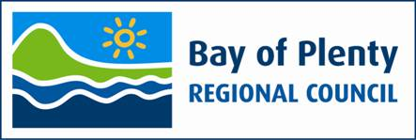

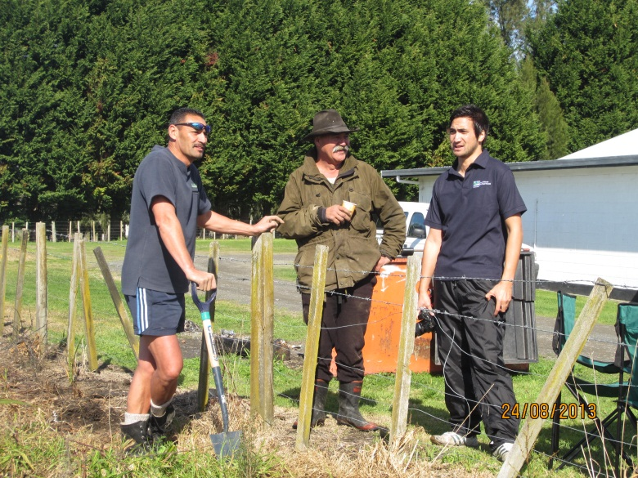

|  |
| --- |
| **Treaty of Waitangi Toolkit**  **May 2015** |

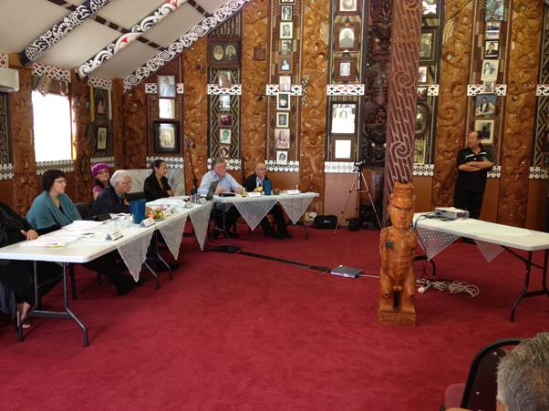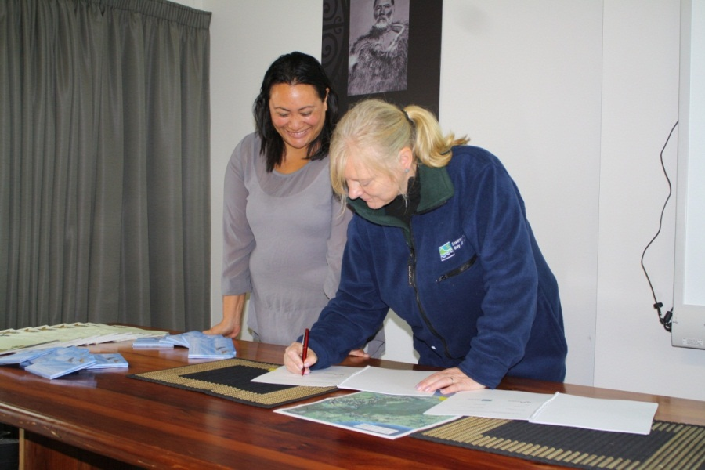

He Mihi

Ki ngā maunga whakahī o te rohe

Ngā tūtohu whenua, ngā tokatū moana

Tae atu ki ngā tōtara haemata

Ngā manu tioritiori huri noa

Tēnā koutou katoa.

Tēnā koutou ngā ringa mahi o te Toi Moana e whakatutuki nei i ngā whāinga me ngā tūmanako mō te rohe whānui. He mahi nui tā koutou ki te rapu i te māramatanga o ngā kaupapa mahi, kātahi ka waihanga mahere mahi tōtika hei whakatinana i ngā kaupapa ki te taumata tiketike. Nō reira ko tēnei kaupapa ako he hāpai i ngā kaimahi katoa kia ekehia ngā taumata tiketike.

Ko te Tiriti o Waitangi te tuhinga taketake, tūāpapa hoki o tēnei motu e paihere ana i te whanaungatanga o te iwi Māori me te Karauna, i whai mana ai te noho a ngā iwi katoa ki Aotearoa. Ko tōna tikanga kia noho tahi ēnei iwi i runga i te tika me te pono tētahi ki tētahi, ahakoa ngā piki me ngā heke.

Whai muri tonu i te hainatanga o te Tiriti ka wāhia te whakaritenga e te Karauna, ā, ka raupatuhia ngā whenua, ka tāmia te iwi Māori e te ringa ū me ngā ture a te Kāwanatanga. Nā tēnei ka whānau mai ko Te Rōpū Whakamana i te Tiriti o Waitangi, i raro anō i tāna ake ture hei whakarite, whakatau hoki i ngā nawe me ngā take raupatu a ngā iwi. He maha ngā iwi i roto i tō tātau rohe kua waitohu whakaaetanga ki te whakarite i ā rātau take raupatu, ā, he maha anō kei te whai tonu i tēnei huarahi.

Kei roto i ēnei whakataunga Tiriti ko ngā āhuatanga hei kōkiri whakamua i ngā iwi. Tae atu hoki ki ngā whakaritenga-ā-ture e tohu ana i te hono o ngā iwi ki ngā tūtohu whenua, tokatu moana. Ka mutu e herea ana te Toi Moana ki te whakamana i ēnei whakaritenga-ā-ture, mātāpono Tiriti hoki ki roto i ā tātau mahi katoa, nō reira me mārama mōhio ngā kaimahi ki te whānuitanga o ēnei kaupapa e tika ai ngā āhuatanga katoa o ēnei mahi. Ko te hua ka puta i te ū ki ēnei mātāpono Tiriti ko te mahi ngātahi, ko te whanaungatanga me te whakatipu kaupapa pai rawa mō tō tātau rohe whānui. E ai ki te kōrero mā pango, mā whero ka oti ai te mahi.

Nō reira kua whakahiatohia mai ēnei kōrero hei whakaū i te mōhiotanga me te māramatanga ki roto ki tēnā ki tēnā o koutou kia ū ai te hōhonutanga o ngā mahi katoa mō te anga whakamua o te rohe whānui.

*Mā te mōhio ka mātau, mā te mātau ka mārama.*

Acknowledge the noble mountains of our region

The significant landmarks, and marine features

And also the strong tōtara

And melodic sounding birds throughout the region (also signifies the leadership and brave guardians throughout the region and reference to natural resources)

Greetings to you all.

Let us firstly acknowledge you the staff of the Regional Council for your work in achieving the objectives and aspirations for the whole region. Your work is important in developing and advancing robust work plans to bring to life these objectives to the highest standard. The purpose of this learning opportunity is to promote and enhance staff to reach these required high standards.

The Treaty of Waitangi is the founding document and foundation of this country that binds the relationship between the Māori tribes and the Crown and that provided the opportunity for all people to live in New Zealand. Its purpose was for these distinct peoples to live alongside each other with integrity and respect.

Immediately after the signing of the Treaty, the Crown dishonoured this agreement through land confiscations, and an oppressive regime of Government force and legislation. The Treaty of Waitangi Tribunal was established to address these past wrongs and historical grievances. This has seen many iwi in our region sign settlement agreements addressing these issues, and many more are still on this journey.

These Treaty settlements provide the means to advance and progress iwi forward. Settlements also include statutory acknowledgements that acknowledge the special relationship of iwi to their traditional land and marine areas. Furthermore, Council is legally obligated to acknowledge these statutory acknowledgements and Treaty principles within all our work. This means staff must have a comprehensive understanding of these issues to bring about the best work results. The benefit of the commitment to the Treaty principles is a collaborative working relationship with iwi and developing positive initiatives for the wider region. With the commitment of all we can achieve the objectives.

This resource has been developed to provide a foundation of knowledge and understanding all staff must acquire in order to provide the required depth in all our work that enhances our region.

*From knowledge comes understanding, from understanding comes enlightenment.*

Acknowledgement

We would like to acknowledge the original document by Waaka Vercoe in 2004 entitled Environment Bay of Plenty Treaty of Waitangi Toolbox – Te Tiriti o Waitangi me Te Taiao o Te Moana a Toi Te Huatahi (The Treaty of Waitangi and Environment Bay of Plenty) He Whakautu (A Response). This revised toolkit will complement Treaty of Waitangi training for staff and will be reviewed regularly.

Contents

He Mihi i

Acknowledgement ii

1 Executive summary 4

2 Introduction 5

3 Historical context 7

4 The Treaty today 14

5 Treaty settlements 20

6 Applying the Treaty in our work 24

7 Ngā kupu - Glossary 27

8 Reference list 28

Appendix 1 – Toolkit Summary 29

Appendix 2 – Māori Engagement Charter 31

Appendix 3 – Iwi within the Bay of Plenty 34

1 Executive summary

**The Treaty of Waitangi Toolkit has been developed to increase the awareness of Council staff in relation to the Treaty of Waitangi (the Treaty). Moving beyond just understanding the historical context, the aim of this toolkit is to ensure that staff appreciate what the Treaty means to their work at Council.**

The Treaty is more than just a document that was signed on 6 February 1840. It is a symbol of the enduring partnership between Māori and the Crown. The Regional Council, as an agent of the Crown, has many obligations to fulfil in relation to the Treaty. Our role under the Treaty is becoming even more relevant as Bay of Plenty hapū and iwi go through the Treaty claims and settlement process. It is essential for staff to understand how these obligations relate to their work.

The Treaty of Waitangi Toolkit provides an overview of:

* the historical context, that is, the events leading up to, and following, the signing of the Treaty
* key pieces of legislation that reference the Treaty
* the principles of the Treaty
* Treaty settlements within the   
  Bay of Plenty region.

The Treaty of Waitangi Toolkit will be implemented with a staff training session. The toolkit will be updated regularly to ensure that the information is current and relevant.

We trust that this Toolkit will be a useful resource for staff.

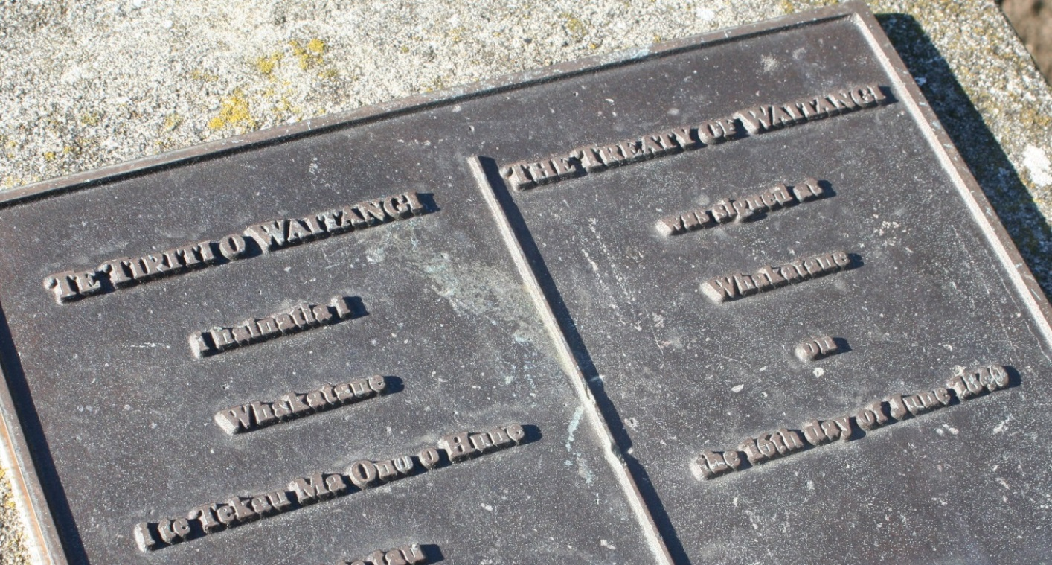

2 Introduction

**The Treaty of Waitangi is important to all people of Aotearoa/New Zealand. It represents the agreement between the British Crown and Māori to:**

* protect the interests of tāngata whenua (people of the land)
* provide for the lawful migration and settlement of all other   
  New Zealanders
* enable British settlers and Māori to live together under a common set of laws.

A lot has changed since the Treaty was signed. The New Zealand Government replaced the role of the British Crown. Treaty breaches are settled in tribunals, courts and through direct negotiations with the Government.

The cartoon below illustrates one of the views of the Treaty.

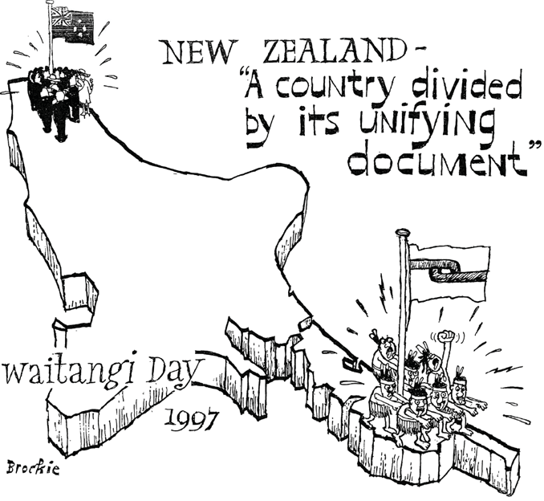

By Bob Brockie, 6 February 1997.

Cartoon Archive, National Library of New Zealand Te Puna Mātauranga o Aotearoa, Alexander Turnbull Library, Wellington (Ref: H-549-071).

**Treaty Toolkit goals**

This Treaty of Waitangi Toolkit aims to provide staff with an understanding of:

* the context in which the Treaty was signed
* the key differences between the two versions of the Treaty
* how the Treaty was breached and the effects on Māori society
* references to the Treaty in contemporary legislation
* the importance of the Treaty principles
* implications of Treaty settlements
* to help staff apply the Treaty obligations to their work.

**This document is important for all staff, irrespective of their ethnicity or role within Council. It serves as a reminder of the collective responsibility of Council officers to fulfil the principles and spirit of the Treaty.**

**Who are Māori?**

Māori are the tribal people indigenous to   
New Zealand. Māori societal structure basically comprises three levels: iwi (tribe), hapū (sub-tribe) and whanau (family). All are connected back to the ancestral waka (canoe).

Hapū and iwi connection is important as it links Māori with the land and is the source of Māori identity.

**Māori in the region**

The Bay of Plenty region is culturally diverse. We have the largest number of iwi within a region in New Zealand.

There are over 35 iwi groups, over   
230 hapū (sub-tribes) and over 160 marae. Other statistics of interest include:

* Māori represent 26 percent of the region’s population and we have the third highest Māori population in New Zealand
* around 37 percent of land tenure in the Bay of Plenty is in Māori title. There are over 5,000 parcels of Māori land in the region
* there are approximately 1,800 land trusts in the region which hold more than $6.6 billion in assets.

*Refer to Appendix 3 for a map of iwi within the Bay of Plenty region.*

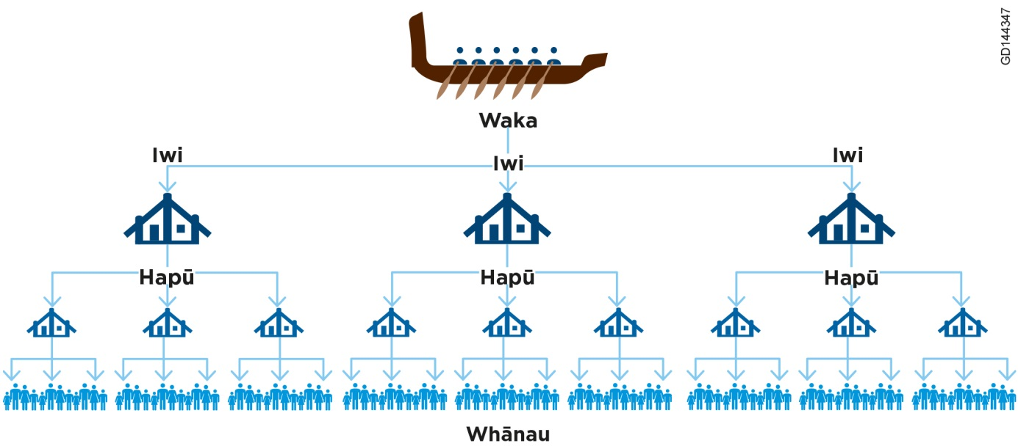

3 Historical context

From the turn of the nineteenth century, New Zealand underwent huge economic, social, religious and political changes.

**The economy**

By 1800, British and American whalers, traders and sealers began working in   
New Zealand with increasing regularity. The commercial interest in New Zealand included timber, flax fibre, ship building, shore whaling and general trading. The trans-Tasman trade increased steadily during the 1930s, as did trade with the French and Americans. There was extensive interest in land purchasing by New South Wales-based buyers.

**Religion**

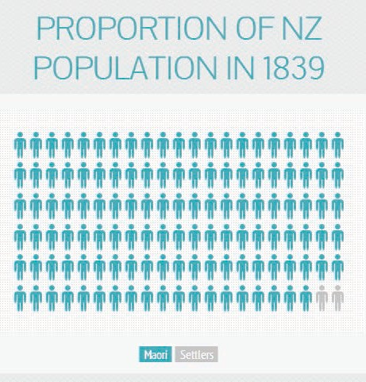In 1814, the Anglican Church set up its first mission station in the Bay of Islands. The Wesleyan Missionary Society established a station in Whangaroa eight years later. Missionaries translated the Bible into Māori to make it more accessible to potential converts to Christianity. The first Catholic mission was established in 1838 at Kororāreka. By 1840, many Māori had become familiar with the spiritual concepts of Christianity. Māori denominations were also established decades later, starting with the Ringatū movement (1875) and the Ratana Church (1925).

**Society and politics**

The first permanent European settler arrived in 1806. By 1839, the population of New Zealand comprised an estimated 2,000 permanent settlers, living mostly in the North Island. The Māori population at the time was estimated to be at least 100,000.

Settlers brought trade, supplies, skills and knowledge to Māori tribes in exchange for services and provisions and products. However, introduced diseases led to a decline in Māori health.

The Māori language was traditionally an oral language. However, through contact with the missionaries (who had translated the Bible into Te Reo Māori), many Māori had also learnt to read and write in Māori.

**Māori trade**

Up until 1860, Māori provided much of the food for early settlers. This included potatoes, pigs, flax fibre and wheat.

Māori also purchased ships to trade with Australia and Europe. This economy deteriorated in the 1860s due to the crash of the wheat market and the New Zealand land wars.

Lawlessness by settlers was also on the increase. British citizens could not be held accountable for crimes committed in   
New Zealand as it was an independent territory outside of British law. Britain, aware of growing interest from France and the United States of America, appointed James Busby as British Resident to New Zealand in 1832. Busby was instructed to work with Māori leaders to create a form of government. This set in motion the events leading up to the signing to the Treaty eight years later.

**The Declaration of Independence**

During the mid-1830s, Frenchman   
Baron de Thierry signalled his intent to establish his own sovereign and independent state in the Hokianga area. In response, James Busby called a meeting of 34 northern chiefs in   
October 1835. Together they signed the Declaration of Independence of the United Tribes of New Zealand.

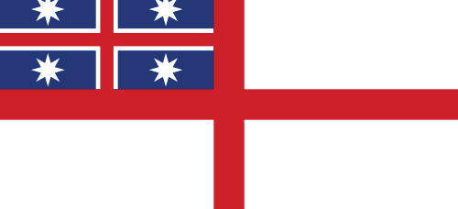

The Declaration of Independence[1] asked for King William IV ‘to be the parent of their infant state and its protector from all attempts upon its independence’. This declaration asserted the United Tribes’ rangatiratanga, or independent chieftainship. Whatever people thought about this document later, the British government acknowledged it formally at the time and gave an assurance that the King would indeed protect the Māori people. The Māori chiefs agreed to meet in Waitangi on an annual basis to discuss and frame laws.

With the Declaration of Independence in place, France and the United States of America formally recognised that the British had declared New Zealand as an independent state.

Sought King William IV to be the parent of their infant state and its protector from all attempts upon its independence.

Signed by 34 northern chiefs in 1835.

Recognised the sovereignty of the United Tribes of   
New Zealand.

**Tino rangatiratanga**

This is a Māori term which refers to absolute sovereignty, total control, complete responsibility, or full authority.

***This was the flag chosen in 1835 to symbolise tribal rights and enabled Māori to trade internationally as the flag was recognised in international ports. The original design of the flag has black stripes instead of white (top left).***

**Push for British sovereignty**

The Declaration of Independence failed to get support from the Colonial Office, the British government department overseeing colony affairs, and Busby fell out of favour. In 1839, the British Government sent William Hobson (British Consul to   
New Zealand) to negotiate a Treaty with Māori to establish British Crown sovereignty over the whole or part of   
New Zealand. Hobson arrived in the   
Bay of Islands on 29 January 1840.

**Te Tiriti o Waitangi – The Treaty of Waitangi**

**Leading up to the signing of the Treaty**

The Treaty was first drafted by   
William Hobson. James Busby, who was not satisfied with the content, redrafted it to include text that established that Māori would retain possession of forests, fisheries and lands.

Local rangatira (chiefs) were invited to Waitangi on 5 February 1840. Refreshments were sold and a marquee set up so that Hobson could explain the Treaty to the rangatira in attendance. The rangatira debated throughout the day and into the evening. The following day,   
6 February 1840, the rangatira agreed to sign the Treaty.

The Treaty is an agreement, in Māori and English, that was made between the British Crown and about 540 Māori rangatira (chiefs, including chiefly women).

The Treaty comprises a preamble, which declares the Crown’s intentions, as well as three articles outlining the agreement between the Crown and Māori.

There was a verbal agreement made on the day of the signing in Waitangi, which outlines the protection of religious freedom. This agreement does not appear on the Treaty. However, since it was recorded as part of the day’s events, it is considered by some as a fourth article of the Treaty: “The Governor says the several faiths of England, of the Wesleyans, of Rome, and also Māori custom shall be alike protected by him”.

A missionary, Henry Williams, translated the Treaty into Māori on the afternoon before it was presented to the rangatira (chiefs).

Copies of the Treaty were made and taken throughout the country by Hobson and his staff to get more signatures.

Eventually over 500 Māori chiefs (including women) signed the Treaty.

Not every chief in Aotearoa signed the Treaty. Some had refused and others did not get a chance as the Treaty was not taken to all regions.

**British sovereignty proclaimed**

Pushed by settlers challenging his authority, Hobson proclaimed British sovereignty over the whole of   
New Zealand on 21 May 1840, in particular:

* the North Island on the basis of cession through the Treaty, and
* the South Island on the basis of right of discovery.

The last signature on the Treaty was obtained on 3 September 1840 near Kawhia.

**Two languages – two versions**

The Treaty of Waitangi was written in English and translated to Māori.

The Māori version was signed by most rangatira, while only 39 signed the English version.

Each version is not an exact translation of the other.

Some of the key features of the articles and differences between the interpretations of the Treaty are outlined below.

**The Preamble**

The British:

* desire that Māori maintain their sovereignty
* want to bring peace to New Zealand – Hobson was appointed for that purpose
* acknowledge that more settlers/immigrants are coming
* wish to establish a government to prevent lawlessness.

**Article 1**

Declared New Zealand an independent state.

* Māori text: gives governorship (kāwanatanga) to the Crown
* English text: gives sovereignty to the Crown.

**Article 2**

* Māori text: Māori are guaranteed tino rangatiratanga (sovereignty) over all of their taonga (lands, villages and property)
* English text: Māori are guaranteed undisturbed possession over their lands and estates and forests.

1. English text: gives sovereignty to the Crown.

**Article 3**

* Māori text: Māori have the same rights as British citizens
* English text: Māori have the same rights and privileges as British subjects.

**What happened next?**

**Loss of land**

Until 1860 Māori still held onto most of their land, except for a few areas, particularly Wellington, Wairarapa, Hawke’s Bay and parts of Northland.

The 1860s saw confiscation of millions of hectares by the government and large areas of land were lost through the work of the Native Land Court. For example, the Native Lands Act (1862) enabled the change from the communal usage of land to individualised ownership of land titles. This meant that Māori owners could sell to anyone, leading to wrongful sales.

The period between 1890 and 1920 saw a boom in government land purchases, despite Māori protests. This included taking Māori land for public works.

**Revitalisation of Te Reo Māori**

In 1987, the Māori Language Act was passed, which gave Te Reo Māori status as an official language of New Zealand. This was vital for the revival of Te Reo Māori. The Bay of Plenty Regional Council has a Te Reo Māori policy to recognise this.

By 1937, very little land was left in Māori ownership.

The maps below illustrate the alienation of Māori land in the North Island over an 80 year period.

**Impact of Land Loss on Māori Society 1840-2012**

* Impact on tribal identity and unity.
* Displacement of tribal members (including urban migration).
* Loss of autonomy.
* Loss of capacity to develop their economic potential.
* Loss of access to traditional food sources.
* Impoverishment and marginalisation (e.g. education, health).
* Land wars.
* Dependence on state for survival.

**Figure 2: Claudia Orange, Illustrated History of the Treaty of Waitangi, Wellington: Bridget Williams Books, 2001, pp. 318-319**

*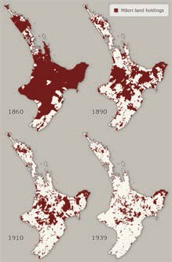***Loss of language and traditional knowledge**

In addition to the loss of land over that time, the Māori language suffered significantly. Initially, early mission schools taught in Te Reo Māori but were required to teach in English from 1847 (only seven years after the Treaty was signed). The Tohunga Suppression Act also imposed penalties for experts in Māori medicine and spirituality. Overall, these Acts of Parliament resulted in loss of a language, traditional knowledge and spiritual connection.

Māori land holdings

.

**Summary timeline: events of significance**

13 northern Māori chiefs petition  
King William IV, asking for his protection from lawlessness of sailors, escaped convicts and adventurers from   
New South Wales, as well as French annexation.

Lieutenant-Governor   
William Hobson declared British sovereignty over all of New Zealand on 21 May 1840 (the North Island by Treaty and South by ‘discovery’).

**Oyster Fisheries Act:** Prevented Māori from fishing commercially. Māori commercial fishing enterprises at the time went broke and they had to sell land to meet their debts.

1814

1831

1835

1839

1840

1886

1862

1841

**Land Claims Ordinance Act:** stated that lands not actually occupied or used by Māori belonged to the Crown. This contradicted Article 2 of the Treaty.

William Hobson appointed Consul to obtain sovereignty over all or part of New Zealand by gaining the consent of a sufficient number of chiefs. Aims to prevent land sharks from further purchasing opportunities (they already claimed more than the size of New Zealand).

Arrival of first missionary, Marsden, in New Zealand.

Declaration of Independence signed.

**Native Lands Act:** Designed to break down Māori communal ownership of land. A land court was set up to individualise title. An amendment to the Act meant that owners could sell to anyone, leading to wrongful sales. (This breached the pre-emption clause in Article 2 of the Treaty).

**Māori Affairs Act:** If Māori land was not occupied or being used then it was declared “waste land” and taken by the government.

**Town and Country Planning Act:** Prevented Māori from building on their land. This forced many Māori to move from rural areas to the cities.

Continued Treaty settlements in the Bay of Plenty: Tapuika (2012) and Tūhoe (2013) sign Deeds of Settlement to settle historical claims.

**Foreshore and Seabed Act:** Concerned the ownership of the country’s foreshore and seabed, with many Māori groups claiming that Māori had a rightful claim to title based on Māori customary law, mana rangatira, that was never ceded but was a taonga tuku iho – passed to successive generations. These claims are based around historical possession and the Treaty of Waitangi.

**Māori Language Act:** Māori now has formal language status and able to be used in courts and Parliament.

**The Treaty of Waitangi Amendment Act:** Amends Section 6 of the Treaty of Waitangi Act 1975 to set a closing date of   
1 September 2008 for submitting historical Treaty claims to the Waitangi Tribunal.

**Māori Fisheries Act:** Re-definition of an important part of Article 2, which guarantees Māori *“full exclusive possession of the Lands and Estates, Forests, Fisheries”.* On   
31 October 1992 Māori were granted   
10 percent of the fishing quota. The Government has re-defined ‘full’ as   
10 percent.

**Māori Land Settlement Act:** Māori land was put under the control of Land Councils. There was no Māori representation. The settler population had increased and so had their desire for land.

1894

1953

1975

1987

1990

2012

2006

2004

Establishment of Waitangi Tribunal.

4 The Treaty today

**Relevance of the Treaty Articles to Council**

The diagram below shows the relevance of the Articles and Principles of the Treaty to Council.

**Crown**

**Māori Rangatira**

**(Chiefs)**

**Tino Rangatiratanga**

**ARTICLE 2**

**Te Tiriti o Waitangi/Treaty of Waitangi**

**Self determination**

**Citizenship**

**Oritetanga**

**ARTICLE 3**

**ARTICLE 1**

**Kawanatanga**

**Treaty Articles**

Agreement

Partnerships

**Treaty Signatories**

**Bay of Plenty Regional Council**

**Bay of Plenty iwi, mataawaka, Māori residents and ratepayers**

**Local Government Level Relationships**

**Governance**

As shown above, the Treaty is an agreement between Māori and the Crown. The Council has delegated responsibilities from the Crown in relation to governance (Article 1). Articles 2 and 3 denote Council’s responsibility in terms of their relationship with iwi, and mataawaka as well as Māori residents and ratepayers.

**Relevance of the Treaty Principles to Council**

The Treaty is articulated in law through an evolving set of principles as opposed to the text of the Treaty itself. This is due to:

* differences in the Māori and English texts of the Treaty, which have led to different understandings of the meaning of the Treaty, and
* the need to apply the Treaty in contemporary circumstances.

The principles interpret the Treaty as a whole, including its underlying meaning, intention and spirit, to provide further understanding of the expectations of signatories.

The principles of the Treaty evolve over time and are implemented and interpreted to suit the context. For example, they may vary from Council to Council or agency to agency.

The following Treaty principles are most commonly applied in our work:

|  |  |
| --- | --- |
| **Treaty Principles** | **Council’s response to these requirements** |
| **Active Protection** To actively protect that which is important to Māori. | * Supporting the development of Iwi Management Plans. * Implementing the Heritage criteria in the Regional Policy Statement. * Developing a Cultural Heritage Strategy for SmartGrowth. * Enabling co-management initiatives such as Pāpāmoa Regional Park and Onekawa Te Mawhai Regional Park. * Acknowledging and using Te Reo Māori in our work and workplace. * Recognising and flying the Māori flag for particular occasions. * Development of a regional marae locations map. |
| **Tribal Autonomy** Guarantees Māori the right to manage, control and enjoy their own resources and taonga in accordance with their cultural preferences. | * Komiti Māori promotes community participation. * Development of policies that recognise kaitiakitanga. * Māori councillors represent Māori interests in Council decision making processes. * Joint decision making through co-governance regimes. * Cultural monitoring initiatives. * Statutory acknowledgements are integrated into work processes. |
| **Redress for the Past**  To address past actions or omissions of the Crown that led to harmful effects for Māori. | * Supporting iwi that are in the process of settling Treaty claims. * Supporting Māori political representation. * Sponsoring Māori to undertake RMA training. * Sponsoring initiatives to enhance Māori capacity and capability. * Employing summer students. * Enabling iwi secondment initiatives. |
| **Duty to Consult** Ensuring Māori are consulted with on matters of importance to them. | * Engagement with Māori in plan changes/reviews. * Engagement with Māori on resource consent applications. * Taking IMPs into account in our decision making. * Maintaining an accurate Māori Contacts Directory. * Holding marae-based Komiti Māori meetings. * Involving Māori in working parties, focus groups, reviews and audits. |

**How do I consult with Māori?**

Council has prepared the Engaging with Māori guide and the Māori Engagement Charter (Appendix 2) to provide further information about engaging with Māori. The Māori Policy Unit is also available to provide guidance.

**References to the Treaty in legislation**

The Crown is recognised as the primary Treaty partner. However, there are several pieces of legislation that direct Council to implement the principles of the Treaty.

**Mechanisms**

Bay of Plenty Regional Council

**Delegated responsibility**

**Legislation**

* Ten Year/Annual Plan
* Regional Policy Statement
* Regional/District Plans
* Regional Land Transport Strategy
* Biosecurity Plans
* Treaty documents

Resource Management Act 1991

Biosecurity Act 1993

Historic Places Act 1993

Local Government Act 2002

Local Government Rating Act 2002

Land Transport Management Act 2003

Māori Commercial Aquaculture Claims Settlement Act 2004

Marine and Coastal Area (Takutai Moana) Act 2011

**Resource Management Act 1991 (RMA)**

The RMA promotes the sustainable management of natural and physical resources. It contains a number of specific references to the Treaty or matters of significance to Māori.

Part 2 outlines the Principles of the RMA:

|  |  |  |
| --- | --- | --- |
|  | **6(e) – Matters of National Importance** |  |
|  |  |
|  | Council to recognise and provide for “the relationship of Māori and their culture and traditions with their ancestral lands, water, sites, wahi tapu and other taonga”. | |
|  |  |  |
|  | **7(a) – Other Matters** |  |
|  |  |
|  | Council to give particular regard to “Kaitiakitanga” (defined in RMA as Guardianship). | |
|  |  |  |
|  | **8 – Treaty of Waitangi** |  |
|  |  |
|  | Council to take into account the principles of the Treaty. | |

**Council’s response to legislative requirements – RMA**

|  |  |
| --- | --- |
| **RMA requirements** | **Council’s response to these requirements** |
| Take into account Iwi Management Plans | Iwi and Hapū Management Plans are taken into account:   * During the development of the Regional Policy Statement. * When preparing changes to regional plans. * When determining if an iwi is an affected party to a resource consent application. * When making a decision on resource consent applications. |
| Consultation with Māori | Specific requirement for consultation with Māori when developing (or changing) the Regional Policy Statement or regional plans.  There is no specific requirement for consultation with Māori for a resource consent application. However, it is considered good practice for consultation where a resource application affects Māori interests and values. |
| Collaboration with Māori (Freshwater Management) | The National Policy Statement (Freshwater Management) places greater responsibility on Council to involve and collaborate with Māori in the management of freshwater. |
| Issues of Significance | Specific section in the Regional Policy Statement acknowledging Issues of significance to Māori. |

**Local Government Act 2002 (LGA) and Land Transport Management Act 2003 (LTMA)**

The LGA provides for effective local government that reflects community-based objectives, while the LTMA provides for strategic land transport planning.

Both Acts require Council to provide opportunities for Māori to contribute to decision making processes. The LTMA also specifically provides for separate consultation with Māori for particular activities.

**Council’s response to Legislative Requirements – LGA and LTMA**

|  |  |
| --- | --- |
| **LGA & LTMA requirements** | **Council’s response to these requirements** |
| Contribute to decision making | * Māori are encouraged to present their views to Council. * The Māori councillors represent Māori interests in Council decision making processes. |
| Foster Māori contribution | * Supporting the development of hapū/iwi resource management plans. * Sponsoring Māori to undertake training e.g. Making Good Decisions training for Hearing Commissioners. * Sponsoring hapū/iwi to hold capacity-building wananga, conferences or hui. * Enabling student internships and/or secondments. |
| Provide relevant information to Māori | Relevant information is provided in a form and manner that is appropriate. This means that:   * Information could be translated into non-technical terms and/or in the Māori language, for example, the Cultural Heritage Strategy for the Western Bay of Plenty was translated into Te Reo. * Discussions could be held on marae or other venues. * Māori can legitimately request separate meetings/hui (separate to the public) with Council staff on matters of importance/significance to them, for example, Māori Hearing Commissioners may be requested. Hearings may also be held on a marae. |
| Processes for consulting with Māori | * Holding marae-based Komiti Māori meetings. * Engagement with Māori in plan changes/reviews as well as resource consent processes. * Development of the Engaging with Māori guide to promote best practice consultation processes. * Engaging early, and developing relationships with iwi groups that are in the process of settling Treaty claims. * Dedicated Māori Policy Unit within Council. * Development of the Māori Engagement Charter to support the way we interact and engage with Māori in the region. |

**Marine and Coastal Area (Takutai Moana) Act 2011 (MACA)**

The MACA provides for unimpeded public access to, and the exercise of customary interests in, the common marine and coastal area. This predominantly has implications for Council regarding processing and deciding on coastal permit applications. Any iwi planning documents prepared by a customary marine title group will hold the same status/recognition as an Iwi/Hapū Management Plan.



5 Treaty settlements

**What is a Treaty settlement?**

A Treaty settlement is an agreement between the Crown and a claimant group in relation to a Treaty claim.

Settlements of historical claims are the Crown’s way of making up for past breaches of the Treaty and restoring good relationships with iwi. Historical breaches may include:

* land confiscation
* execution or detention of prisoners without trial
* failure to preserve enough land for iwi
* impact of native land laws
* taking of Māori public land for public works.

Contemporary settlements may arise due to government policy, action or inaction that impacts on Māori interests.

**Case Study: Basis for Tūhoe Treaty Claim**

The Tūhoe settlement reflects the very serious nature of the breaches by the Crown of its obligations, and their continued consequences to this day.

Large scale confiscation of the best agricultural land, brutal military campaigns targeting Tūhoe settlements, and later unjust land purchases are all Crown behaviour that has made a harmonious relationship with Tūhoe impossible.

Past dealings that breached the Crown’s obligations under the Treaty of Waitangi included:

* indiscriminate raupatu, wrongful killings, and years of scorched earth warfare
* denying Tūhoe the right of a self-governing Urewera Reserve by subverting the Urewera District Native Reserve Act 1896
* excluding Tūhoe from the establishment of Te Urewera National Park over their homelands
* wrongly treating Lake Waikaremoana as Crown property for many years.

Today around 85 percent of Tūhoe live outside Te Urewera. Those who remain struggle to make a living and face various restrictions placed on the land and resources in the area. Many suffer from socio-economic deprivation of a severe nature.

Tūhoe’s history shows clearly why it is important to settle genuine historical Treaty grievances. The legislation relevant to the Tūhoe Settlement includes the Ngai Tūhoe Settlement Claim Act 2014 and Te Urewera Act 2014.

**Aspirations for independence and self-determination**

The Tūhoe settlement will enable the following:

* Te Urewera - the return of Tūhoe homelands and restoration of cultural pride
* Mana Motuhake (absolute independence), and
* financial redress ($170 million) - financial resources to support and enable Tūhoe projects and initiatives.

Tūhoe have already signed Crown protocols to establish and manage their own health clinics.

**The Treaty settlement process**

The **Waitangi Tribunal** considers Treaty claims and then issues a report about each claim (including the evidence provided in the inquiry) and makes recommendations.

**The Waitangi Tribunal**

The Tribunal was established in 1975 to provide a legal process for determining whether a Treaty claim is well founded.

The recommendations of the Waitangi Tribunal are not binding on the Crown.

The Tribunal comprises Māori and   
non-Māori members.

If the Government decides to settle a Treaty claim, the **Office of Treaty Settlements** negotiates with the claimants on behalf of the Crown. Once claimants and the Crown agree on the terms of a settlement, they sign a deed and the Crown passes legislation to give effect to it. Settlement redress is then transferred to the claimants.

**Settlement legislation passed**

**Deed of Settlement**

**Agreement in principle**

**Negotiations**

**Pre-negotiation**

|  |  |  |  |
| --- | --- | --- | --- |
|  | **1 Historical acknowledgement and Crown apology** | |  |
|  |  |
|  | * Outline historical events. * Crown apology to the claimant group for its actions or inactions. | | |
|  |  |  | |
|  | **2 Cultural redress** |  | |
|  |  | |
|  | * Redress that recognises the historical, traditional, spiritual and cultural significance of sites or areas to the claimant group. * Includes statutory acknowledgement areas, return of land or sites, changes to place names, co-governance agreements, joint management agreements and protocols. | | |
|  |  |  | |
|  | **3 Commercial redress** |  | |
|  |  | |
|  | * Provides the claimant group with the ability to purchase Crown property. * Property purchase can be outright at settlement, conditional on the Crown leasing the property or offered for purchase at a later date (right of first refusal). | | |
|  |  |  | |
|  | **4 Financial redress** |  | |
|  |  | |
|  | * The cash component of a settlement. | | |

**Treaty settlements in the Bay of Plenty**

The Treaty landscape we work in is culturally rich and dynamic. This provides opportunities and challenges for decision making by iwi and local government. At the time of writing, 15 Treaty settlements have been achieved in the Bay of Plenty region.

All Treaty settlements have statutory acknowledgements, which are formal acknowledgements by the Crown of the relationship of tangata whenua over a specified area. Statutory acknowledgements recognise the particular cultural, spiritual, historical and traditional association of an iwi with the site that is identified as a statutory area. For example, Ngāti Awa has statutory acknowledgements over the Whakatane River, the Rangitāiki River and the Tarawera River.

The Te Arawa Lakes settlement has been one of the most significant in our region, providing a co-governance model to manage the Te Arawa lakes. Unlike co-management, co-governance involves shared decision making. The Te Arawa Lakes settlement is the first co-governance model established between iwi and local government over a natural resource in New Zealand.

Subsequent Treaty settlements have included some form of co-governance. For example, the Rangitāiki River Forum was jointly established by the Ngāti Whare settlement and the Ngāti Manawa settlement and is explained on the following page.

Te Maru o Kaituna (the Kaituna River Authority) was set up in 2014 under the Tapuika settlement to provide strategic leadership in relation to the restoration, protection and enhancement of the environmental, cultural and spiritual wellbeing of the Kaituna River. Representatives on Te Maru o Kaituna include Tapuika, Waitaha, Ngāti Rangiwewehi, Te Pumautanga o Te Arawa, Tauranga City Council, Western Bay of Plenty District Council, Rotorua District Council and Bay of Plenty Regional Council. Ngāti Whakaue will also become a member when their Treaty claim is settled.

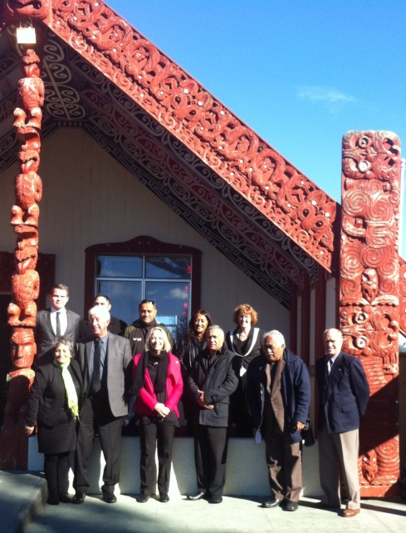

The Tūhoe settlement establishes the   
Te Urewera Board (under the Te Urewera Act 2014) and will be the primary decision maker for Te Urewera. This model gives Te Urewera its own legal identity where the governance and management of Te Urewera will be fully serviced by Tūhoe representatives and the Crown’s role will phase out. The model shows the evolution of co-governance models in the Bay of Plenty.

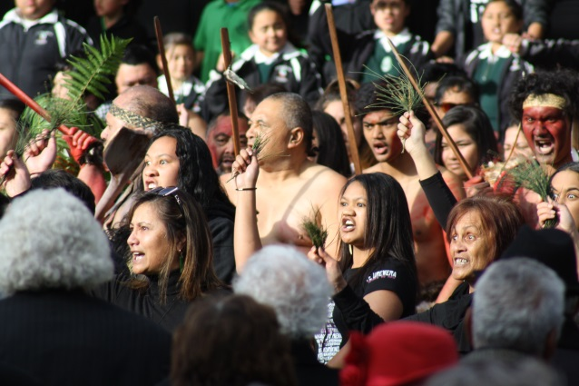

These partnerships are significant in our work and are important for the relationships we have with iwi in the region.

**Those groups who have signed Deeds of Settlement with the Crown** **(awaiting legislation)** include: Ngāti Ranginui,   
Ngāti Pūkenga, Ngāi Te Rangi,   
Ngāti Rangiteaorere, and Ngāti Raukawa.

**Rangitāiki River Forum**

* Jointly established in 2012 through the Ngāti Whare and Ngāti Manawa settlements.
* Is a partnership between Ngāti Whare, Ngāti Manawa, Ngāti Awa, Tūwharetoa (Bay of Plenty), as well as Bay of Plenty Regional Council and Whakatāne District Council. Other iwi will join once their Treaty legislation has been passed.
* The Forum’s role is to protect and enhance the environmental, cultural and spiritual health and wellbeing of the Rangitāiki River.

**Those groups who are progressing towards signing Deeds of Settlement:** Tauranga Moana Iwi Collective and   
Pare Hauraki tribes.

**Those Treaty claims to be settled in the next two to five years:** Ngāti Tūwharetoa (Taupō), Ngāti Whakaue, Ngāi Tai,   
Ngāti Rangitihi, Te Whakatōhea, Ngāti Hinerangi and Ngāti Whakahemo.

**Impact of Treaty settlements on Council**

Settlement legislation can include triggers for further engagement and involvement with local Māori. For example, Council may enter into a relationship agreement, such as a Memoranda of Understanding or Joint Management Agreement. Council may also be part of a formal co-governance structure, such as the Rangitāiki River Forum or Te Arawa Lakes Strategy Group.

In terms of statutory acknowledgements (typically applying to land and/or water):

* The Regional Policy Statement and regional plans must include information relating to these areas.
* The Post-Settlement Governance Entity (PSGE) must receive a summary of all resource consent applications for activities within, adjacent to, or directly impacting on the area.
* Affected iwi may be considered a potentially affected party to a consent process.

In the current Treaty climate, settlements with Bay of Plenty iwi have become vital. Council must maintain enduring relationships with Māori, particularly when the Crown’s involvement in the settlement process ceases.

6 Applying the Treaty in our work

This toolkit provides a basic introduction to the Treaty and it is important for us to understand the relevance of the Treaty in our work and to make the Treaty principles an integrated part of how we approach our work.

**Council values**

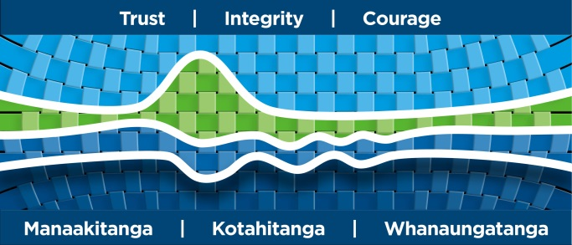

Our Council values reflect who we are and what is important to us. The values in more practical detail include:

* Trust - We work to build trust and to trust each another.
* Integrity - We do what we say we will do. We act with purpose to achieve results.
* Courage - We act boldly to lead and do the right thing for our region.
* Manaakitanga - Leadership. We build strength and show courage. We are a positive influence, proud and courageous. We show and practise professionalism. We trust and respect others. We show reciprocity (sharing), and nurture and support others.
* Kotahitanga - Unity. We have a strong emphasis on collaboration. We are inclusive and nurture a positive team spirit. We have a sense of ownership.
* Whanaungatanga - We have a strong focus on relationships. We like having fun, being happy. We enjoy socialising and friendships are important. We support each other.

These values also guide how we work with our Treaty partners. For example, this could include organising an appropriate marae venue or giving of koha for a meeting with iwi, or could be Council staff providing technical support and information for our co-governance forums and Māori conference. A practical example of whanaungatanga is the combined kapa haka group Te Moana a Toi of staff from Whakatane District Council and Regional Council staff from the Whakatane office. This group was formed in 2014 as part of the celebrations for Te Wiki o Te Reo Māori/ Māori Language Week.

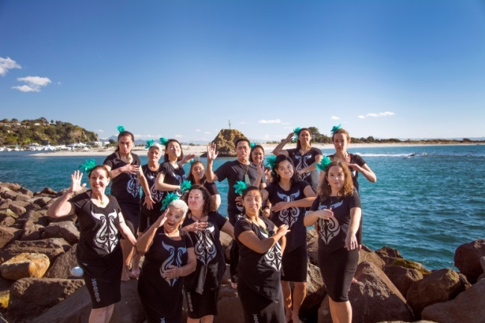

The long-term planning processes of Council benefit from the engagement and relationships we have with Māori and the importance of ensuring our Council supports hapū and iwi capacity building.

**Engaging with Māori Guide**

The Engaging with Māori Guide (2011) is another tool to help us apply the Treaty in our work. This resource was developed to raise the cultural competency of staff to work more effectively with Māori. It covers an overview of our Treaty and statutory obligations and the provisions for Māori within Council documents and processes.

In summary, the five levels of engagement build and develop as follows:

|  |  |
| --- | --- |
| **Whakamohio/ Inform** | We will keep you informed about what is happening. |
| **Whakauiuia/ Consult** | We will listen to you and make our decisions. |
| **Whakaura/**  **Involve** | We will involve you in the decision making process. We will ultimately decide. |
| **Mahi Ngatahi/ Collaborate** | We will discuss and decide together. |
| **Whakamanahia/ Empower** | Māori will decide. Māori may choose to discuss with us. |

The document outlines different engagement methods and tips for planning Māori engagement. It is a valuable resource for all staff and is available on the Council website [http://www.boprc.govt.nz/media/161331/ Māori_engagement_toolkit.pdf](http://www.boprc.govt.nz/media/161331/%20%20maori_engagement_toolkit.pdf).

**Māori Engagement Charter**

In 2014, the Māori Engagement Charter (refer Appendix 2) was developed to provide a set of principles and guidelines for staff to support the way we interact and engage with Māori in the region. Fundamental to the charter is a set of commitments on how Council staff will engage with Māori across the region and guidelines on expected approaches to Māori engagement.

* Commitment 1: We will respond in a manner that demonstrates our values.
* Commitment 2: Principles are given due consideration when engaging with Māori.

The charter takes into account the organisation values and Treaty principles and sets a standard for staff on Māori engagement and communication.

**Māori Policy Unit**

The Māori Policy Unit is available to provide further information or advice on Māori issues, policy and engagement. This includes, but is not limited to, identifying who to contact within an iwi organisation, marae and hui protocols, Treaty advice, iwi management plans and improving the cultural competency within Council.

The team provides advice and support to the Komiti Māori, co-governance forums and engagement support for Council projects. The Māori Policy Unit is actively engaged in building the capacity and capability of Māori and is committed to building enduring relationships both internally and externally.

**The Māori (tino rangatiratanga) Flag**

The Māori flag was unveiled at Waitangi in 1990 following a nationwide competition to design a national Māori flag.

It comprises elements that represent the three realms:

* Black represents Te Korekore - the realm of potential, the long darkness from which the world emerged
* White represents Te Ao Mārama - the realm of being, the world of light, the physical world
* Red represents Te Whai Ao - the realm of coming into being. Red is the female element, Papatuanuku, the earth mother, the sustainer of all living things.

The koru is symbolic of a curling fern frond, representing the unfolding of new life, hope for the future and the process of renewal. The flag does not carry official status.

In 2011 the Bay of Plenty Regional Council adopted to fly this flag every Waitangi Day as acknowledgement of the cultural importance to Māori. The flag may also be flown on other days of significance to Māori such as ANZAC, Matariki, or in memory of the passing of prominent people.

**Summary**

This toolkit is a Council resource to assist and improve staff awareness and understanding of the Treaty. A summary of the toolkit is provided in Appendix 1. The information we have covered explores the historical context and principles of the Treaty and the implications of key legislation for Council. Māori are a significant part of our region’s population and how we engage with Māori is important. Treaty settlements are an integral part of our regional landscape. Together with other resources identified in the toolkit, we trust that this information will help staff to understand the significance of the Treaty in our work and for the Bay of Plenty region.

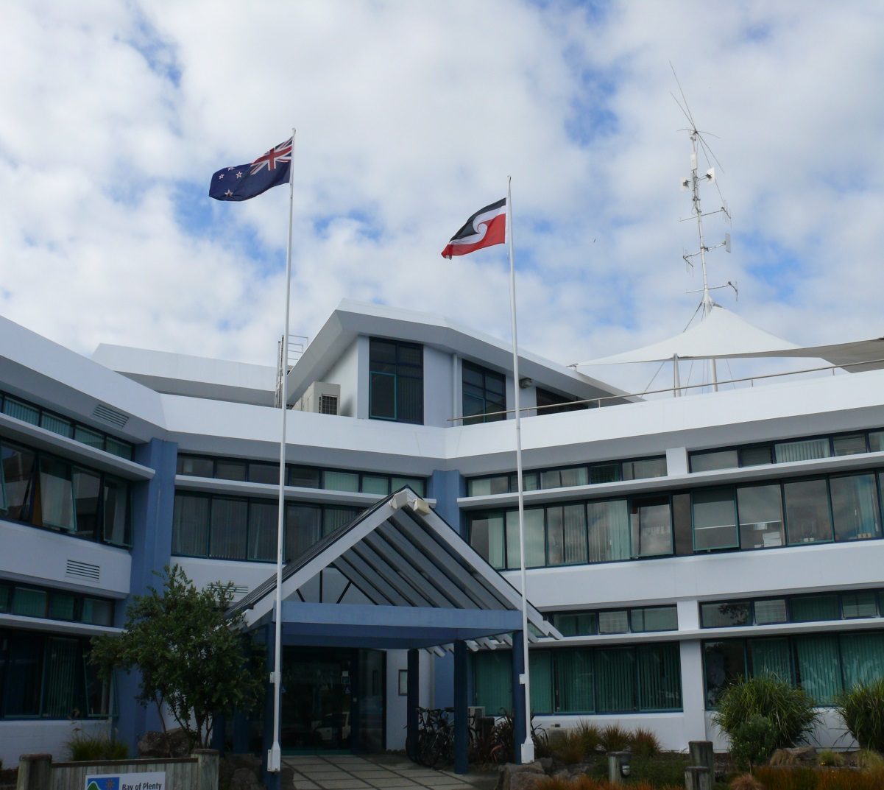

7 Ngā kupu - Glossary

Claimant group Those people whose claims will be settled and who will be the beneficiaries of the settlement and the governance entity.

Deed of Recognition Deed issued by Minister of the Crown responsible for an area of Crown land covered by a statutory acknowledgement, recognising a statement of the claimant group’s associations with the area and allowing for consultation with the claimant group on specified matters.

Deed of Settlement The complete, detailed and formal settlement agreement signed on behalf of the Crown and the claimant group.

Iwi Māori tribe, usually containing a number of hapū with a common ancestor.

Hapū Sub-tribe (of the iwi).

Kaitiakitanga RMA definition: The exercise of guardianship by the tāngata whenua of an area in accordance with tikanga Māori in relation to natural and physical resources; and includes the ethic of stewardship.

Koha Gift, present, donation, token of appreciation.

Mana whenua Power associated with possession and occupation of tribal land.

Mataawaka Māori who are living outside their traditional area.

Nohoanga Temporary dwelling or campsite.

Statutory Statutory instrument in which the Crown recognises (in settlement

Acknowledgement legislation) the claimant group’s statement of its cultural and traditional links with a specified area or feature, such as rivers, lakes, mountains, coastal areas, wetlands, etc.

Tāngata whenua People of the land – RMA definition: In relation to a particular area, means that iwi, or hapū that holds mana whenua over that area. In the context of this document, can mean Māori that remain resident in their own traditional territories to differentiate from those Māori who are living outside their areas and commonly referred to as taurahere, mataawaka or rāwaho.

Taonga Something highly prized or treasured, tangible and intangible, that contributes to Māori well-being. Included are Te Reo (the Māori language) waahi tapu, waterways, fishing grounds, mountains and places names.

8 Reference list

Auckland Council (2012). The Auckland Plan.

Bay of Plenty Regional Council (2011). Engaging with Māori: A guide for staff of the   
Bay of Plenty Regional Council.

Consedine, B. (2007). Historical Influences: Māori and the Economy. Te Puni Kōkiri Environment Bay of Plenty (2008). Regional Policy Statement.

Environment Bay of Plenty (2009). Ten Year Plan.

Immigration New Zealand (n.d.). The Treaty of Waitangi: An Introduction to the Treaty of Waitangi for Migrants.

Te Puni Kōkiri (2001). He Tirohanga o Kawa ki te Tiriti o Waitangi. A Guide to the Principles of the Treaty of Waitangi as expressed by the Courts and Waitangi Tribunal. Wellington: Te Puni Kōkiri.

Office of Treaty Settlements (1999). Healing the past, building a future: A guide to Treaty of Waitangi claims and negotiations with the Crown. Wellington: Office of Treaty Settlements.

Orange, C. (1987). The Treaty of Waitangi. Wellington: Bridget Williams Books Limited.

Parliamentary Commissioner for the Environment (2002). Exploring the concept of a   
Treaty-based environmental audit framework – Legislation/Ngā Ture. Wellington: Parliamentary Commissioner for the Environment.

**Key websites**

[www.boprc.govt.nz](http://www.boprc.govt.nz) Bay of Plenty Regional Council

[www.legislation.govt.nz](http://www.legislation.govt.nz) New Zealand Legislation

[www.mch.govt.nz](http://www.mch.govt.nz) Ministry for Culture and Heritage

[www.ots.govt.nz](http://www.ots.govt.nz) Office of Treaty Settlements

[www.pce.govt.nz](http://www.pce.govt.nz) Parliamentary Commissioner for the Environment

[www.tpk.govt.nz](http://www.tpk.govt.nz) Te Puni Kōkiri

[www.treaty2u.govt.nz](http://www.treaty2u.govt.nz) Treaty2U (Te Papa, Museum of New Zealand)

Appendix 1 – Toolkit Summary



|  |  |  |  |
| --- | --- | --- | --- |
| **Treaty of Waitangi**  The Treaty of Waitangi was signed on 6 February 1840. It represents the agreement between the British, Crown and Māori. Signed initially by 40 Māori rangatira (chiefs) on 6 February 1840. Eventually over 500 Māori chiefs signed the Treaty by September 1840. | |  | **Treaty settlements**  Settlements of historical claims are the Crown's way of making up for past breaches of the Treaty and restoring good relationships with iwi.  Historical breaches may include:   * land confiscation, * execution or detention of prisoners without trial, * failure to preserve enough land for iwi, * impact of native land laws, * taking of Māori public land for public works.   Settlement legislation can include triggers for further engagement and involvement with local Māori.  Council must maintain enduring relationships with Māori, particularly when the Crown's involvement in the settlement process ceases. |
|  | |
| **Two languages, two Treaties**  The Treaty of Waitangi was written in English and translated to Māori. The Māori version was signed by most rangatira (chiefs), while only 39 signed the English version. Each version is not an exact translation of the other.   |  | | --- | | **The Preamble**  The British:   * desire that Māori maintain their sovereignty * want to bring peace to New Zealand – Hobson was appointed for that purpose * acknowledge that more settlers/immigrants are coming * wishes to establish a government to prevent lawlessness. | | **Article 1**  Declared New Zealand an independent state:   * Māori text: gives governorship (kawanatanga) to the Crown * English text: gives sovereignty to the Crown. | | **Article 2**   * Māori text: Māori are guaranteed tino rangatiratanga (sovereignty) over all of their taonga (lands, villages and property) * English text: Māori are guaranteed undisturbed possession over their lands and estates and forests. | | **Article 3**   * Māori text: Māori have the same rights as British citizens * English text: Māori have the same rights and privileges as British subjects. | | |
| **Land Loss**  Between 1860 and 1930, millions of hectares of land were confiscated by the Government.  Large areas of land were also lost through the Native Land Court.  For example, the Native Lands Act 1862 enabled the change from the communal usage of land to individualised ownership of land titles. This meant that Māori owners could sell to anyone, leading to wrongful sales. By 1937, very little land was left in Māori ownership. | *Above: Changes in Maori Land Holdings.* |  | |  |  | | --- | --- | | **Māori in the BOP region** | | | Largest number of iwi within a region in New Zealand | | | 35+ iwi, 230+ hapū and 160+ marae. | 37% land tenure in Māori title. | | Māori represent 26% of the region’s population. | 1,800 land trusts and hold more than $6.6 billion in assets. | |

**THE TREATY OF WAITANGI/TE TIRITI O WAITANGI**

|  |  |  |
| --- | --- | --- |
| **Te Tiriti o Waitangi/Treaty of Waitangi** | | What does the Treaty of Waitangi mean to our work?  The Treaty is more than just a document that was signed on 6 February 1840. It is a symbol of the enduring partnership between Māori and the Crown. The Regional Council, as an agent of the Crown, has many obligations to fulfil in relation to the Treaty.  Our role under the Treaty is becoming even more relevant as Bay of Plenty hapū and iwi go through the Treaty claims and settlement process. Therefore, it is essential for staff to understand these obligations through their work. |
| ***Treaty signatories***  ***Treaty Articles***  ***Local Government Level Relationships*** | *Agreement partnership*  Crown  Māori Rangatira  (Chiefs)  *Mechanisms*  *Legislation*   * Ten Year/Annual Plan * Regional Policy Statement * Regional/District Plans * Regional Land Transport Strategy   Resource Management Act 1991  Local Government Act 2002  Land Transport Management Act 2003  Marine and Coastal Area Act 2011  Bay of Plenty Iwi,  Mataawaka  Māori Residents & Ratepayers  Bay of Plenty Regional Council  Kawanatanga   |  | | --- | | ARTICLE 1 |   Citizenship  Oritetanga   |  | | --- | | ARTICLE 3 |   Citizenship  Tino Rangatiratanga   |  | | --- | | ARTICLE 2 |   Self-determination |

|  |  |  |  |  |
| --- | --- | --- | --- | --- |
| **Foster Partnerships** | **Enable Participation** | **Protect Māori Interests and Values** | **Support capacity building** | **Encourage early and meaningful engagement** |
| * Supporting iwi that are in the process of settling Treaty claims * Enabling co-management initiatives * Relationship agreements e.g. Memoranda of Understanding, Joint-Management Agreements * Recognising Statutory Acknowledgement Areas and Customary Marine Titles | * Use of Iwi Management Plans in work processes * Māori Councillors represent Māori interests in Council decision-making processes * Holding marae based Komiti Māori meetings * Information translated into non-technical terms and/or in the Māori language * Cultural monitoring initiatives | * Regional Policy Statement Heritage Criteria * SmartGrowth Cultural Heritage Strategy * Specific section in the Regional Policy Statement acknowledging issues of significance to Māori * Developing of policies that recognise kaitiakitanga * Development of a regional marae locations map * Use of Te Reo Māori in our work * Use of the Māori Flag | * Supporting development of Iwi Management Plans * Sponsorship Māori to undertake RMA training e.g. Making Good Decisions training for Hearing Commissioners * Sponsorship hapū/iwi to hold capacity-building wananga, conference or hui * Enabling student internships and/or secondments   *Examples of implementation at Council* | * Maintaining an accurate Māori Contacts Directory * Use of the Engaging Māori Guide and Māori Engagement Charter to promote best practice consultation processes * Use of the Engaging Māori Guide and Māori Engagement Charter to promote best practice consultation processes * Encouraging consultation with iwi for resource consent applications * Engaging early and developing relationships with Iwi groups that are in the process of settling Treaty claims |
|  |

Appendix 2 – Māori Engagement Charter

***Message from the Chief Executive***

Kei ngā maunga whakahī huri noa i te rohe nei na, kei ngā tihi o ngā puke, e ngā mana, e ngā reo, e ngā karangatanga maha, tēnā koutou. Kei te hunga kua whakawhetūrangitia, rātau kua whakawhiti atu ki tua o te ārai, haere, haere, haere atu rā. Huri noa ki a tātau anō ngā kanohi ora o rātau mā, tēna tātau katoa.

*We acknowledge the unique cultural richness and significance of Māori in the Bay of Plenty Region. We understand the importance of working for and alongside Māori to ensure Māori perspectives are respected and taken into account. This charter can apply to any Māori entity in the region (external) and will be applicable to relevant staff (internal).*

1. *Outlined in this charter is a set of* ***COMMITMENTS*** *that aim to:*
2. *Provide a commitment on how we will engage with Māori across the region*
3. *Provide a guideline to staff on expected approaches to Māori engagement*

|  |  |  |  |  |  |
| --- | --- | --- | --- | --- | --- |
| COMMITMENT 1  WE WILL RESPOND IN A MANNER THAT DEMONSTRATES OUR VALUES | | | | | |
| Manaakitanga | **Kotahitanga** | **Whanaungatanga** | **Trust** | **Integrity** | **Courage** |
| Respect, support, reciprocity, trust. | Collaboration, inclusiveness. | Relationships and whakapapa. | Trust in the relationship. | We do what we say we will. | We do the right thing for our region. |

|  |  |  |  |
| --- | --- | --- | --- |
| COMMITMENT 2  PRINCIPLES ARE GIVEN DUE CONSIDERATION WHEN ENGAGING WITH MĀORI | | | |
| PRINCIPLES | **Treaty Principles**  Treaty principles are taken into account. | **Relationship Principles**  We will act in good faith to build and maintain relationships. | **Engagement Principles**  Tikanga, Te Reo and Matauranga Māori is respected and accommodated. |
| * We acknowledge Māori views on rangatiratanga (independence/autonomy). * We will fulfil our statutory obligations to Māori. * Māori will be consulted on Council matters that we consider important/ relevant. * We recognise and give consideration to relevant Māori concerns. | * We acknowledge Māori entities and respect their views on mana whenua/or ancestral interests * We recognise the importance of collaboration * We will look for opportunities to improve and enhance relationships * We appreciate the respective kaitiaki roles and responsibilities of Māori. | * Māori values will be respected and incorporated as appropriate. * We will keep an open mind on the views that Māori present. * We will be prompt, responsive and professional to information requests. * We will meet and listen to Māori in a manner that is culturally inclusive. * Kanohi ki te kanohi is encouraged (face to face meetings). |

|  |  |  |  |
| --- | --- | --- | --- |
| Action/Communication | Communicating with Māori | | |
| **When you contact us we will** | **When we meet with you we will** | **If you are not satisfied** |
| * Connect you with the right person at the right level. * Acknowledge all emails and letters within two working days of receiving them. * Respond to phone messages or voicemails within two working days. * Provide a response to emails and letters within  10 working days of receiving them. | * Arrange a meeting venue that suits all parties. * Consider on a case by case basis, reimbursement for travel and meeting expenses. * Enable Tikanga and  Te Reo Māori to be expressed. * Keep a record/notes of the meeting (if resources allow). * Organise refreshments (if/when possible). * We will endeavour to engage with the relevant people/entities. | * You have the option of providing feedback to staff (or councillors) including the Māori Committee members. * Your concerns will be followed up and if mutually agreeable, a meeting can be arranged with a senior staff member or members of the executive leadership team. * We will endeavour to negotiate an outcome that is suitable to all parties. * We will advise you in writing of our response to your concerns. |

**Staff guidelines**

**Purpose**

The purpose of the Māori Engagement Charter (MEC) is two-fold. The MEC provides a set of principles and guidelines for staff to support the way we interact and engage with Māori in the region. It also provides a statement to Māori on our commitment to excellence in the way we communicate, respond and engage with them. It is intended to foster enduring relationships and bring our values into practice.

**Mandate**

The MEC was approved by the Executive Leadership Team on 7 July 2014. The MEC can be provided to any Māori entity in the Bay of Plenty region whether it be a whanau group, hapū, iwi, land trust or incorporation.

**Staff implementation**

The MEC sets a standard for Māori engagement and communication. Staff must refer to and implement the MEC where relevant to do so. The MEC can be used as a handy reminder of our responsibilities to Māori either via statute and/or best practice models.

There are many Engagement Champions that are available to help with implementation. The Te Kotahitanga Team (Strategic Engagement) are happy to give advice and support. Invitations to team or group meetings are available for those that want a dedicated session. Our Māori Committee and Māori councillors are happy to provide advice.

**When can staff push back?**

If staff believe the request, communication or expectation from a Māori individual or group to be unfair or unreasonable, they should put the matter on hold and seek advice from a suitably experienced staff member such as a group manager, third tier manager, team leader or senior staff member. The matter can be assessed and the appropriate action executed. Responses to external parties should be done in a timely and respectful manner.

Be mindful of the importance of relationships. It is not unusual for staff and external parties to disagree. Having a strong relationship based on respect, trust and confidence will enable parties to ‘agree to disagree’.

In some instances there may be a negative reaction from external parties. This is rare but can occur. Please seek guidance from experienced staff in this situation.

**Supporting engagement**

The level of staff effort/support is dependent on the importance of the issue and should be assessed on a case by case basis. In some instances it will be appropriate to organise a suitable venue. Providing refreshments is a means of showing manaakitanga to guests and is encouraged, even if it’s just a cuppa and biscuits.

**Linkages to existing documents**

The Charter is consistent with the Customer Services Charter and the Engaging with Māori Guide and should be used in conjunction with these documents.

**Questions**

If you have any question please contact the Strategic Engagement Manager,   
Kataraina Belshaw or the following staff: Jane Waldon, Raina Meha-Rangitauira,   
Matemoana McDonald or Kerry Gosling.

**Glossary**

Kaitiaki (guardian); mana whenua (recognised historical association); Matauranga Māori (Māori knowledge); Rangatiratanga (self-autonomy); Te Reo Māori (Māori language), Tikanga (protocols); Manaakitanga (being a good host, respect, sharing).

Appendix 3 - Iwi within the Bay of Plenty

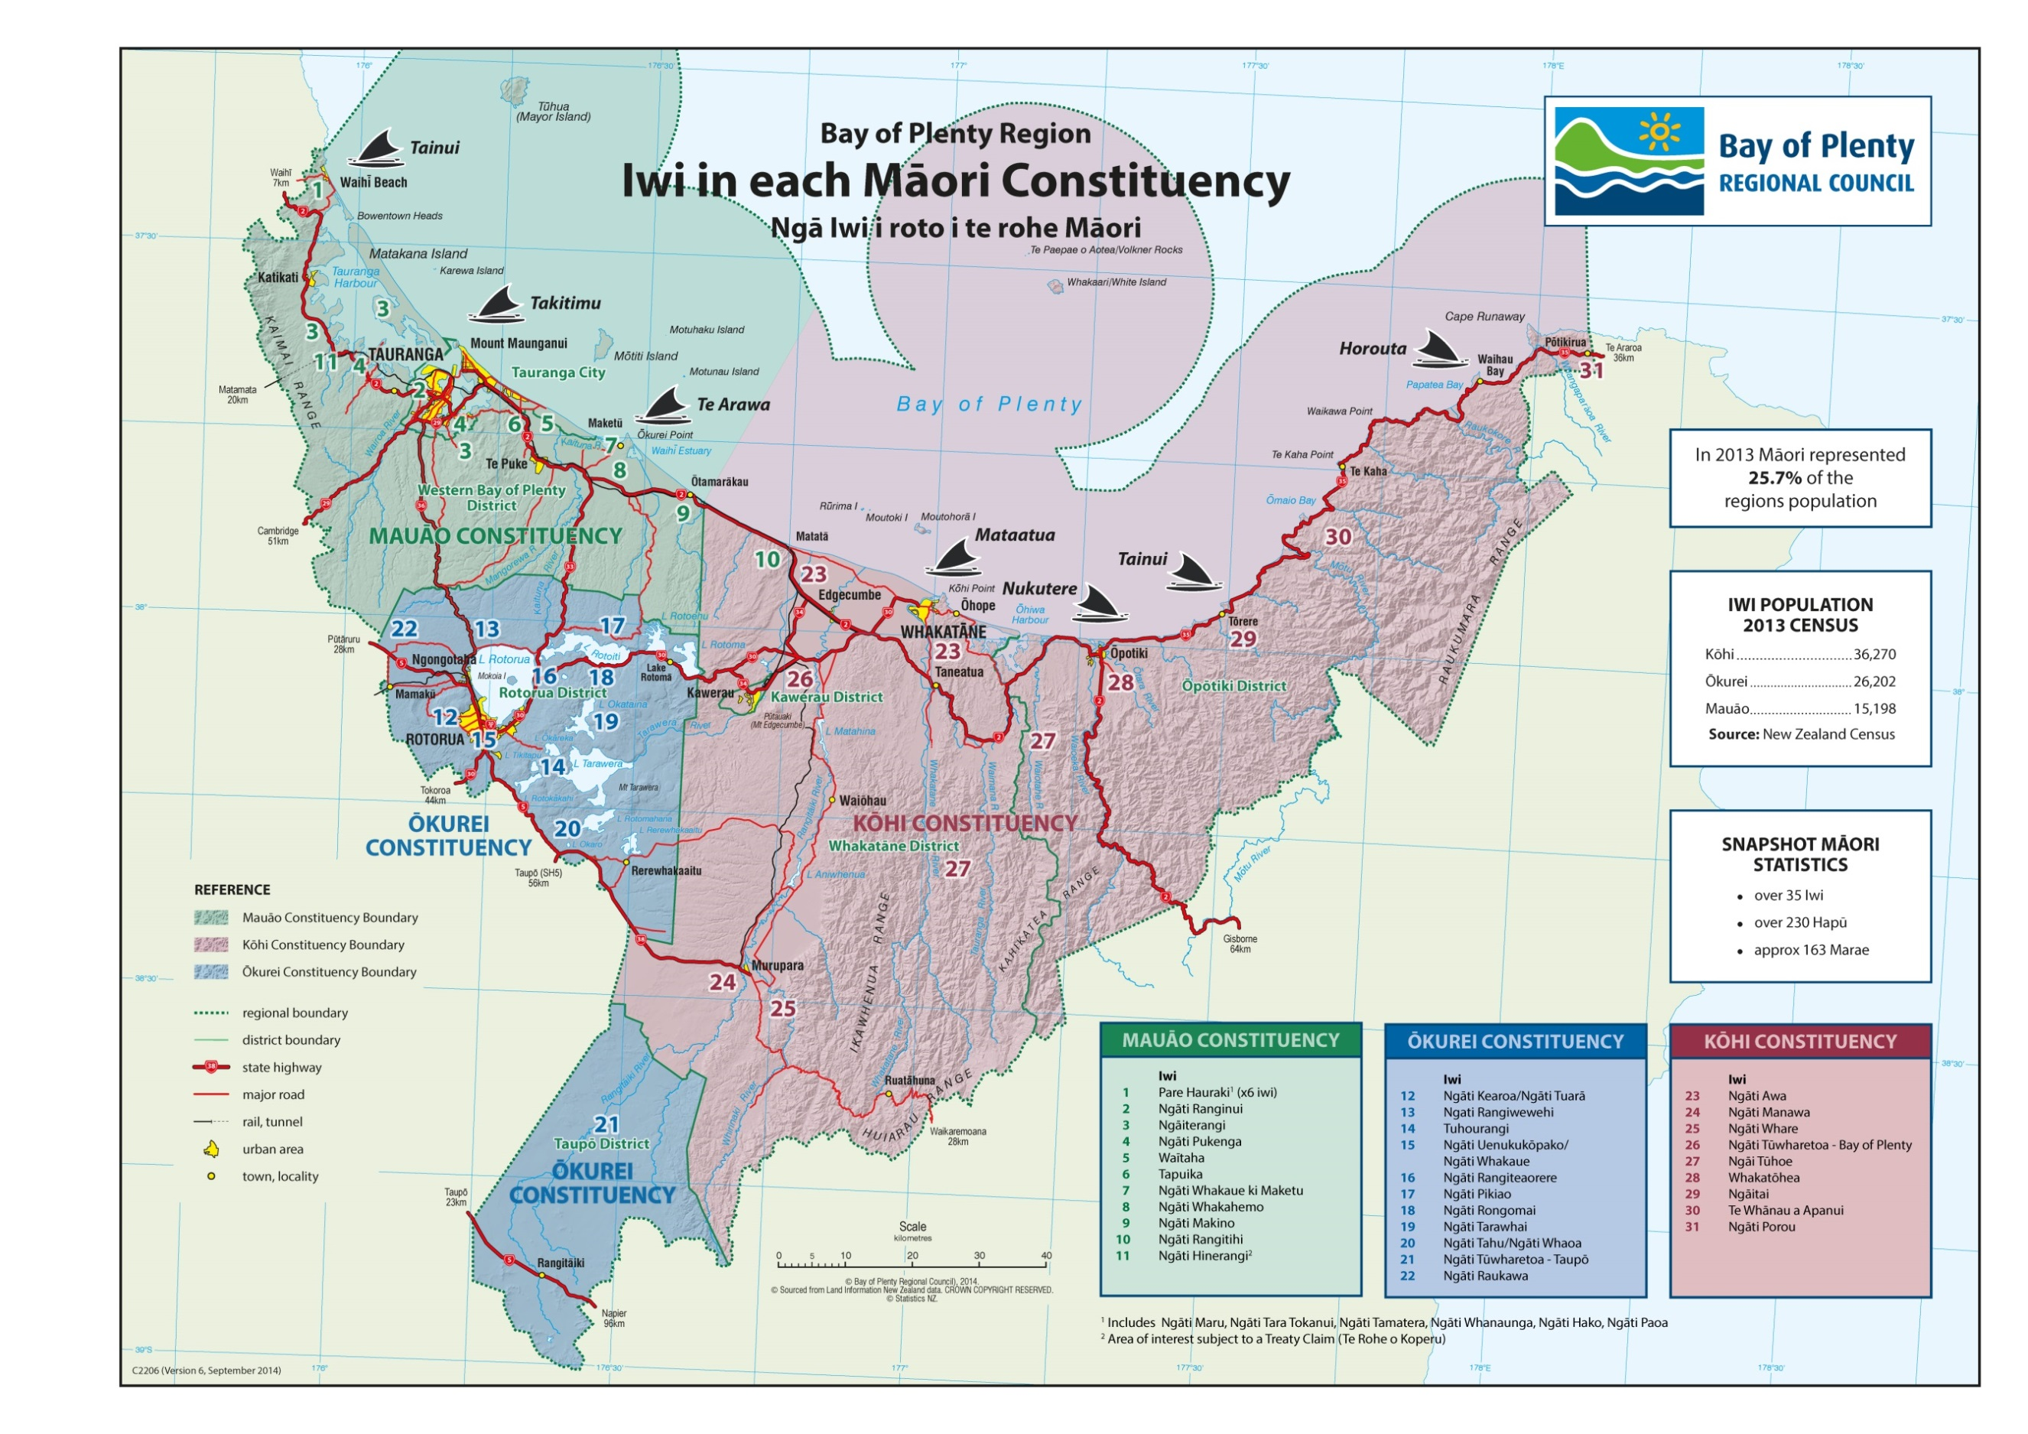

1. For further reading and wording of the Declaration of Independence, refer to <http://www.teara.govt.nz/en/he-whakaputanga-declaration-of-independece>.