Bay of Plenty Regional Council
Section 42A Officer’s Report for non-notified resource consent application, Resource Management Act 1991 (RMA)
Date: 18/02/2021
Prepared by: Danielle Petricevich
Senior Consents Planner
Approved by: Jacob Steens
Senior Consents Planner

Application details
Application ID: RM20-0615
Applicant: Ōpōtiki District Council
Application: New Land Use Consents
Location of activity: From Ōpōtiki to the Waiōtahe River

Summary of the proposal
Ōpōtiki District Council (the applicant) is applying for resource consent to construct a walkway/cycleway (hereafter referred to as a cycleway) between Ōpōtiki and the Waiōtahe River (approx. 1021 State Highway 2).
This application is to extend the current Motu Trails, the new section of the trail is proposed to start north of the Ōpōtiki township at the existing Motu Trails bridge, which spans the Otara River, the cycleway then will go west along the existing stopbanks of the Otara and Waioeka River, along the Waiōtahe Beach dunes to the Te Ahiaua Reserve, at the mouth of the Waiōtahe River. Figure 1 (below) shows the general alignment of the cycleway.
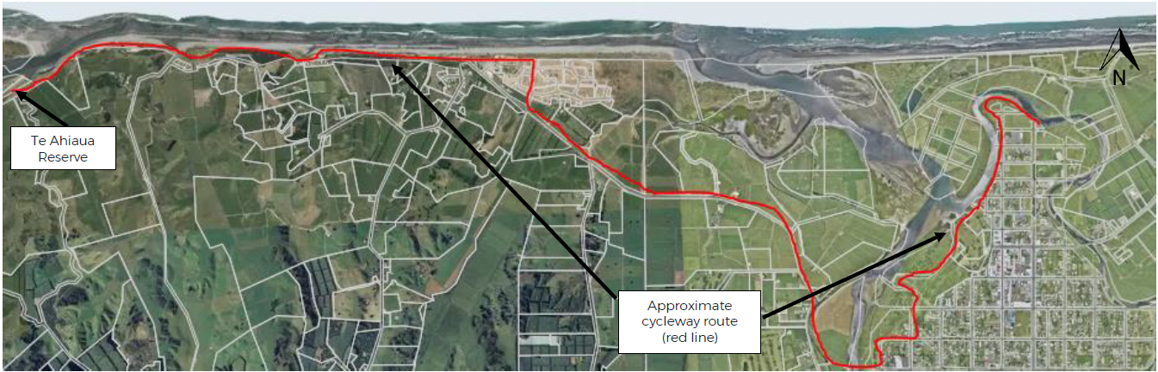
Figure 1: Approximate cycleway route
It is noted that the applicant has applied for and received a Floodway and Drainage Bylaw Authority (20028) from the Bay of Plenty Regional Council (BOPRC), to undertake earthworks and construct a structure within 12 metres of the Waioeka and Otara Rivers stopbanks and erect structures within 12 metres of Duke Street Drain.
The applicant has provided the following description of works within section 5 of the application. The construction of the cycle trail is broken up into the following physical works:
- Formation and of a cycle trail, including associated earthworks and spreading of aggregate.
- Construction of bridges for the cycle trail.

The cycle trail is designed for use by walkers and cyclists, and to conform to minimum specifications set out in SNZ HB 8630:2004 New Zealand Handbook Trails and Outdoor Visitor Structures and the NZCT Cycle Trail Design Specifications for Grade 2 trails. The cycle trail will be formed in accordance with the following general specifications, which may be adjusted for physical conditions on site:
- A flat, wide (2.2m minimum width, reduced in some sections for structures), smooth trail, which feels safe to ride. Ideal as a first ride for non-cyclists, and those wanting an easy gradient or experience. The trail allows for cyclists to ride two abreast most of the time, and provides a social component to the ride.
- A gradient of 0-2 degrees. Sections with more than 2 degrees gradient are recommended to be no longer than 200m at a time, and surfaced with a permanent or hard pack surface for traction.
- The surface will be formed by removing vegetation by scraping a layer of topsoil or sand, spreading the base and top course and rolling the trail surface to form a firm level surface. A minimum of 100mm depth of compacted Country Roads All Passing 30mm (CRAP30); with crusher dust to minimum depth 5mm rolled into the surface.
- The top layer will typically be constructed with a single cross section fall towards the seaward side of the trail for coastal sections, and away from the road for roadside sections.
- Wooden boardwalks will be used where a standard pathway is unsuitable, or where the trail traverses alongside, or over areas of vegetation with high ecological value.
- Construction of bridges over watercourses. Proposed bridge locations are shown at Appendix E.
- Barriers/handrails will be installed as required, e.g. on bridges where a fall would result in significant harm.
- No obstacles for the length of the cycle trail e.g. stiles.
- Various provisions related to traffic and pedestrian safety, wayfinding signage, security and access.

The formation of the cycle trail can be split into three distinct types - firstly where the it is situated on top of stopbanks or along the sand dunes, and secondly where the cycle trail runs alongside an existing formed road and thirdly where the cycle trail is on a structure of some description. The typical cross-sections of the proposed cycle trail are shown below, and may be altered as necessary to suit the varied terrain along the route.

Where the cycle trail runs alongside the formed sections of SH2 and sand dunes, the construction will generally consist of a 2.2m wide cycle trail.

The cycle trail will include up to five bridge structures where it crosses over watercourses. Plans of the proposed structures are included at Appendix E.

Where the cycle trail traverses sand dunes along Waiōtahe Beach, there will be removal of indigenous and exotic vegetation to allow for the construction of the cycle trail. This may include minor disturbance of pōhutukawa trees during construction of the trail beneath the dripline and ongoing maintenance.
The area of vegetation clearance required for the cycle trail is approximately 0.4 ha. Much of this will take place in vegetation with moderate to low ecological value, with less than 0.2 ha of vegetation with high ecological value being removed.

The dune vegetation disturbance will be limited to the formation of the trail, and mainly through the back dunes, the trail is proposed to follow existing walkways where practicable. The dune vegetation disturbance is isolated to a section of the cycle trail approximately 500 m long along the Waiōtahe Beach dunes, to the north of the subdivision known as ‘The Drifts’. For the remaining length of the cycle trail along Waiōtahe Beach, it follows an existing unformed track, and boardwalks will be built underneath the first pōhutukawa tree ‘tunnel’. The extent of the trimming of the pōhutukawa trees will be limited to small branches underneath the trees, to provide clearance for those who will use the cycle trail.

Background
Further information was requested on 9/10/2020, with responses received on 11/11/2020, 18/11/2020, 2/12/2020 and 8/12/2020. While the applicant has responded to the request, they have not engaged a technical expert on the planning or ecological matters raised.

A site visit was undertaken on 24/11/2020, with Gerard McCormack, Gary Page and Yvette Shirley attending from Ōpōtiki District Council and Ella Tennant, Tim Senior, Heather MacKenzie and myself attending from the Bay of Plenty Regional Council. During the site visit we all walked the proposed track along Waiōtahe Beach and discussed the key areas of concern, these being the area of track along the front of the campground and houses (see Figure 2) and the section of track along the second Pōhutukawa tree ‘tunnel’ (see Figure 3).

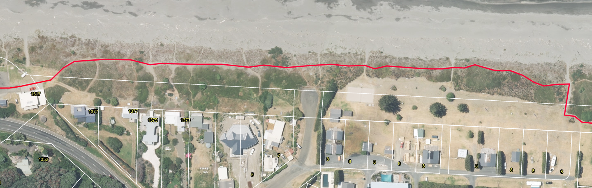
Figure 2: Section of track along the front of the camp ground and dwellings ‘The Drfts’. Vegetation within the road reserve is already highly distrubed.

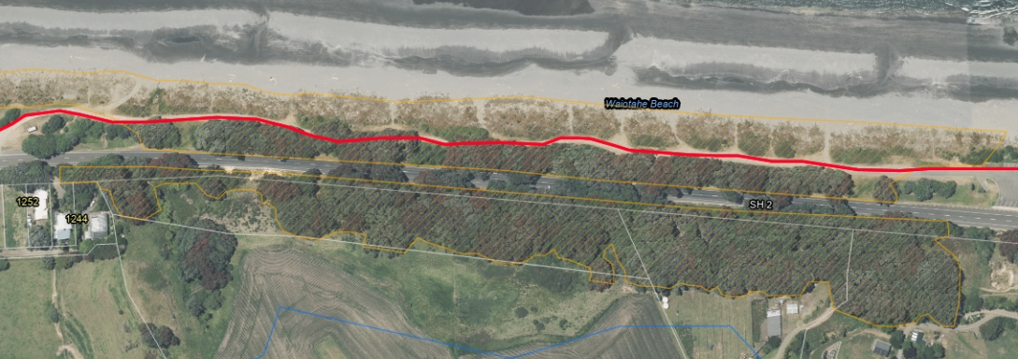
Figure 3: Section of track along the front of the second pōhutukawa ‘tunnel’ within an area (orange hatched) classified as Indigenous Biodiversity Area B in the Regional Coastal Environment Plan.

Recreation and enhancement of the dunes via the Remediation Plan is considered as a mitigation measure rather than an offset. This is because the recreation and enhancement is within the same dune system as the works (loss of extent and habitat). Biodiversity offsetting has been defined as a process that seeks to counter-balance the unavoidable impacts of development activities on biodiversity by enhancing the state of biodiversity elsewhere.

While the applicant initially proposed to consent the entire cycleway, they have since undertaken any permitted activity works that they can. Therefore this application only relates to areas of the cycleway that are within the CEZ or near to surface waterways.

Description of the environment
Section 3 of the application¹ contains a description of the existing environment. I consider that this description is accurate and therefore have not repeated it, rather have provided a summary key points of this description and any further key matters below:
- No works are within the CMA, but (as above) are within the CEZ.
- The parts of the cycleway within the CEZ are also within/adjacent to areas classified as Outstanding Natural Landscapes and Features (ONFL), Indigenous Biodiversity Area (IBDA) B, as classified in the RCEP.
- Some of the trail follows State Highway 2.
- The cycle trail traverses stop banks through Ōpōtiki Township, the back dunes at Waiōtahe Beach, several streams (via bridges to be constructed) and through residential areas.
- Both stable and active dues are considered a ‘naturally uncommon ecosystem’ ranked endangered at national level (as assessed by Holdaway et al 2012 using IUCN red list criteria for ecosystems).
- Protection of sand dunes and naturally uncommon ecosystems are priority 2 and 3 in MFE/DOC’s Priorities for Protection of Biodiversity on Private Land (2008).

Relevant rules
Resource consents are required under the Regional Natural Resources Plan (RNRP).
- The disturbance of land and soil resulting from vegetation clearance is a discretionary activity under rule LM R10.
- The use, erection, reconstruction, placement, alteration or extension of a single span bridge or single span pipe bridge, over the bed of a river, stream, or lake is a controlled activity under rule BW R21.
- The discharge of contaminated stormwater to land soakage, where the rate of discharge is greater than 125 litres per second for a 10 minute duration 10% AEP storm event (10 year return period storm) is a restricted discretionary activity under rule DW R23.
An earthworks consent is not required for this activity as the definition of earthworks in the RNRP excludes the formation of walking tracks.
No works are within the Coastal Marine Area (CMA) so the rules of the Regional Coastal Environment Plan (RCEP) do not apply, however some of the activities are located within the Coastal Environment Zone (CEZ), so the objectives and policies of the RCEP apply to these activities.
Certificate of compliance
The applicant also applied for a certificate of compliance to add a concreted part of track on top of an existing authorised rock rip rap structure. This is to show compliance with rule SO9 of the RCEP.
However, where the cycleway will be is actually now considered land rather than CMA as the rock rip rap structure is now the boundary of the CMA. Therefore no rules apply to concreting the area for the cycleway. In addition, if this was to be considered part of the structure, the consent (65831) requires planting to have occurred on the structure. If this was to be removed as part of concreting the track then it could mean that the consent holder no longer is compliant with their consent.
For these reasons it is considered inappropriate to issue a certificate of compliance, this was discussed with the applicant on the site visit and no concerns or objections were raised.

National Environmental Standards for Freshwater 2020
The proposed activities are not within 100 metres of any natural wetlands.
No reclamation of any waterways is occurring and no structures will be placed in any waterways.
Therefore no activities require resource consent under the National Environmental Standards for Freshwater 2020 (NPS-FM).
When bundled, the activities are considered to be for a discretionary activity.

Assessment of environmental effects
An assessment of the environmental effects of the proposal, pursuant to Section 104(1)(a) RMA, is below:
The following adverse effects are relevant to this proposal and are assessed as follows.

Vegetation Clearance:
- Soil erosion;
- Water quality;
- Ecology including indigenous biodiversity;
- Cultural and heritage values;
- Natural Character;
- Public Access to the coast; and
- Dune systems.

Bridges:
- Measures to account for prevailing ground slope;
- The timing of any disturbance of the bed of a surface water body in relation to adverse effects on aquatic ecosystems, including indigenous biodiversity;
- Erosion protection works;
- Maintenance of the bridge;
- Soffit height above the watercourse;
- Velocity of water under the bridge;
- Construction standards;
- Location of the bridge;
- Flood design levels;
- Measures to account for soil type and geology; and
- Monitoring requirements.

Vegetation Clearance

I note that heritage values are made up of both natural heritage and historic heritage, the RCEP has objectives and policies relating to these matters to help inform the effects that activities may have on these values.

Natural heritage values in the coastal environment (through the RCEP) tend to be identified through identifying and protecting areas where there are outstanding natural features and landscapes of the coastal environment and areas of high, very high and outstanding natural character in the coastal environment. Important areas of indigenous biodiversity (IBDAs) are also identified in the RCEP through the establishment of areas zoned as IBDA A and IBDA B (which give effect to Policy 11 of the New Zealand Coastal Policy Statement). These have therefore been considered within the ecological effects assessment of this report, as there is significant overlap separating these would been there is duplication of assessments.

Historical heritage values in the coastal environment tend to have a lot of cross over with areas of cultural significance, this is also backed by the issues, objectives and policies of the RCEP with the interlinking of the historical heritage sections with the iwi resource management sections. Again, for the reason that there is significant overlap, separating these would mean there is duplication of assessments, therefore I have considered matters of historical heritage in with the assessment of effects in relation to cultural values.

It is noted that the applicant plans to complete a Vegetation Remediation Plan to offset the loss of native vegetation.

Erosion, Sedimentation and Water Quality

Where the cycleway follows alongside road reserve, works are made up of turf removal and removal of some shrubs. The potential adverse effects for the majority of the cycleway adjacent to the road reserve are considered to be minimal. For these sections of the cycleway, it will be necessary for the consent holder to ensure that appropriate erosion and sediment controls are in place so that during rainfall events, sediment contaminated stormwater does not discharge on surrounding land, into the roadside drains or nearby surface waterways.

Where the cycleway has the most potential to cause erosion and sedimentation issues is in the areas of track that are within the Erosion Hazard Zone or Coastal Margin, due to the proximity of the works to the coastal environment and watercourses. The applicant has proposed to mitigate these effects through a Construction Management Plan¹. The application states:

“This plan will include the construction methodology and erosion and sediment control measures (where appropriate), and will be prepared and submitted to the Consent Authorities for certification prior to commencement. Any erosion and sediment control measures will be designed, installed, and maintained in accordance with the Bay of Plenty Regional Council’s Erosion and Sediment Control Guidelines for Land Disturbing Activities (2010/01).”

The applicant has also noted during the consent process that small areas of clearance will occur at any one time during the construction works as the works will be staged. I consider that conditions proffered by the applicant, requiring the provision of a Construction Management Plan consistent with the Bay of Plenty Regional Council’s guidelines to be sufficient to mitigate the actual/potential adverse effects relating to erosion and sedimentation.

The Bay of Plenty Regional Council’s Erosion and Sediment Control Guidelines for Land Disturbing Activities (2010/01) prefer works in sand to occur outside of the summer months, as there is less risk of dust and the risk of sediment discharges is low due to the permeability of sand. Earthworks within “Riparian Zones” is also being controlled via consent conditions to ensure the adverse effects of works within these higher risk areas are minimised.

Provided works are undertaken as proposed the adverse effects relating to erosion and sedimentation and on water quality will be mitigated.

Ecological effects

A technical review of the application was completed by Bay of Plenty Regional Councils Support Environmental Scientist, Heather MacKenzie. Ms MacKenzie concludes that she generally agrees with the findings of the Assessment of Environmental Effects (AEE) which conclude that the adverse effects over a short term will be minor and there will be little no long term effects. However it is noted that there are some inconsistencies with the Wildlands Report (Appendix B of the application) and the AEE, this is because since the Wildlands report was completed the cycleway route has changed.

Clarification and further assessment was requested under s92(1) of the Resource Management Act (RMA) on the ecological effects given the inconsistencies of the two application documents and it is noted that while the applicant has provided their comments in relation to the further assessments sought, no formal further ecological assessment or amendments to the Wildland’s Report were made by an Ecologist.

There are still areas of the application/assessment which do not provide a full and complete assessment of effects, these relate to the areas noted in Figures 2 and 3 of this report, where there is the potential for the greatest ecological effects.

There are areas where the track traverses through or next to areas that are identified as outstanding natural features/landscapes (ONFL) and significant natural indigenous habitat as identified in the RCEP as IBDA B, the areas of natural character are identified because of the ecological values they have within the dune systems of Waiōtahe Beach (see Figure 4).
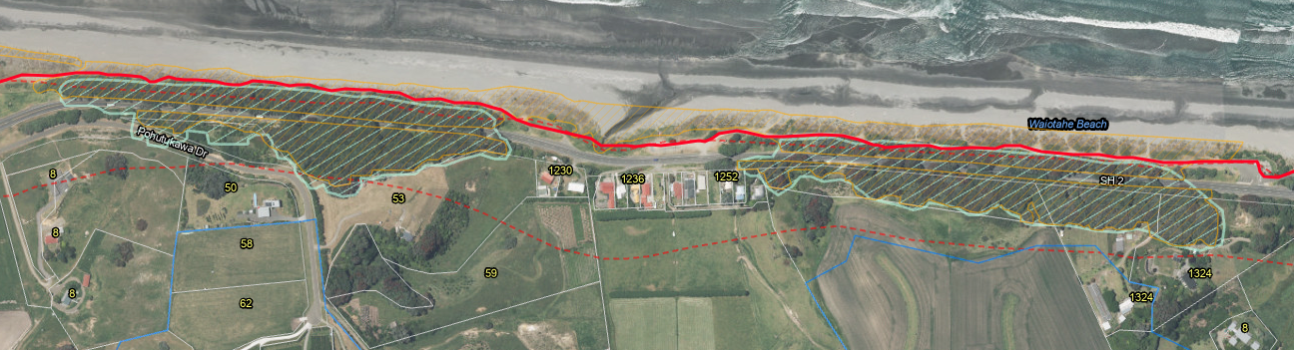
Figure 4: The cycleway (solid red line) traverses through the dunes at Waiōtahe Beach by the pōhutukawa ‘tunnels’. Mint green area is identified as ONFL. ‘Tunnel 1’ being the area of pōhutukawa to the right of the image, ‘Tunnel 2’ being the area of pōhutukawa on the left of the image.

The Huntress Creek conservation area, Waiōtahe Estuary and Waiōtahe Beach are recognised as areas of high ecological value under the RCEP with particular importance for migratory shorebirds and indigenous vegetation. The original Wildland Report considers the effects of the cycleway on the Huntress Creek conservation area (which is an IBDA A), however the application has been amended and the cycleway is no longer proposed to go through the conservation area. The application states:

“The most important roosts, breeding, and nesting sites are within the fore dunes of Waiōtahe Beach. The cycle trail does not impact these identified areas of importance, and therefore will result in minimal disturbance of any established roosts or breeding sites. Where the cycle trail passes alongside the Waiōtahe Estuary no indigenous vegetation is required to be removed, nor habitats disturbed to construct the cycle trail.”

“Physical disturbance of terrestrial habitat and any associated adverse effects is largely restricted to the clearance of indigenous and exotic grasses from the back dunes and road reserve in order to form the cycle trail. The majority of the coastal vegetation disturbed is of moderate or low ecological value. In other areas where the ecological value of the vegetation is more significant, the Wildlands Ecological Assessment has recommended a suitable alignment that will either avoid or reduce the impact of the route and associated works on those areas of high ecological value. A vegetation remediation plan will be developed to offset the vegetation removed as part of the construction phase.”

The Waiōtahe dunes and escarpment is an area identified within the Regional Policy Statement (RPS) Table 19 of appendix J as having high natural character due to having a large outcrop of pōhutukawa dominated native bush and coastal dune planting. It is clear that the pōhutukawa native forest is the key value of the ONFL. The proposed track will go under ‘Tunnel 1’ via an existing roadway and will go along the outer edge of ‘Tunnel 2’ via a newly constructed track within the dunes (see Figure 4).

To compensate for the lacking ecological assessment in the application, consent conditions have been drafted and agreed upon in order to establish appropriate mitigation measures. Following this, BOPRC’s Ecologists consider that while there are alternative locations that would be much more suitable in terms of reducing the impacts on the dunes, the conditions of consent, including the minimum requirements for the Vegetation Remediation Plan that the adverse effects/loss of dune ecosystem will be compensated for.

Policy 11 of the New Zealand Coastal Policy Statement (NZCPS) seeks to avoid effects in IBDA A areas and avoid significant effects and avoid, remedy or mitigate all other effects in IBDA B areas. As stated above, no works are occurring within an IBDA A and the adverse effects are considered to be mitigated (via consent conditions) in the IBDA B. It is noted that dune systems are sensitive environments and are rare ecosystems, therefore there is a need to consider the adverse effects on these ecosystems.

Some of the specific consent conditions drafted to mitigate the effects on the dunes (extent and habitat), biodiversity, ecology and the outstanding natural landscape and features (pōhutukawa Tunnel 2) include:

- Marking out the location of the track (with suitably qualified and experienced BOPRC Land Management Staff and Ecologists) within the dunes to ensure the placement is going minimise any adverse effects;

- The requirement to recreate and enhance the dunes along Waiōtahe beach via a Vegetation Remediation Plan;

- Ensuring habitat of NZ Dotterel and Pied Shags are not disturbed during breeding seasons; and

- Placing the track parallel to Tunnel 2 of the pōhutukawa 1 metre outside of the dripline so that the potential for trimming requirements is minimised, therefore maintaining the values of the ONFL.

Taking into account the technical expert reports, technical reviews, application, and proposed consent conditions, I consider that the adverse effects in relation to ecology are mitigated.

Public Access to the coast

The applicant has adequately considered the effects of the activity on public access to the coast within section 8.8 of the application¹. They have concentrated on the positive effects once the cycleway has been finished, these positive effects cannot be considered at this stage of the consent process.

The vegetation clearance will require works which at times may temporarily restrict access to the coast, however this will be limited in duration and extent and there are many accesses to the coast in these location, therefore the adverse effects considered to be mitigated.

Dune Systems/Coastal Processes

Technical advice was sought from BOPRC Coastal Land and Air Science Team Leader, Shane Iremonger in relation to the effects on coastal processes. He noted “that there is no coastal erosion information to access” and that “the erosion risk will vary as location does “meander” and in some locations the erosion potential is closer”. He also notes that “one location that does stand out, it is where the Waiōtahe River discharges onto the coast”. This is because there has been erosion in this area before, which is now protected by a coastal rock rip rap structure covered by a consent which NZTA holds. NZTA have an interest in this area as State Highway 2 runs along the coast in this area and the highway is protected by the coastal structure. In this area of the track the applicant proposes to concrete the track alongside the structure, therefore mitigating the effects of vegetation removal and potential erosion and instability.

In addition to this, it is important to consider the effects of climate change. While this has not been assessed in the application, provided that the track is either removable or can be re-created (if possible) with the impact of climate change and potential for sea level rise, then it is considered appropriate to place the track within the dunes. The cycleway is to be made from compacted gravel and if any boardwalk is going to be used, the conditions of consent require it to be removable. Therefore the construction of the cycleway will not exacerbate any effects of climate change.

Bridges

There are five proposed bridges over the course of the track, all of these are where the track runs alongside a roadway. The application has been technically reviewed by BOPRC’s Engineering Team and while some details of the bridges (soffit height) needed to be adjusted to provide for flood flows, the conclusion is that the adverse effects of the construction, use and maintenance of the bridges are mitigated.

Cultural effects of the entire proposal

The applicant has assessed the potential adverse cultural effects of the proposal within the application after engaging with iwi and hapū who have an interest in the area of the application. I concur with the assessment of environment effects provided by the applicant, which concludes that the potential adverse effects of the proposal will be less than minor. Conditions of consent have been proposed and agreed to in regards to accidental discovery of any historical heritage.

Positive effects
The construction of a cycleway will provide recreation benefits to the users and economic benefits to the region though increased visitors to the region. It will also provide a formal access to the coastal environment and reduce informal access ways through the dunes.

Statutory analysis
Section 104(1)(b) of the RMA requires that when processing a resource consent application, the consent authority must, subject to Part 2 of the RMA, have regard to the relevant provisions of national and regional policies, plans and standards. An assessment of the relevant Section 104 matters below.

Relevant plans
An assessment of the application against the relevant objectives and policies of the RNRP and RCEP is below.
The applicant is undertaking the majority of the vegetation clearance outside of the Coastal Environment Zone (CEZ) as permitted activity, the only vegetation clearance that triggers consent outside of the CEZ is works in the riparian zones. Consent conditions have been drafted to ensure that the works are in line with the objectives and policies of the RNRP, such as the inclusion of erosion and sedimentation protection when working in these areas.
The bridges fall under the objectives and policies of the RNRP and RCEP as some of these are in the CEZ and some are outside. Key policies of both plans require the consideration of cultural effects, natural hazards, climate change, and public access, stability of beds and banks of waterways, water quality, flood flows, natural character and landscapes and ecology.
These effects have been considered in the effects assessment. All effects are considered to be mitigated and therefore the activities are considered to be consistent with the objectives and policies of these plans.
The key activity which requires a more in depth analysis of the objectives and policies of the relevant plan is the vegetation clearance within the dunes of Waiōtahe Beach. As this activity is within the CEZ the objectives and policies of the RCEP apply, of these the policies within the Natural Heritage section of the RCEP are the key policies (ones which may significantly influence the recommendation on whether to grant or decline) to consider.
All other policies of the RCEP relating to this activity have been considered within the AEE of this report, these effects are considered to be less than minor and therefore consistent with the objectives and policies of the RCEP.
Consideration of the activities within the dunes against the Natural Heritage provisions of the RCEP are as follows:
Objective/Policy Reference | Theme | Comment
Policy NH 5 | Adverse effects must be avoided on the values and attributes of the following areas:  - Outstanding Natural Character areas (as identified in Appendix I to the RPS);  - Outstanding Natural Features and Landscapes (as identified in Schedule 3);  - Any Indigenous Biological Diversity Area A (as identified in Schedule 2, Table 1); and  Adverse effects must be avoided on taxa that meet the criteria listed in Policy 11(a)(i) or (ii) of the NZCPS. | The cycleway is proposed to run parallel and adjacent to an ONFL, this being pōhutukawa “Tunnel 2”. The cycleway will be low profile, outside the dripline by 1 metre to reduce the likelihood of maintenance trimming required. This ONFL is recognised due to the nature of the pōhutukawa growing in a tunnel like form with branches reaching back down to the ground. The cycleway (including potential maintenance trimming) will not affect these values of the ONFL.
Policy NH 6 | When assessing the extent and consequence of any adverse effects on the values and attributes of the areas listed in Policy NH 5 and identified in Schedules 2 and 3 to this Plan and Appendix I to the RPS (a) – (e).
Policy NH 10 | Areas of indigenous biodiversity in the coastal environment not identified in Schedule 2 contribute to the overall natural character of the environment and cumulative adverse effects on these areas should be avoided, remedied or mitigated. | As discussed in the AEE, effects on biodiversity, including extent, habitat and value will be mitigated through the proposed consent conditions.  Recreation and enhancement of the dunes has been required as part of the proposed consent conditions.
Policy NH 11 | There should be no net loss as a result of subdivision, use and development of the quality and extent of established mangroves seagrass beds, saltmarsh wetlands, bird roosting sites, sand dunes and coastal forest in the areas identified in Schedule 2. Where a biodiversity offset is proposed, it should be developed in a manner consistent with the principles contained in Schedule 13.
Policy NH 13 | Maintain ecological interconnections that are necessary to sustain indigenous species, including migratory routes, intact ecological sequences and ecological corridors. Irreversible and other significant adverse effects on these interconnections should be avoided, including significant cumulative adverse effects; other effects should be avoided, remedied or mitigated. | While the cycleway will dissect the dune system, the permanent track will only be 2.2 metres wide and to mitigate effects of the trail recreation and enhancement of the dunes is required.
Policy NH 14 | Recognise and provide for Māori cultural values and traditions when assessing the effects of a proposal on natural heritage | This has been assessed in the AEE.
Policy NH 21 | Planting associated with remediation or mitigation of effects on natural heritage should use appropriate native species, and give preference to the use of eco-sourced native plants. The introduction of exotic plants into areas of Outstanding Natural Character (as identified in Appendix I to the RPS) or an Indigenous Biological Diversity Area A is inappropriate. The introduction of exotic plants into an Indigenous Biological Diversity Area B (as identified in Schedule 2 of the Plan), is inappropriate except where consistent with Policy BS 1. | The proposed consent conditions give effect to this policy.
Policy NH 23 | In the consideration of resource consents, maintain identified view shafts of the outstanding natural features and landscapes identified in Schedule 3 Outstanding Natural Features and Landscapes. | As discussed for Policies NH 5 and 6, the ONFL in the area of this application should not be impacted by the cycleway.
Conclusion | Taking into account the above assessment, I consider that the application is consistent with the provisions of the RCEP.

Bay of Plenty Regional Policy Statement
The RCEP gives effect to the Bay of Plenty Regional Policy Statement (RPS) and the purpose of the RMA. While the RPS is relevant to this application, the proposal is consistent with the objective and policies of the relevant plans, so I have not given further consideration to the RPS.

National Policy Statements
National Policy Statement for Freshwater Management 2020
The National Policy Statement for Freshwater Management (NPS-FM) supports improved freshwater management in New Zealand by directing regional councils to establish objectives and set limits for freshwater in their regional plans.
The fundamental concept of the NPS-FM is Te Mana o te Wai, which is of relevance to all freshwater management. The key objective of the NPS-FM is to ensure that natural and physical resources are managed in a way that prioritises; first, the health and wellbeing of water bodies and freshwater ecosystems, second, the health and needs of people and third, the ability of people and communities to provide for their social, economic and cultural wellbeing.
The operative RNRP and RPS do not give direct effect to the NPS-FM as they were developed before the NPS-FM and therefore there is the potential for incomplete coverage. However, I do not think this is the case in this instance and consider the direction they provide is line with the purpose and intent of the NPS-FM, so I have not given further consideration to the NPS-FM.
New Zealand Coastal Policy Statement 2010

The NZCPS is relevant to this application as it is within the coastal environment. I have checked the objectives and policies and consider that the application is not contrary to the direction provided by the NZCPS and that the RCEP gives effect to the NZCPS.

However, there are two key policies to consider for this application, these being Policies 11 and 15. I have provided a brief assessment of the application against these key policies.

Policy 11 relates to indigenous biodiversity, the application triggers part (b) of the policy as some of the cycleway is within an IBDA B (classified in the RCEP). The direction on policy 11(b) is to avoid significant effects and avoid, remedy, mitigate all other adverse effects. Through the implementation of the Vegetation Remediation Plan it is considered that the adverse effects of the activity are mitigated.

Policy 15 relates to the protection of natural features and landscapes, where part (a) seeks to avoid adverse effects of activities on outstanding natural features and outstanding natural landscapes in the coastal environment. As previously discussed, the track will be low profile and set in a location to avoid impacting on the ONFL that is the pōhutukawa tress that run adjacent to the proposed track.

The proposal also provides some positive benefits through the provision of formal and enhanced access to the coast which is in line with Policy 19 and will control informal access which is in line with Policy 20.

RMA Part 2 matters

The Court of Appeal decision on RJ Davidson provides statutory direction with regards to the need to have regard to Part 2 in consent applications. The case law indicates that there is a statutory direction for planning documents to give effect to the principles of the Resource Management Act (through Part 2) and where a plan has clearly given effect to Part 2, then there is no need to revert back to Part 2 as the ‘planning documents, have already given substance to the principles in Part 2’ and ‘doing so will not add to the evaluative exercise’.
This proposal is considered to be consistent with the policy direction of the RNRP, RCEP and the RPS and has been assessed against the NPS-FM 2020 and NZCPS. It is also considered that the regional and national planning documents have given substance to the principles in Part 2 of the RMA and therefore, consistent with the Court of Appeal decision in R J Davidson I have not considered it necessary to revisit Part 2 of the RMA or make an overall broad judgement as doing so will not add to the evaluative exercise.

Sections 105(1) and 107 of the RMA
Section 105 matters need to be considered as the application is for a discharge that would contravene Section 15.
This section requires the consenting authority to have regard to the nature of the discharge and the sensitivity of the receiving environment, the applicant’s reasons for the proposed choice and any possible alternative methods of discharge including into another receiving environment.
The application is for a discharge that would contravene Section 15 RMA, so Section 105 matters need to be considered. Section 105 requires that regard be given to the nature of the discharge, the sensitivity of the receiving environment, the reasons for the applicant’s choice and alternative methods of discharge including into another receiving environment.
Section 107(1) states that a discharge permit should not be approved if, after reasonable mixing, the contaminant is likely to give rise to adverse effects. The application reviewed the potential for the effects listed under Section 107(1) RMA.
The application and Consent Authority have had regard to Sections 105 and 107. The discharge of stormwater to land is considered to be the most suitable method at this site. As long as the consent holder complies with consent conditions, I consider that any discharge from the activity should not result in the production of any of the effects listed in Section 107(1).

Conclusion

The construction of a cycleway via vegetation clearance and construction of bridges will result in actual adverse effects on the environment, including loss of dune ecosystem and vegetation and there is the potential for adverse effects relating to sediment reaching water. However, the proposed consent conditions will ensure the adverse effects are mitigated to the extent they are considered to be no more than minor. In addition, the proposal will provide for positive effects, including providing for formalised access to the coast and removing informal access which creates more damage in the dune environment.

The application is considered to achieve the purpose of the objectives and policies of the RNRP, RCEP and NZCPS.

Term of consent
The applicant has applied for a 5 year consent duration, however a 10 year consent duration is considered more appropriate. This will ensure that the mitigation measures proposed via the consent conditions will be able to be monitored and fully implemented. This is important for this application as the mitigation measures include planting and weed control, is considered that a 10 year timeframe will ensure planting is estalished and weeds are under control.

Recommendation
Having considered all relevant matters under Sections 104-104D, I recommend granting resource consent RM20-0615 for a duration of 10 years, subject to the attached conditions.
Danielle Petricevich
Senior Consents Planner
Reasons for the decision:
- The decision meets the purpose of the Resource Management Act 1991 and is consistent with the provisions of Part 2 of the Act.
- The activity is not contrary to the relevant rules, objectives and policies of the National Policy Statement for Freshwater Management, the Bay of Plenty Regional Policy Statement, the Operative Regional Natural Resources Plan.
- The effects of the activity are considered to be less than minor, subject to compliance with consent conditions.
- The term is considered appropriate.

Motu Trails Cycle Trail Extension, Resource Consent Application to Ōpōtiki District Council and Bay of Plenty Regional Council, 22 September 2020.
Guidance on Good Practice Biodiversity Offsetting in New Zealand - August 2014 (doc.govt.nz)
https://www.landcareresearch.co.nz/publications/naturally-uncommon-ecosystems/coastal/active-sand-dunes/
https://www.doc.govt.nz/globalassets/documents/getting-involved/volunteer-or-start-project/funding/biodiversity-funds/protecting-our-places-priorities-brochure.pdf

