Annex 2 – Iwi Engagement, Mobilisation and Contacts
Contents
Initial Spill Verification 3
Iwi response and engagement 3
Tauranga Moana Iwi Response Framework 4
Mobilising personnel 6
Safety 6
Priority for mobilisation 6
Mobilisation requirements 6
Requirements of the Regional On-Scene Commander and
Health and Safety Advisor 7
Insurance and payment of responders 7
Response personnel 7
Key personnel contact details 7
Oil Spill field staff and the Incident Command Centre Team 8
Emergency Management staff and Civil Defence trained staff for
ICC roles 8
Possible personnel and resource suppliers for clean-up 8
News and media 8

Initial Spill Verification

Iwi response and engagement
Iwi’s special role and relationship with the coastal and marine environment is recognised in the Bay of Plenty Regional Environment Coastal Plan. Iwi occupy a central role as partners in the decision making process for every major marine oil spill response in the region. Over the years this role has evolved, particularly in regards to Tauranga Harbour spills. This plan formally recognises that every effort shall be made during a response to observe and embody Tikanga Māori.
Where appropriate, this includes cultural site inductions to be provided by appropriate local hapū representatives. The response shall make use of the labour provided by suitably trained and experienced local hapū members where available. The principles and processes of Matauranga Māori (traditional Māori systems of knowledge) are supported and applied in conjunction to conventional science to assist with the response, to monitor effects and determine the appropriate time (or end point criteria) where a response can transition to the recovery phase.
Practical efforts shall be made to engage with local groups on their own terms, to explain and relate the statutory powers and roles that the Regional On-Scene Commander (ROSC) and their teams perform during a marine oil spill.
Hapū/Iwi Resource Management Plans (HIMP) are documents developed and approved by hapū and/or iwi. These plans can be useful during a marine oil spill as they describe resource management issues of importance to them as tangata whenua. The plans may also contain information relating to specific cultural values, historical accounts, descriptions of areas of interest (hapū/iwi boundaries/rohe) and consultation/engagement protocols for resource consents and/or plan changes.
Plans may be accessed via the Regional Council’s website at:
https://www.boprc.govt.nz/about-council/kaupapa-maori/hapuiwi-resource-management-plans/
Additional useful resources including the council’s framework document He Korowai Mātauranga can be accessed here:
https://www.boprc.govt.nz/your-council/working-with-iwi/kaupapa-maori
To assist the application of He Korowai Mātauranga Council staff involved in marine oil spill response and prevention work will regularly present and engage with groups such as Tauranga Moana Iwi Collective. This may include the periodic review of agreements such as the Tauranga Moana Iwi Response Framework and/or providing updates on significant spills and/or developments in the field of response and prevention.

Tauranga Moana Iwi Response Framework
Iwi groups and interests in and around Tauranga Harbour, led to the development of a response framework to assist the management of cultural issues during a marine oil spill. This included the development of agreed notification procedures and opportunities to engage directly in the response at every level.
In case of a spill in Tauranga Harbour, the initial notification consists of the responding ROSC sending a text message to the two Iwi Liaison Representatives advising of a verified spill. This initial text message also includes the Communications Duty Person who then notifies as appropriate, a wider group of affected/interested iwi and rohe groups located around the harbour. The message is also sent to the Regional Harbourmaster, General Manager of Regulatory Services, a Māori Policy Representative and the Regulatory Compliance Manager.
(In addition, the Mount Hot Pools shall receive the initial notification if oil is likely to affect their intake located in Pilot Bay. The contact is 07 577 8551 or for the Manager’s contacts, refer to the Confidential Contacts List Objective ID: A3749135).
Reporting of marine oil spills to interested parties is crucial in promoting transparency, trust, cooperation and support of our iwi partners. Bay of Plenty Regional Council seeks to promote similar response structures being developed elsewhere if appropriate in the region.

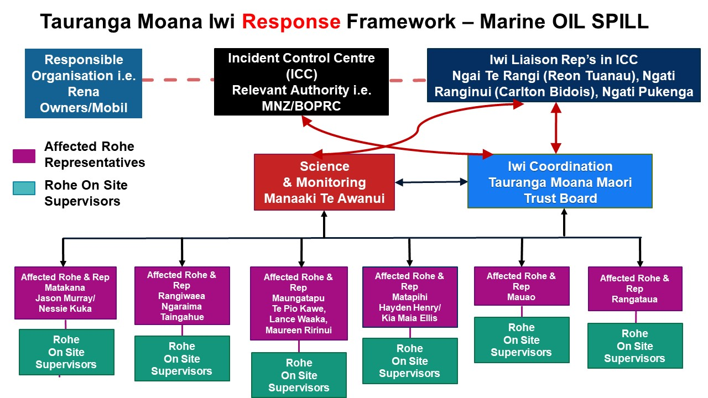

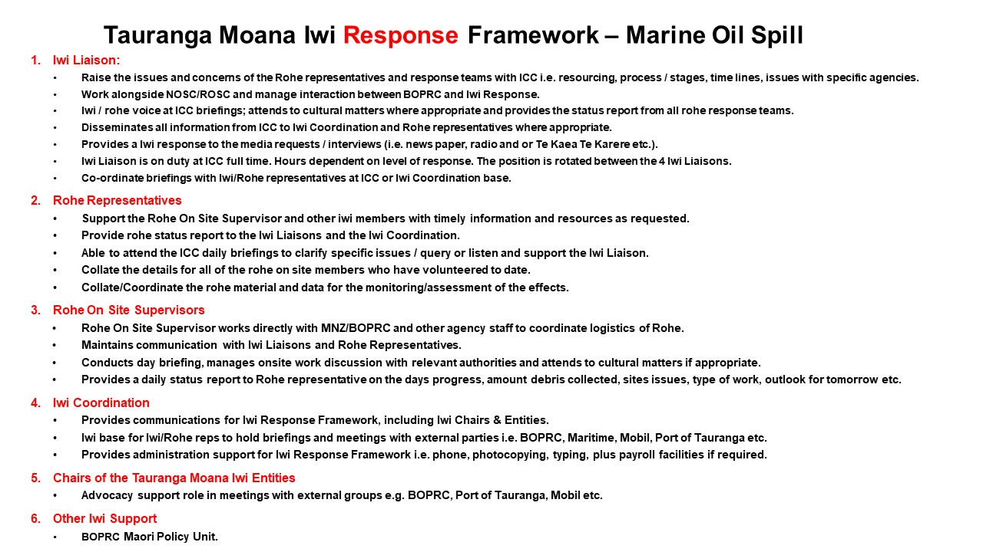

Mobilising personnel
The decision with respect to which personnel to use will be made by the ROSC.

Safety
The safety of human life, both responders and the general public, is to take precedence over all aspects of the response operation. Persons employed in these operations are to do so in compliance with the Health and Safety at Work Act (2017). Maritime New Zealand (MNZ) is developing a suite of health and safety related templates and Standard Operating Procedures (SOPs) that are available in WebEOC. Persons mobilising responders are to verify that they have been appropriately trained, equipped and briefed in the hazardous nature/danger of this work.

Priority for mobilisation
For cost and administrative purposes personnel should be mobilised in the following order of priority:
- On-duty ROSC
- Incident Command Team
- Other BOPRC staff referred to in this annex
- Port of Tauranga staff
- Department of Conservation (DOC) staff
- Marine Contractor
- Oil Company Contractors
- City and district council staff
- Adjacent regional councils
Notwithstanding the above priority list, DOC staff and other persons may need to be mobilised early to address any required wildlife response operation. Maritime New Zealand will be notified in all spill events and their level of involvement assessed at the time.

Mobilisation requirements
Person mobilising responders are to ensure that:
- Responders are trained.
- Responders are adequately attired and have adequate safety equipment, including personal flotation devices, as appropriate for work around water and/or aboard vessels.
- Transport to the appropriate site is arranged for the responders (as required), and the responders are informed of these arrangements.
- Responders are briefed where they will be working, for approximately how long they will be deployed in the field (hours, days or longer), and who they are to report to on arrival. This may include a site safety and cultural induction.
- The Operations Manager is informed who the responders are and their estimated time of arrival (ETA).
- Adequate accommodation is arranged for the responders (if required), with transport to and from the site at which they will be working.
- Adequate first aid and medical facilities are arranged.

- Sufficient and timely relief personnel are provided to allow adequate rest for response staff. The relief staff are to be treated as for first-call staff above.
- The Administration and Logistics Manager is informed of the responder’s name, hourly pay rate, commencement and finish times for pay.
- Return transport and debriefing is arranged on their release by the On Scene Commander (OSC).

Requirements of the Regional On-Scene Commander and Health and Safety Advisor
The ROSC or Health and Safety Advisor are to ensure that:
- Responders are not employed in hazardous situations beyond their training and/or experience.
- Responders wear safety equipment appropriate to the conditions under which they are working.
- Responders are given adequate supervision, rest and refreshments.
- The times worked by individual responders are noted for payment purposes.
- Responders receive adequate medical care and rest, as and when required.

Insurance and payment of responders
Responders or their parent organisations are expected to arrange suitable insurance for the response operation. Special payments will not be made to responders.
A responder’s organisation will be reimbursed wages/salaries incurred for the period of employment undertaken on the response operation. This will be made upon the recovery of response costs from the oil spill polluter or the Marine Oil Pollution Fund.

Response personnel

Key personnel contact details
Regional Harbourmaster Tauranga | Work | 0800 884 880
On duty Officer for Maritime Team | Work | 0800 55 6687 (0800 5 KNOTS)
Manager Operations | Port of Tauranga | 07 572 8882
Chief Executive - BOPRC | Work | 0800 884 880
General Manager - Natural Hazards | Work | 0800 884 880
General Manager – Regulatory Services | Work | 0800 884 880
Civil Defence Duty Manager | Work  Cell phone | 0800 884 880
ROSC Phone | Work  Cell phone | 0800 884 880  027 405 8995

Oil Spill field staff and the Incident Command Centre Team
The following personnel have been identified as suitable to fulfil the duties as designated and may be called upon in the event of a marine oil spill. Contact details are held with the ROSC and are kept in the Oil Spill Cupboard in the EOC.
All Regional Council personnel responsible for implementing the Plan and dealing with oil spills shall receive training appropriate to their responsibilities under this Plan.
Objective ID: A2763843 - Regional Responders List

Emergency Management staff and Civil Defence trained staff for ICC roles
Emergency Management Bay of Plenty, working alongside BOPRC, are responsible for the maintenance of the GECC/ICC roster. This process incorporates identifying sufficient staff and providing/delivering coordination centre training. Where there is a need to establish an EOC, Emergency Management
Bay of Plenty would activate the EOC under direction of the ROSC. The level of activation and staffing requirements will be determined by the scale of the required response.

Possible personnel and resource suppliers for clean-up
Up to date contact lists are stored in Microsoft Teams in the Duty Harbourmaster Team in the General Section under the title: Maritime Duty Harbourmaster Contacts and Service Providers.xlsx

News and media
Contact information for all news and media sources is available through the Media Liaison Advisor or through the BOPRC Strategic Communications Department.

