Notification/Non-Notification Recommendation and Decision
Sections 95A to 95F Resource Management Act 1991

Application details
Application ID: RM20-0615
Applicant: Ōpōtiki District Council
Application: New Land Use Consents
Location of activity: From Ōpōtiki to the Waiōtahe River

Summary of Application
Ōpōtiki District Council (the applicant) is applying for resource consent to construct a walkway/cycleway (hereafter referred to as a cycleway) between Ōpōtiki and the Waiōtahe River (approx. 1021 State Highway 2).
This application is to extend the current Motu Trails, the new section of the trail is proposed to start north of the Ōpōtiki township at the existing Motu Trails bridge, which spans the Otara River, the cycleway then will go west along the existing stopbanks of the Otara and Waioeka River, along the Waiōtahe Beach dunes to the Te Ahiaua Reserve, at the mouth of the Waiōtahe River. Figure 1 (below) shows the general alignment of the cycleway.
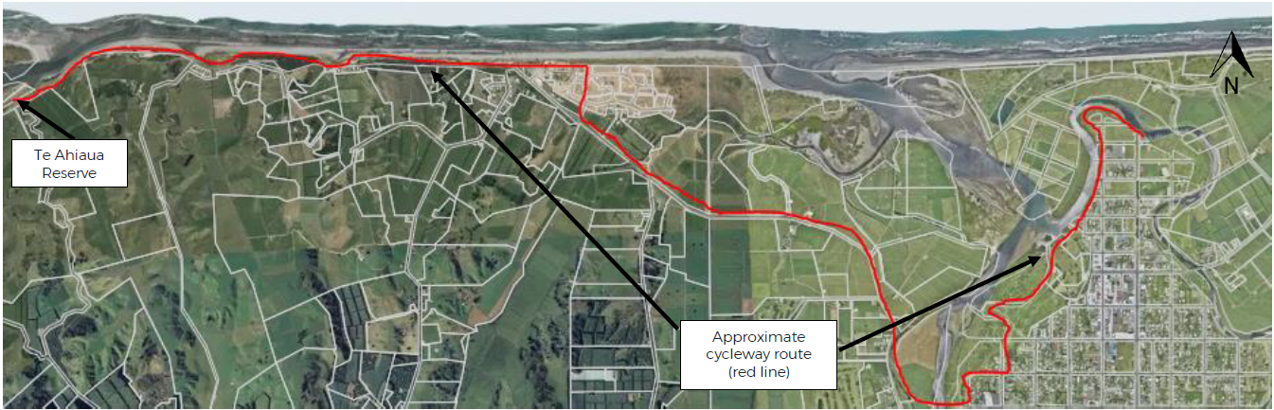
Figure 1: Approximate cycleway route
It is noted that the applicant has applied for and received a Floodway and Drainage Bylaw Authority (20028) from the Bay of Plenty Regional Council (BOPRC), to undertake earthworks and construct a structure within 12 metres of the Waioeka and Otara Rivers stopbanks and erect structures within 12 metres of Duke Street Drain.

The applicant has provided the following description of works within section 5 of the application. The construction of the cycle trail is broken up into the following physical works:
- Formation of a cycle trail, including associated earthworks and spreading of aggregate.
- Construction of bridges for the cycle trail.

The cycle trail is designed for use by walkers and cyclists, and to conform to minimum specifications set out in SNZ HB 8630:2004 New Zealand Handbook Trails and Outdoor Visitor Structures and the NZCT Cycle Trail Design Specifications for Grade 2 trails. The cycle trail will be formed in accordance with the following general specifications, which may be adjusted for physical conditions on site:
- A flat, wide (2.2m minimum width, reduced in some sections for structures), smooth trail, which feels safe to ride. Ideal as a first ride for non-cyclists, and those wanting an easy gradient or experience. The trail allows for cyclists to ride two abreast most of the time, and provides a social component to the ride.
- A gradient of 0-2 degrees. Sections with more than 2 degrees gradient are recommended to be no longer than 200m at a time, and surfaced with a permanent or hard pack surface for traction.
- The surface will be formed by removing vegetation by scraping a layer of topsoil or sand, spreading the base and top course and rolling the trail surface to form a firm level surface. A minimum of 100mm depth of compacted Country Roads All Passing 30mm (CRAP30); with crusher dust to minimum depth 5mm rolled into the surface.
- The top layer will typically be constructed with a single cross section fall towards the seaward side of the trail for coastal sections, and away from the road for roadside sections.
- Wooden boardwalks will be used where a standard pathway is unsuitable, or where the trail traverses alongside, or over areas of vegetation with high ecological value.
- Construction of bridges over watercourses. Proposed bridge locations are shown at Appendix E.
- Barriers/handrails will be installed as required, e.g. on bridges where a fall would result in significant harm.
- No obstacles for the length of the cycle trail e.g. stiles.
- Various provisions related to traffic and pedestrian safety, wayfinding signage, security and access.

The formation of the cycle trail can be split into three distinct types - firstly where the it is situated on top of stopbanks or along the sand dunes, and secondly where the cycle trail runs alongside an existing formed road and thirdly where the cycle trail is on a structure of some description. The typical cross-sections of the proposed cycle trail are shown below, and may be altered as necessary to suit the varied terrain along the route.

Where the cycle trail runs alongside the formed sections of SH2 and sand dunes, the construction will generally consist of a 2.2m wide cycle trail.

The cycle trail will include up to five bridge structures where it crosses over watercourses. Plans of the proposed structures are included at Appendix E.

Where the cycle trail traverses sand dunes along Waiōtahe Beach, there will be removal of indigenous and exotic vegetation to allow for the construction of the cycle trail. This may include minor disturbance of pōhutukawa trees during construction of the trail beneath the dripline and ongoing maintenance.
The area of vegetation clearance required for the cycle trail is approximately 0.4 ha. Much of this will take place in vegetation with moderate to low ecological value, with less than 0.2 ha of vegetation with high ecological value being removed.

The dune vegetation disturbance will be limited to the formation of the trail, and mainly through the back dunes, the trail is proposed to follow existing walkways where practicable. The dune vegetation disturbance is isolated to a section of the cycle trail approximately 500 m long along the Waiōtahe Beach dunes, to the north of the subdivision known as ‘The Drifts’. For the remaining length of the cycle trail along Waiōtahe Beach, it follows an existing unformed track, and boardwalks will be built underneath the first pōhutukawa tree ‘tunnel’. The extent of the trimming of the pōhutukawa trees will be limited to small branches underneath the trees, to provide clearance for those who will use the cycle trail.

Background
Further information was requested on 9/10/2020, with responses received on 11/11/2020, 18/11/2020, 2/12/2020 and 8/12/2020. While the applicant has responded to the request, they have not engaged a technical expert on the planning or ecological matters raised.

A site visit was undertaken on 24/11/2020, with Gerard McCormack, Gary Page and Yvette Shirley attending from Ōpōtiki District Council and Ella Tennant, Tim Senior, Heather MacKenzie and myself attending from the Bay of Plenty Regional Council. During the site visit we all walked the proposed track along Waiōtahe Beach and discussed the key areas of concern, these being the area of track along the front of the campground and houses (see Figure 2) and the section of track along the second Pōhutukawa tree ‘tunnel’ (see Figure 3).

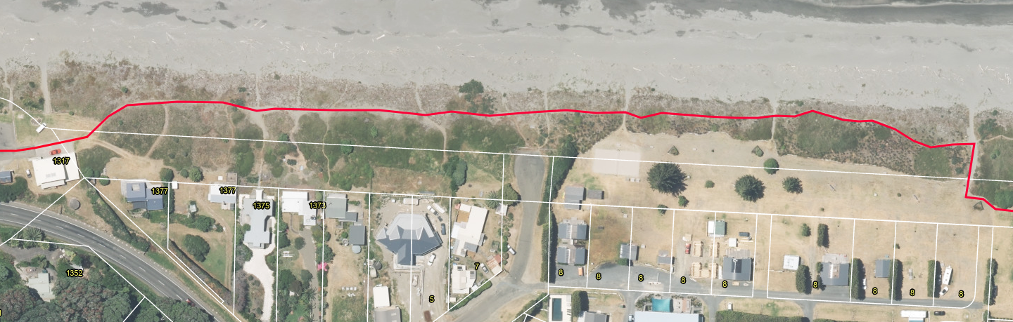
Figure 2: Section of track along the front of the camp ground and dwellings ‘The Drifts’. Vegetation within the road reserve is already highly distrubed.

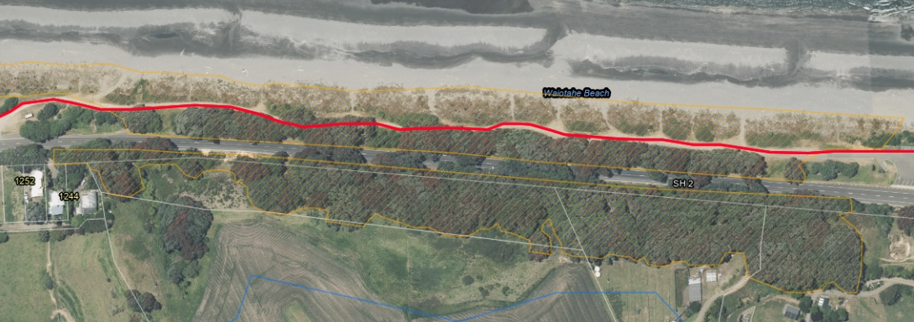
Figure 3: Section of track along the front of the second pōhutukawa ‘tunnel’ within an area (orange hatched) classified as Indigenous Biodiversity Area B in the Regional Coastal Environment Plan.
It is noted that the applicant has received, reviewed and agreed to the proposed consent conditions, these conditions have subsequently been used to help inform the assessment of environmental effects and have been included as mitigation measures.

Recreation and enhancement of the dunes via the Remediation Plan is considered as a mitigation measure rather than an offset. This is because the recreation and enhancement is within the same dune system as the works (loss of extent and habitat). Biodiversity offsetting has been defined as a process that seeks to counter-balance the unavoidable impacts of development activities on biodiversity by enhancing the state of biodiversity elsewhere.

While the applicant initially proposed to consent the entire cycleway, they have since undertaken any permitted activity works that they can. Therefore this application only relates to areas of the cycleway that are within the CEZ or near to surface waterways.

Description of the existing environment
Section 3 of the application¹ contains a description of the existing environment. I consider that this description is accurate and therefore have not repeated it, rather have provided a summary key points of this description and any further key matters below:
- No works are within the CMA, but (as above) are within the CEZ.
- The parts of the cycleway within the CEZ are also within/adjacent to areas classified as Outstanding Natural Landscapes and Features (ONFL), Indigenous Biodiversity Area (IBDA) B, as classified in the RCEP.
- Some of the trail follows State Highway 2.
- The cycle trail traverses stop banks through Ōpōtiki Township, the back dunes at Waiōtahe Beach, several streams (via bridges to be constructed) and through residential areas.
- Both stable and active dunes are considered a ‘naturally uncommon ecosystem’ ranked endangered at national level (as assessed by Holdaway et al 2012 using IUCN red list criteria for ecosystems).
- Protection of sand dunes and naturally uncommon ecosystems are priority 2 and 3 in MFE/DOC’s Priorities for Protection of Biodiversity on Private Land (2008).

Planning framework
Resource consents are required under the Regional Natural Resources Plan (RNRP).
- The disturbance of land and soil resulting from vegetation clearance is a discretionary activity under rule LM R10.
- The use, erection, reconstruction, placement, alteration or extension of a single span bridge or single span pipe bridge, over the bed of a river, stream, or lake is a controlled activity under rule BW R21.
- The discharge of contaminated stormwater to land soakage, where the rate of discharge is greater than 125 litres per second for a 10 minute duration 10% AEP storm event (10 year return period storm) is a restricted discretionary activity under rule DW R23.
When bundled, the activities are considered to be for a discretionary activity.
An earthworks consent is not required for this activity as the definition of earthworks in the RNRP excludes the formation of walking tracks.
No works are within the Coastal Marine Area (CMA) so the rules of the Regional Coastal Environment Plan (RCEP) do not apply, however some of the activities are located within the Coastal Environment Zone (CEZ), so the objectives and policies of the RCEP apply to these activities.
Certificate of compliance
The applicant also applied for a certificate of compliance to add a concreted part of track on top of an existing authorised rock rip rap structure. This is to show compliance with rule SO9 of the RCEP.
However, where the cycleway will be is actually now considered land rather than CMA as the rock rip rap structure is now the boundary of the CMA. Therefore no rules apply to concreting the area for the cycleway. In addition, if this was to be considered part of the structure, the consent (65831) requires planting to have occurred on the structure. If this was to be removed as part of concreting the track then it could mean that the consent holder no longer is compliant with their consent.
For these reasons it is considered inappropriate to issue a certificate of compliance, this was discussed with the applicant on the site visit and no concerns or objections were raised.

National Environmental Standards for Freshwater 2020
The proposed activities are not within 100 metres of any natural wetlands.
No reclamation of any waterways is occurring and no structures will be placed in any waterways.
Therefore no activities require resource consent under the National Environmental Standards for Freshwater 2020 (NPS-FM).

Is public notification mandatory?
Step 1 – Has the applicant requested public notification (s95A(3)(b))?
☒ No - go to Step 2.
Step 2 – Is public notification required under s95C (s95A(3)(b))?
- Has further information (s92(1)) been requested or has the applicant been notified of the intention to commission a report (s92(2))?
☒ Yes – go to Step 2b.
- Did the applicant refuse the request, or fail to respond, or fail to provide the information by the deadline?
☒ No – Go to Step 3.

Is public notification precluded?
Step 3 – Are all activities in the application subject to one or more rules or national environmental standards that preclude public notification (s95A(5)(a))?
☒ No – Go to Step 4.
Step 4 – Is the application for one or more of the following (but no other) activities?
☐ Controlled Activity (s95A(5)(b)(i)).
☒ No – Go to Step 5.

Is public notification required?
Step 5 – Does a rule or national environmental standards require public notification (s95A(8)(a))?
☒ No - go to Step 6.
Step 6 – Are adverse effects on the environment more than minor (s95A(8)(b))?
☒ No – (go to Step 7) I recommend the application is not publicly notified for the following reasons:
Assessment of adverse effects
The following adverse effect are relevant to this proposal and are assessed as follows.

Vegetation Clearance:
- Soil erosion;
- Water quality;
- Ecology including indigenous biodiversity;
- Cultural and heritage values;
- Natural Character;
- Public Access to the coast; and
- Dune systems.

Bridges:
- Measures to account for prevailing ground slope;
- The timing of any disturbance of the bed of a surface water body in relation to adverse effects on aquatic ecosystems, including indigenous biodiversity;
- Erosion protection works;
- Maintenance of the bridge;
- Soffit height above the watercourse;
- Velocity of water under the bridge;
- Construction standards;
- Location of the bridge;
- Flood design levels;
- Measures to account for soil type and geology; and
- Monitoring requirements.

Vegetation Clearance

I note that heritage values are made up of both natural heritage and historic heritage, the RCEP has objectives and policies relating to these matters to help inform the effects that activities may have on these values.

Natural heritage values in the coastal environment (through the RCEP) tend to be identified through identifying and protecting areas where there are outstanding natural features and landscapes of the coastal environment and areas of high, very high and outstanding natural character in the coastal environment. Important areas of indigenous biodiversity (IBDAs) are also identified in the RCEP through the establishment of areas zoned as IBDA A and IBDA B (which give effect to Policy 11 of the New Zealand Coastal Policy Statement). These have therefore been considered within the ecological effects assessment of this report, as there is significant overlap separating these would been there is duplication of assessments.

Historical heritage values in the coastal environment tend to have a lot of cross over with areas of cultural significance, this is also backed by the issues, objectives and policies of the RCEP with the interlinking of the historical heritage sections with the iwi resource management sections. Again, for the reason that there is significant overlap, separating these would mean there is duplication of assessments, therefore I have considered matters of historical heritage in with the assessment of effects in relation to cultural values.

It is noted that the applicant plans to complete a Vegetation Remediation Plan to offset the loss of native vegetation.

Erosion, Sedimentation and Water Quality

Where the cycleway follows alongside road reserve, works are made up of turf removal and removal of some shrubs. The potential adverse effects for the majority of the cycleway adjacent to the road reserve are considered to be minimal. For these sections of the cycleway, it will be necessary for the consent holder to ensure that appropriate erosion and sediment controls are in place so that during rainfall events, sediment contaminated stormwater does not discharge on surrounding land, into the roadside drains or nearby surface waterways.

Where the cycleway has the most potential to cause erosion and sedimentation issues is in the areas of track that are within the Erosion Hazard Zone or Coastal Margin, due to the proximity of the works to the coastal environment and watercourses. The applicant has proposed to mitigate these effects through a Construction Management Plan¹. The application states:

“This plan will include the construction methodology and erosion and sediment control measures (where appropriate), and will be prepared and submitted to the Consent Authorities for certification prior to commencement. Any erosion and sediment control measures will be designed, installed, and maintained in accordance with the Bay of Plenty Regional Council’s Erosion and Sediment Control Guidelines for Land Disturbing Activities (2010/01).”

The applicant has also noted during the consent process that small areas of clearance will occur at any one time during the construction works as the works will be staged. I consider that conditions proffered by the applicant, requiring the provision of a Construction Management Plan consistent with the Bay of Plenty Regional Council’s guidelines to be sufficient to mitigate the actual/potential adverse effects relating to erosion and sedimentation.

The Bay of Plenty Regional Council’s Erosion and Sediment Control Guidelines for Land Disturbing Activities (2010/01) prefer works in sand to occur outside of the summer months, as there is less risk of dust and the risk of sediment discharges is low due to the permeability of sand. Earthworks within “Riparian Zones” is also being controlled via consent conditions to ensure the adverse effects of works within these higher risk areas are minimised.

Provided works are undertaken as proposed the adverse effects relating to erosion and sedimentation and on water quality will be less than minor.

Ecological effects

A technical review of the application was completed by Bay of Plenty Regional Councils Support Environmental Scientist, Heather MacKenzie. Ms MacKenzie concludes that she generally agrees with the findings of the Assessment of Environmental Effects (AEE) which conclude that the adverse effects over a short term will be minor and there will be little no long term effects. However it is noted that there are some inconsistencies with the Wildlands Report (Appendix B of the application) and the AEE, this is because since the Wildlands report was completed the cycleway route has changed.

Clarification and further assessment was requested under s92(1) of the Resource Management Act (RMA) on the ecological effects given the inconsistencies of the two application documents and it is noted that while the applicant has provided their comments in relation to the further assessments sought, no formal further ecological assessment or amendments to the Wildland’s Report were made by an Ecologist. There are still areas of the application/assessment which do not provide a full and complete assessment of effects, these relate to the areas noted in Figures 2 and 3 of this report, where there is the potential for the greatest ecological effects.

There are areas where the track traverses through or next to areas that are identified as outstanding natural features/landscapes (ONFL) and significant natural indigenous habitat as identified in the RCEP as IBDA B, the areas of natural character are identified because of the ecological values they have within the dune systems of Waiōtahe Beach (see Figure 4).

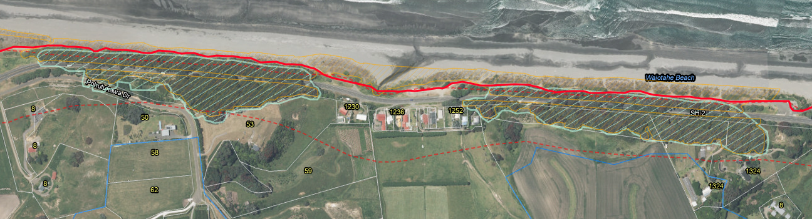
Figure 4: The cycleway (solid red line) traverses through the dunes at Waiōtahe Beach by the pōhutukawa ‘tunnels’. Mint green area is identified as ONFL. ‘Tunnel 1’ being the area of pōhutukawa to the right of the image, ‘Tunnel 2’ being the area of pōhutukawa on the left of the image.

The Huntress Creek conservation area, Waiōtahe Estuary and Waiōtahe Beach are recognised as areas of high ecological value under the RCEP with particular importance for migratory shorebirds and indigenous vegetation. The original Wildland Report considers the effects of the cycleway on the Huntress Creek conservation area (which is an IBDA A), however the application has been amended and the cycleway is no longer proposed to go through the conservation area. The application states:

“The most important roosts, breeding, and nesting sites are within the fore dunes of Waiōtahe Beach. The cycle trail does not impact these identified areas of importance, and therefore will result in minimal disturbance of any established roosts or breeding sites. Where the cycle trail passes alongside the Waiōtahe Estuary no indigenous vegetation is required to be removed, nor habitats disturbed to construct the cycle trail.”

“Physical disturbance of terrestrial habitat and any associated adverse effects is largely restricted to the clearance of indigenous and exotic grasses from the back dunes and road reserve in order to form the cycle trail. The majority of the coastal vegetation disturbed is of moderate or low ecological value. In other areas where the ecological value of the vegetation is more significant, the Wildlands Ecological Assessment has recommended a suitable alignment that will either avoid or reduce the impact of the route and associated works on those areas of high ecological value. A vegetation remediation plan will be developed to offset the vegetation removed as part of the construction phase.”

The Waiōtahe dunes and escarpment is an area identified within the Regional Policy Statement (RPS) Table 19 of appendix J as having high natural character due to having a large outcrop of pōhutukawa dominated native bush and coastal dune planting. It is clear that the pōhutukawa native forest is the key value of the ONFL. The proposed track will go under ‘Tunnel 1’ via an existing roadway and will go along the outer edge of ‘Tunnel 2’ via a newly constructed track within the dunes (see Figure 4).

Policy 11 of the New Zealand Coastal Policy Statement (NZCPS) seeks to avoid effects in IBDA A areas and avoid, remedy or mitigate all other effects in IBDA B areas. As stated above, no works are occurring within an IBDA A and the adverse effects are considered to be mitigated (via consent conditions) in the IBDA B. However, it is noted that dune systems are sensitive environments and are rare ecosystems, therefore there is a need to consider the adverse effects on these ecosystems.

To compensate for the lacking ecological assessment in the application, consent conditions have been drafted and agreed upon in order to establish appropriate mitigation measures. Following this, BOPRC’s Ecologists consider that while there are alternative locations that would be much more suitable in terms of reducing the impacts on the dunes, the conditions of consent, including the minimum requirements for the Vegetation Remediation Plan that the adverse effects/loss of dune ecosystem will be compensated for.

Some of the specific consent conditions drafted to mitigate the effects on the dunes (extent and habitat), biodiversity, ecology and the outstanding natural landscape and features (pōhutukawa Tunnel 2) include:

- Marking out the location of the track (with suitably qualified and experienced BOPRC Land Management Staff and Ecologists) within the dunes to ensure the placement is going minimise any adverse effects;

- The requirement to recreate and enhance the dunes along Waiōtahe beach via a Vegetation Remediation Plan;

- Ensuring habitat of NZ Dotterel and Pied Shags are not disturbed during breeding seasons; and

- Placing the track parallel to Tunnel 2 of the pōhutukawa 1 metre outside of the dripline so that the potential for trimming requirements is minimised, therefore maintaining the values of the ONFL.

Taking into account the technical expert reports, technical reviews, application, and proposed consent conditions, I consider that the adverse effects in relation to ecology are no more than minor.

Public Access to the coast

The applicant has adequately considered the effects of the activity on public access to the coast within section 8.8 of the application¹. They have concentrated on the positive effects once the cycleway has been finished, these positive effects cannot be considered at this stage of the consent process.

The vegetation clearance will require works which at times may temporarily restrict access to the coast, however this will be limited in duration and extent and there are many accesses to the coast in these location, therefore the adverse effects considered to be less than minor.

Dune Systems/Coastal Processes

Technical advice was sought from BOPRC Coastal Land and Air Science Team Leader, Shane Iremonger in relation to the effects on coastal processes. He noted “that there is no coastal erosion information to access” and that “the erosion risk will vary as location does “meander” and in some locations the erosion potential is closer”. He also notes that “one location that does stand out, it is where the Waiōtahe River discharges onto the coast”. This is because there has been erosion in this area before, which is now protected by a coastal rock rip rap structure covered by a consent which NZTA holds. NZTA have an interest in this area as State Highway 2 runs along the coast in this areas and the highway is protected by the coastal structure. In this area of the track the applicant proposes to concrete the track alongside the structure, therefore mitigating the effects of vegetation removal and potential erosion and instability.

Bridges

There are five proposed bridges over the course of the track, all of these are where the track runs alongside a roadway. The application has been technically reviewed by BOPRC’s Engineering Team and while some details of the bridges (soffit height) needed to be adjusted to provide for flood flows, the conclusion is that the adverse effects of the construction, use and maintenance of the bridges are less than minor.

Cultural effects of the entire proposal

The applicant has assessed the potential adverse cultural effects of the proposal within the application after engaging with iwi and hapū who have an interest in the area of the application. I concur with the assessment of environment effects provided by the applicant, which concludes that the potential adverse effects of the proposal will be less than minor. Conditions of consent have been proposed and agreed to in regards to accidental discovery of any historical heritage.

Special circumstances and public notification
Step 7 – Are there special circumstances which warrant public notification?
☒ No - There are no special circumstances. Go to Step 8.

Is limited notified mandatory?
Step 8 – Are there affected protected customary rights groups (s95B(2)(a)), customary marine title groups (s95G), or statutory acknowledgement group (s95B(3))?
☒ No – Go to Step 9.

Is limited notified precluded?
Step 9 – Are all activities in the application subject to one or more rules or national environmental standards that preclude limited notification (s95B(6)(a))?
☒ No – Go to Step 10.

Limited notification of other affected persons?
Step 10 – Are the adverse effects on a person minor or more than minor (but not less than minor) (s95B(8))?
☒ No – There are no affected owners/persons and/or the effects are less than minor. Go to Step 11.
While the adverse effects of the vegetation clearance within the dunes may be minor (but no more than minor), there are no adversely affected parties identified, The Department of Conservation and all iwi and hapū interested in the area have responded to the applicant or myself during the process of this consent and have not raised any concerns that are not covered by the proposed consent conditions. Therefore I consider that there are no adversely affected parties to this proposal.

Special circumstances and limited notification
Step 11 – Are there special circumstances which warrant limited notification?
☒ No – There are no special circumstances.

Recommendation
In accordance with the above assessment I recommend that the application be:
☒ Processed non-notified, on the basis that:
☒ The adverse effects are no more than minor, but no affected persons can be identified.
This recommendation is made by:
Danielle Petricevich
Senior Consents Planner Date: 08/03/2021

Decision under delegated authority
☒ I agree with the recommendation that the application should be processed non-notified.
This decision is made under delegated authority by:
Jacob Steens 19th March 2020
Senior Consents Planner Date

Motu Trails Cycle Trail Extension, Resource Consent Application to Ōpōtiki District Council and Bay of Plenty Regional Council, 22 September 2020.
Guidance on Good Practice Biodiversity Offsetting in New Zealand - August 2014 (doc.govt.nz)
https://www.landcareresearch.co.nz/publications/naturally-uncommon-ecosystems/coastal/active-sand-dunes/
https://www.doc.govt.nz/globalassets/documents/getting-involved/volunteer-or-start-project/funding/biodiversity-funds/protecting-our-places-priorities-brochure.pdf

