- LAKE ROTOITI TRIAL UPDATE
Bay of Plenty Regional Council (BOPRC) is the consent holder of two resource consents that authorise activities associated with the operation and maintenance of the Okere Control Gates at the outlet of Lake Rotoiti.
BOPRC is seeking variation to these resource consents. These changes fall into two groups;
- A trial for a period of three years and five months to vary the lake level management regime and also drawing the lake level down to RL278.85m for a period of one week within the trial period. This is close to the lowest level the lake has been recorded at. This trial is based on a joint proposal by BOPRC and Ngāti Pikiao Environmental Incorporated Society (NPES), and will allow investigation of impacts on Lake Rotoiti identified in the Cultural Management Plan.
- At the same time, BOPRC is seeking permanent changes to conditions covering four aspects of the resource consent which are either no longer required or require modification for administrative efficiency.
BOPRC has undertaken considerable consultation on the proposal and has attempted to minimize the impact on any parties by planning the lowering only on one occasion during the 3 year period and programming it during the winter so that once the low level is achieved the lake can be rapidly re-filled. Further detailed information can be found in the Lake Rotoiti Trial Summary

9th June 2020
Proposed Variation to Resource Consents 65979 and 65980
Lake Rotoiti Lake Level Control Trial and Permanent Changes.
1. Background
Bay of Plenty Regional Council (BOPRC) is the consent holder for Resource Consents 65979 and 65980.
These resource consents authorise activities associated with the operation and maintenance of the Okere Control Gates at the outlet of Lake Rotoiti. The consent specifically authorises the following activities:
(i) Use and maintain a control structure, being the Okere Control Gates, at the outlet of Lake Rotoiti; and
(ii) Dam the outlet of Lake Rotoiti, being at or about map reference NZMS 260 U15039485; and
(iii) Artificially control the water levels in Lake Rotoiti; and
(iv) Discharge water from Lake Rotoiti to the Kaituna River through the Ok ere Control Gates.

BOPRC is seeking variation to resource consents 65979 and 65980. These changes fall into two groups;
- A trial for a period of three years and five months to vary the lake level management regime which includes drawing the lake level down to RL278.85m for a period of one week within the trial period. This trial is based on a joint proposal by Bay of Plenty Regional Council (BOPRC) and Ngāti Pikiao Environmental Incorporated Society (NPES), and will allow investigation of impacts on Lake Rotoiti identified in the ‘Cultural Management Plan (CMP) for the Okere Gates and Ohau Weir’ prepared by Atkins, Holm and Majurey (2016).
- At the same time, BOPRC is seeking permanent changes to conditions covering four aspects of the resource consent which are either no longer required or require modification for administrative efficiency.

2. Proposed Trial
Duration - Three Years and 5 Months
Within the current Resource Consent (RC 65979) for the management of the water levels in Lake Rotoiti and operation of the Okere Control Gates, Condition 9.9 required preparation of a Rotoiti Cultural Management Plan (CMP). The Plan was developed by Atkins Holm Majurey Limited on behalf of the Ohau ki Rotoiti Kaitiaki Group and NPES. The plan identified issues and concerns including reduction of the lake level range, loss of beaches, flooding and loss of access to sites of cultural significance. Following discussions between NPES and BOPRC, it was agreed that BOPRC as the holder of the resource consent will seek a variations to RC 65979 and 65980 to allow a trial to be undertaken for a period of three years and five months to address some of the concerns raised.

The Key parameters for the trial are outlined below. Appendix 1 contains the original resource consent along with the proposed changes to conditions.

2.1 Removal of the aspirational target range Consent Condition 7.4. Parts a - e).
Resource Consent 65979 Condition 7.4 details the ‘operational limits’ of the Okere discharge. Figure 1 shows the current and proposed level range. The blue figures in the graph below summarises the lake level target range specified in condition 7.4. The red figures are the proposed range for the duration of the trial.
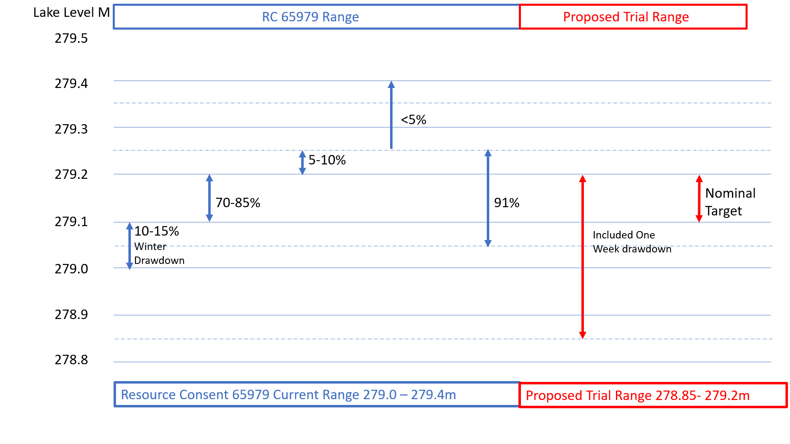Figure 1 Current and trial target lake levels
The graph in Figure 2 shows the lake level from March 2017 to April 2020. Even by applying best management practices to maintain levels within the specified consent range and inter-range bands, natural conditions can override available management tools resulting in the consent target levels not always being met. The graph shows that the upper consent limits were breached in the extremely wet spring of 2017 and the lower limits by the dry summer in 2020. Given the overriding natural conditions and extreme weather patterns occurring in recent years, the aspirational range becomes meaningless and create an added difficulty in trying to manage lake levels.
For the duration of the trial lake levels above RL279.20m will be suppressed and at lake level below RL279.10m the lake discharge will be managed in accordance with condition 7.4.i – i.e. The outflow at the Okere Gates will be equal to or greater than the inflow from the Ohau Channel. This requirement remains in place because it is essential in ensuring that flows discharging from Lake Rotorua via the Ohau Channel discharge through the gates and do not reflux beyond the end of the diversion wall back into Lake Rotoiti.
The reason for the removal of the aspirational targets is that they create an added layer of complication to the management of the lake level and natural weather patterns can override management objectives, rendering the targets unattainable.
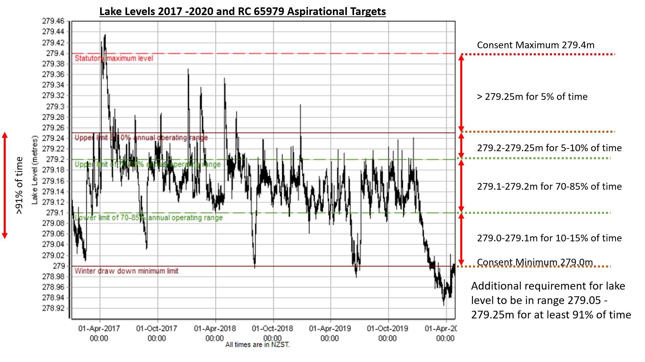
Figure 2 Lake levels 2017-2020 and RC 25979 Aspirational Targets

2.2 Lake Level Reduction Trial
Within the period after Waitangi Day (6th February) to June 30th the lake level will be drawn down to RL278.85m (150mm lower than current consent minimum) and held at that level for one week before allowing the level to return to the trail target range of 279.1- 279.2m. This will be a one off drawdown during the three years and five months trial. The one week drawdown will allow time for the community, particularly iwi, to observe and monitor the beaches and cultural sites. This will be attempted in the first autumn of the trial (from 6th February). If, due to high lake levels and/or high rainfall the drawdown cannot be achieved in first year of the drawdown will be deferred until autumn 2022 and if necessary 2023, but it will be a one off activity for one week within the trial period and will not be repeated.

During the trial, the following key guiding parameters will remain:

- Maintain Kaituna minimum flows
- The outflow through the Kaituna Gates will be equal to or greater than the inflow from the Ohau Channel.

3. Proposed Permanent Changes to RC 65979

In addition to the 3 year 5 month trial variation, BOPRC is seeking the following four permanent changes to Resource Consent: RC 65979 and one of those conditions is also contained in RC 65980.
- Removing Condition 12.2. – Resurveying the area indicates that a bund is no longer required (Operational).
- Addition of mechanical weed control to the condition 12.3 which covers weed control by the use of herbicide on two beaches (Operational).
- Removing Condition 13.1-13.5 the annual lake level drawdown to 279.0m for flushing of the Ohau Channel (Operational).
- Change to Condition 15 - The annualise reporting date from 31 August to 1 June (Administrative).

3.1 Reasons for the proposed permanent changes
3.1.1 Condition 12.2

It is proposed to removal condition 12.2 as updated survey information has determined that ground levels in the location of the bund are higher than originally thought meaning that the bund is no longer required.

12.2 Within 12 months of the commencement of this consent, the consent holder shall, subject to obtaining the written consent of the affected landowner/s, construct earth bunding at low lying properties located adjacent to the Ohau Chanel in accordance with the Application and as updated in Memorandum dated 25 November 2010 from Robbin Britton. Where the bund crosses existing open drains, flapgates shall be installed to prevent water from the Ohau Channel entering the drains. Once installed the flapgates shall be maintained by the consent holder in good working order.

3.1.2 Condition 12.3
A change to condition 12.3 is proposed due to concerns from iwi regarding the use of herbicide along the lake edge. As a result, there is a need to consider alternative methods of vegetation removal in these locations
It is proposed that the current consent condition will be removed
12.3 Within 6 months of the commencement of this consent, the consent holder shall, subject to obtaining the written consent of the landowner, apply herbicide for a maximum width of 2.0m to the landward side of beaches at Hinehopu and Ruato Bay with the objective of widening the beaches. There shall be no direct discharge of herbicide to Lake Rotoiti and the consent holder shall remove any dead vegetation resulting from the application of the herbicide. The application of herbicide shall occur at least annually thereafter, for the duration of this consent
And replaced with the following
12.3 Within 6 months from the date of this variation, the consent holder shall prepare management plan for controlling encroaching exotic weeds and grasses on the landward side of beaches at Hinehopu and Ruato Bay with the objective of widening the beaches.
The management plan shall;
a) Specify methods that will be used to control vegetation over a maximum width of 2.0 m on an ongoing basis.
b) Include the removal of any dead vegetation resulting from the control measures.
c) Be developed in consultation with the Ohau ki Rotoiti Kaitiaki Group and landowners
The management plan shall be submitted to the Chief Executive of the Bay of Plenty Regional Council, or delegate.
The consent holder shall thereafter implement the programme of control measures set out in the management plan.

3.1.3 Condition 13.1-13.5
It is proposed to delete condition 13.1 which then removes the need for subsequent conditions 13.2-13.5
The purpose of this condition was to attempt to flush sediment from the Ohau Channel by drawing down the lake level to 279.0m. This has been undertaken annually and subsequent monitoring and survey assessments indicate that the drawdown does not mobilise sediment. As the drawdown is not achieving the objective, it is proposed to remove condition 13.1 and associated conditions 13.2- 13.5 which refer to notification, management and monitoring of the drawdown.
13.1 Subject to condition 13.5, flushing of the Ohau Channel shall be carried out once a year between 1 May and 30 September as provided for and subject to the distribution in condition 7.4(b)(i)(a) and subject to condition 7.4(i). Flushing shall be undertaken by controlling Lake Rotoiti levels to fall to a level of RL 279.00m and be held at that level until rainfall allows a return to RL 279.l0m

3.1.4 Condition 15
It is proposed to change the annual reporting date from 31 August to 1 June to better align with the operational calendar. This means the reporting period will be 1 April to 31 March with the annual report due 1 June. Condition 15.1 will be reworded as below
15.1 By 31 August 1 June each year for the term of this consent the consent holder shall provide a report to the Chief Executive of the Bay of Plenty Regional Council or delegate, the Rotorua Te Arawa Lakes Operational Liaison Group and the Ohau ki Rotoiti Kaitiaki Group setting out:

4. Proposed Permanent Changes to RC 65980
Resource Consent 65980 has the same annual reporting date as RC 65980 Condition 15 and will be changed to the revised reporting date in the same way.
4.1. Condition 15
It is proposed to change the annual reporting date from 31 August to 1 June to better align with the operational calendar. This means the reporting period will be 1 April to 31 March with the annual report due 1 June. Condition 15.1 will be reworded as below;
15.1 By 31 August 1 June each year for the term of this consent the consent holder shall provide a report to the Chief Executive of the Bay of Plenty Regional Council or delegate, the Rotorua Te Arawa Lakes Operational Liaison Group and the Ohau ki Rotoiti Kaitiaki Group setting out:

5. Potential Environmental Effects
5.1 Removal of the Aspirational Target Range Consent Condition 7.4. Parts a - e).
The removal of the aspirational target range for the duration of the trial is unlikely to have more than minor adverse effects. Suppression of lake levels above RL279.2m is likely to result in lower flooding risk. At lake levels below RL279.1m the lake discharge will be managed to ensure that the outflow is equal to or greater than the inflow from the Ohau Channel. Overall, there may be a slight reduction in lake levels at the expense of levels above 279.2m, but generally the target range will be RL279.1-279.2m.

5.2 Lake Level Reduction Trial
Within the trial, the lake level will be drawn down to RL278.85m and held at that level for one week. After the one week drawdown the lake level will be allowed to return to the ‘normal’ range RL279.1m – 279.2m. This will be achieved by maintaining the lake discharge at, or just above the inflow from the Ohau Channel in accordance with the resource consent. The lake level will increase in response to rainfall in the Rotoiti catchment. When balancing catchment contribution (rainfall and spring fed) and surface water evaporation, the lake level response to rainfall is approximately 1:1, i.e. a rainfall event of 100mm will result in a 100mm increase in lake level. The proposed drawdown to RL278.85m is 250mm below the ‘normal’ target minimum. Figure 3 shows monthly rainfall at Okawa Bay for the historical average, 2019 and 2020.

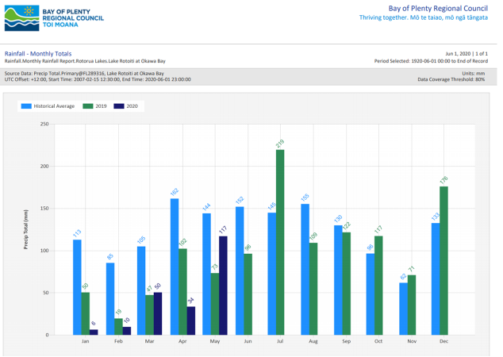
Figure 3 Rainfall Okawa Bay; Historic Average*, 2019 and 2020
*Historical Average 2007 - 2020
From these data sets, Figure 4 shows the monthly rainfall totals for the months of March to June.
Period | March | April | May | June | July | August
Historical Average | 105 | 162 | 144 | 151 | 145 | 155
2019 | 47 | 102 | 73 | 96 | 219 | 109
2020 | 50 | 34 | 117

Figure 4 Monthly Rainfall Totals
* Table constructed 1 June 2020. The 2020 June figure is the average of the historical average and 2019 value
Based on the monthly totals, after the drawdown trial, the lake would be below RL279.1m for;
- Historical Average 50 - 57 days
- 2019 84 -104 days
- 2020 114 days

A number of owners and boating organisations have raised concerns about low lake levels. Reduction in lake level can have an adverse effect on boat access to some jetties and ramps and also cause navigation issues. Effects of low water levels have been experienced recently (March 2020) when the lake level fell to RL278.93mm which is only 80mm above the target drawdown level. There will be three opportunities to draw the level down (February to June in 2021, 2022 or 2023). If levels are high in any year the drawdown will be deferred. This will reduce the duration of low levels. Concern have been raised that although the drawdown is only for one week, if there is no subsequent rainfall, the lake level will remain low. Whilst there is no guarantee of rain after the drawdown, the recovery duration based on Figure 4 will be between 50 and 102 days to return to the normal range. Boat access occur at levels below RL279.1m so the duration of limited access is likely to be less than 50 -102 days.
Figure 5 shows that historically (pre gates) the lake level fluctuated by 942mm with lake levels below the proposed target minimum (RL279.1m) for 15% of the time
Figure 5 Historic Lake Levels Pre Okere gates (1906 to 1981).
The reduction trial could have an adverse effect on the ecology of the lake, particularly in the lake margins (littoral zone) and beaches. These potential effects have been assessed by Wildlands Consultants and fisheries expert Dave Rowe. Both have made recommendations about the timing of the drawdown and these will be considered when determining the timing of the drawdown. Both experts have concluded that the effects will be no more than minor unless there is a subsequent drought but even then, the effects will be of short duration. They also noted that the trial is still within the natural pre-gates range.

5.3 Condition 12.2
It is proposed to removal condition 12.2 as updated survey information has determined that ground levels in the location of the bund are higher than originally thought meaning that the bund is no longer required. This change will have no adverse effects.

5.4 Condition 12.3
A change to condition 12.3 is proposed due to concerns from iwi regarding the use of herbicide along the lake edge. As a result, there is a need to consider alternative methods of vegetation removal in these locations. This change adds a further non-chemical option for weed management and will have no adverse effects.

5.5 Condition 13.1-13.5
It is proposed to delete condition 13.1 which then removes the need for subsequent conditions 13.2-13.5
The purpose of this condition was to attempt to flush sediment from the Ohau Channel by drawing down the lake level to 279.0m. This has been undertaken annually and subsequent monitoring and survey assessments indicate that the drawdown does not mobilise sediment. As the drawdown isn’t achieving the objective it is proposed to remove condition 13.1 and associated conditions 13.2- 13.5 which refer to notification, management and monitoring of the drawdown. This change will have no adverse effects.
5.6 Condition 15
It is proposed to change the annual reporting date from 31 August to 1 June to better align with the operational calendar. This means the reporting period will be 1 April to 31 March with the annual report due 1 June. This change will have no adverse effects.

6 Summary
The proposed permanent and short duration trial changes to the operation of the Okere gates and lake level controls resource consents will allow investigation of beaches and historic sites and streamline some of the management and reporting procedures. Although the lake level reduction trial may affect lake access for some users, these effects will be of short duration and the level reduction more closely mirrors the natural lake level fluctuation than the current managed level regime.

