Your Ref:
Our Ref: fA1205842

15 April 2020

Tēnā koe / koutou ranei
Update on Rangitāiki Floodway
Ko te tumanako, e noho hamuru nei koutou ko to whanau, i ngā taumahatanga o te wa.
Firstly can we acknowledge the difficult times we are in and we hope that you and your whanau are keeping safe and well.
The Rangitāiki Floodway project has been identified as one of the essential services that Regional Council is continuing whether at COVID-19 Alert Level 4 or when we move to Alert Level 3.
Therefore, the purpose of this letter is to update you on progress for the above project and to seek feedback on the increased cost to complete Stage 6 of the project. We will be asking:
- Do you want to continue with Stage 6 given the increased costs
- Given the increased costs for Stage 6 do you want to continue with the Spillway preferred option, being; Lower fixed crest weir with contingency gates.
In these unprecedented times we are unable to continue our regular in-person consultative approach and appreciate your understanding of the alternative options above. Your views remain important to us and we look forward to receiving your individual feedback.
Further information on Stage 6 can be found on the project page on the Bay of Plenty Regional Council website: www.boprc.govt.nz/rangitaikifloodway

Your feedback is important and we’ve attached a form for you to complete and return via email or post. Alternatively, submit your feedback using an online form here, or available via the web page. We ask that all feedback is provided by 5pm 3 May 2020.
Emailed responses to: Engineering@boprc.govt.nz

Online forms can be found at: www.boprc.govt.nz/rangitaikifloodway

Additionally we have set up two online consultation sessions. These are scheduled for 10am and 3pm on Thursday 30 April 2020. To join, you will need to register and receive your login details by emailing us at Engineering@boprc.govt.nz. You will receive a return email with a website link.
Background
The Rangitāiki Floodway is part of our network of flood protection and drainage that protects our people, property and livelihoods from flooding. The current upgrade was initiated as a result of the Edgecumbe Stopbank breaches in 2004 and 2017, which caused significant damage ($35M and $90M respectively) and brought major disruption to the Edgecumbe community.
The project is multi-staged, designed to take pressure off the flood-prone Rangitāiki River. This is achieved by increasing the capacity of the floodway thereby reducing flood levels in the Rangitāiki River upstream of Edgecumbe, to the river mouth at Okorero / Thornton.
Consent for the project was granted and work across various stages has been underway for several years. Ongoing engagement with the community and other stakeholders remains an important part of the project and we continue to provide regular updates at key points.
The project provides a number of benefits for Edgecumbe and the surrounding environment, including better protection from future flood events, reassuring the safety and future stability of its vibrant community. Several wetlands and inanga (whitebait) spawning areas were established in earlier Stages and riparian planting will be undertaken as part of Resource Consent conditions. Collectively these measures support the broader alignment of the project with key strategic and planning documents including the Rangitāiki River Document and its objectives.
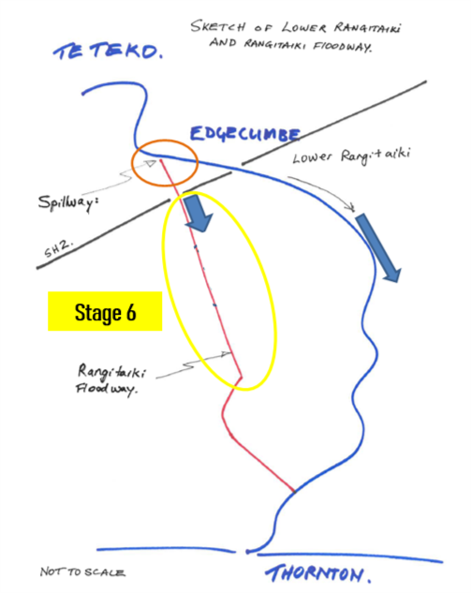
Fig 1: Sketch showing location of Rangitāiki Floodway and Stage 6
Rangitāiki Floodway Stage 6
Initially a ponding option downstream of Fonterra was being considered, to reduce the overall project costs. This option has now been abandoned as detailed designs showed it would be more expensive and yield fewer benefits than originally assessed. Accordingly, raising the stopbank is now the preferred option.
The detailed design stage for all options also showed the scale of work required, to be much greater than anticipated by previous modelling. For this reason, Stage 7 was brought forward for completion before Stage 6. As Stage 6 is significantly more complex, it required more detailed design and geotechnical testing that will inform the final design.
The final estimate for Stage 6 has now been produced and is shown in table 1 below:
Stage | LTP Cost Estimate (000) | Updated Estimate (000) | Difference (000)
6 | $ 2,428 | $ 10,915 | $ 8,487
Table 1: Cost increase for Rangitāiki Floodway Stage 6
It is acknowledged that this is a substantial increase and it is important to get your feedback on the cost increase for Stage 6.
Rangitāiki Floodway Spillway
During 2018 consultation was undertaken within the local community on options for the spillway design. The proposed option was for a lower fixed crest weir with contingency radial gates and was generally supported at the culmination of the consultation on 24th November 2018.
The option that had been prepared prior to this consultation taking place in the Long Term Plan (LTP) was for a lower fixed crest weir with no contingency allowance.
Table 2 below shows the increase in cost for the Spillway.
Stage | LTP Cost Estimate – Lower Fixed Crest Weir  (000) | Lower Fixed Crest Weir with contingency gates (000)
Spillway | $ 0.360 | $ 2,800
Table 2: Rangitāiki Floodway Spillway Cost Comparison
Given the increased cost in Stage 6 we felt it was important to re-confirm with the local community that the lower fixed crest weir with contingency gates was still the preferred option, see question 6 on the survey form.
Impact on Rates
Attached to this letter are some examples of different property types and the impact the above proposals will have on rates. Please review these before filling out the feedback form referenced near the top of this letter.
Crown Infrastructure Partners (CIP) Funding
Central Government has announced a stimulus package to assist economic recovery following removal of Covid-19 restrictions. We have put the Rangitāiki Floodway project up as a “spade ready” project that Central Government could help fund. If successful, the increased costs outlined in this letter could be offset by the CIP funding. We will not know the outcome from our application for some weeks, but will inform you of the outcome as soon as we hear.
Naku noa, na

Mark Townsend
Engineering Manager

