**Te Runanga o Ngāti Awa**

**Context**

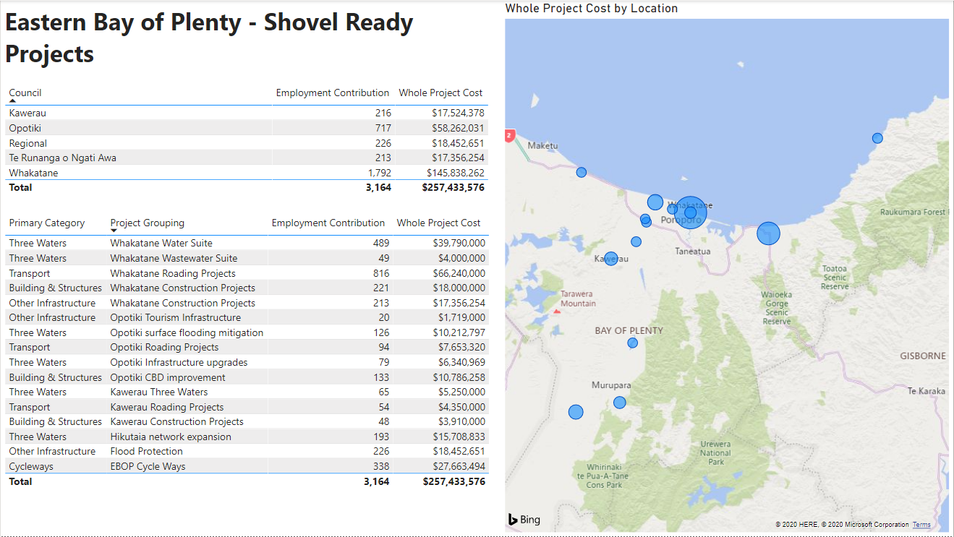

**Ngāti Awa Projects**

