Bay of Plenty Regional Council
Context
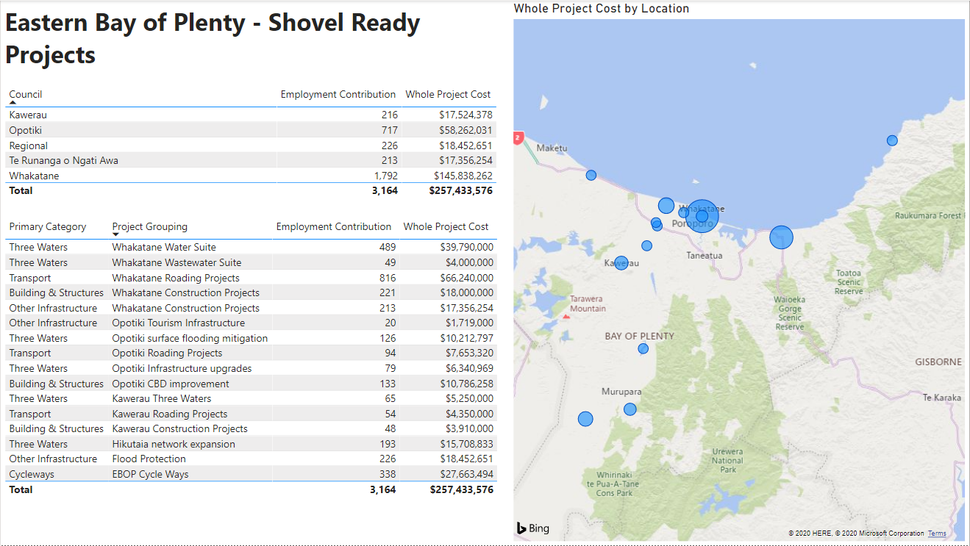

Regional Projects

