2019-2020 Post Sampling report on Charybdis japonica in the Bay of Plenty Region

Prepared for the Bay of Plenty Regional Council
February 2020

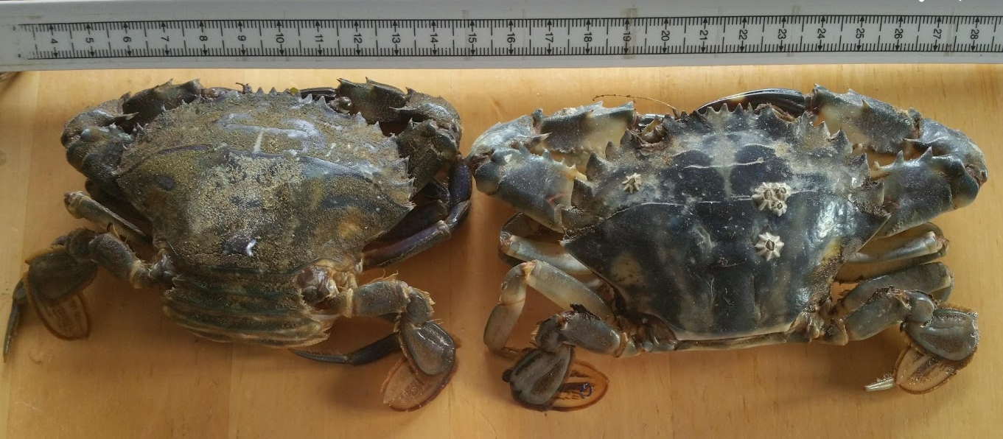

Table of Contents

1. Purpose of this document 1
2. Charybdis japonica overview 1
3. Background and previous effort 2
4. Trapping methods 3
5. Results overview 2019/2020 period 4
6. Trapping Location Maps 4
7. Discussion 10
8. Manaaki Te Awanui 10
9. References 11
10. Appendix 12

Figure 1: Summary of previous Charybdis caught 2
Figure 2: Traps used for sampling 3

Purpose of this document
To provide the Bay of Plenty Regional Council (BOPRC) with the results of the 2019/2020 delimiting survey designed to establish the existing boundaries of Charybdis japonica within the Bay of Plenty Region and to provide an indication of the level of infestation that can be compared to previous years on an effort vs result basis

Charybdis japonica overview

The coastal marine environment within the Bay of Plenty provides significant economic, social and cultural benefits to the region. With some 259 km of open coastline, including numerous offshore islands, three sizable harbours (Tauranga, Whakatane and Ohiwa), estuaries of various size, areas of rocky coastline and extensive stretches of sandy open coast. The Bay of Plenty coastal habitats are diverse and support a high level of biodiversity (see: https://www.boprc.govt.nz/our-region-and-environment/land/biodiversity-programme/). Some of the regions, habitats and associated biodiversity is protected within the Tuhua and Te Paepae o Aotea Marine Reserves.
Charybdis japonica (A. Milne-Edwards, 1861) (hereon Charybdis) was first detected in Waitemata Harbour, New Zealand by commercial fisherman in September 2000 (Webber 2001), and has since spread throughout the Waitemata Harbour and into Northland (see: https://marinebiosecurity.org.nz for current distribution). Charybdis is a portunid (swimming) crab, which grows up to 110mm carapace width (Fowler and McLay 2013). Charybdis are omnivorous feeders in their native range, feeding on a diverse range of crustaceans, bivalves fish and shrimp (Fowler et al. 2011). New Zealand has only one species of native portunid crab of similar size Ovalipes catharus (hereon Ovalipes) (Gust and Inglis 2006; Townsend et al. 2015; Wong et al. 2016). Ovalipes occupy similar estuarine habitats as Charybdis during two vulnerable stages in their life cycles; Juvenile and reproductive stages (Wear, 1984; Osborne, 1987). Charybdis pose a serious threat to Ovalipes through predation and competition (Fowler and McLay 2013; Townsend et al. 2015).
In its native range of East Asia, adult Charybdis are able to acclimate to a wide range of salinities (30 – 14 ‰) and temperatures (4 to 34 °C) (Gust & Inglis 2006; Hong-Yu et al. 2008). Similarly, Fowler et al (2010) have empirically shown that the larvae of Charybdis also tolerate a broad range of temperatures and salinities (11 to 43 °C and 5 to 45 ‰ respectively), illustrating that the abiotic conditions within the Bay of Plenty are well suited to this invader. Charybdis has the potential to spread via natural and human mediated vectors. Natural dispersal is facilitated by ocean currents and the ability for the mobile larvae to spend ≥ 40 days in plankton (Yatsuzuka 1952); Human mediated spread is facilitated by the myriad of commercial and recreational marine uses (e.g. ballast water and hull fouling (Gust and Inglis 2006).
Charybdis is a highly fecund species, reaching reproductive maturity within a year at a carapace width of between 45.4 – 54.0 mm, and produce in excess of 400,000 eggs (Fowler and McLay 2013). Furthermore, research within Charybdis’ natural range have shown that a female can produce three broods per year (Kim 2001). The lifespan of female Charybdis is 4 years in its native region, so it can be surmised that a single female has the potential of producing up to 4 millions eggs in a lifetime. Their reproduction is dependent on the females’ condition, as males contain spermatozoa year-round (Wong 2015). Research within New Zealand shows that mating begins in early spring and spawning begins late spring and continues for around 5 months (Wong and Sewell 2015; Fowler 2011). Tauranga harbour offers favourable substrate types and conditions for Charybdis and given Charybdis’ environmental plasticity and fecundity, an established population here could become a source population to further its invasion into other areas within the Bay of Plenty and further South.

Background and previous effort
During the biannual Marine High Risk Site Surveillance (MHRSS) summer survey of Tauranga harbour, conducted by NIWA and funded by the Ministry for Primary Industries, two mature Charybdis (one male and one female) were found in a single crab trap south of the Matapihi railway bridge -37.69119 S, 176.17571 E. This was the first detection of this invasive species in Tauranga Harbour and represented a southern range extension.
In response to this initial find by NIWA, the BOPRC initiated a delimiting survey to be carried out by the University of Waikato’s Coastal Marine field station which was conducted between 07/04/18 & 20/02/19. 197 locations were sampled within the southern harbour between the Bridge Marina and Maungatapu bridge yielding just one female caught (In berry). A further 23 locations were sampled in the northern section of the harbour encompassing Bowentown, Tanners Point, Ongare and Kauri Point with none found in this region.
NIWA also conducted further sampling effort to establish the extent of the infestation. Summarised results of catch in the 2018/2019 period are shown in Figure 1.
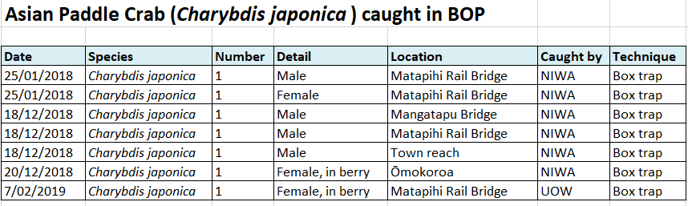
Figure 1: Summary of previous Charybdis caught

Trapping methods
Baited Crab traps were used to sample mobile crabs and other small epibenthic scavengers (Figure 2). Traps consisted of a weighted (~ 3kg) collapsible trap 60 x 45 x 20cm with 1.4 cm square mesh netting. Traps were baited with pilchards contained within a small snifter pot suspended within the trap. The traps are designed so the attracted organisms enter through slits in inward sloping panels at each end. Traps were deployed in pairs, 2m apart on a single line and float. Trap soak time was approximately 24hrs. Depths were also recorded to establish any patterning in regard to depth.

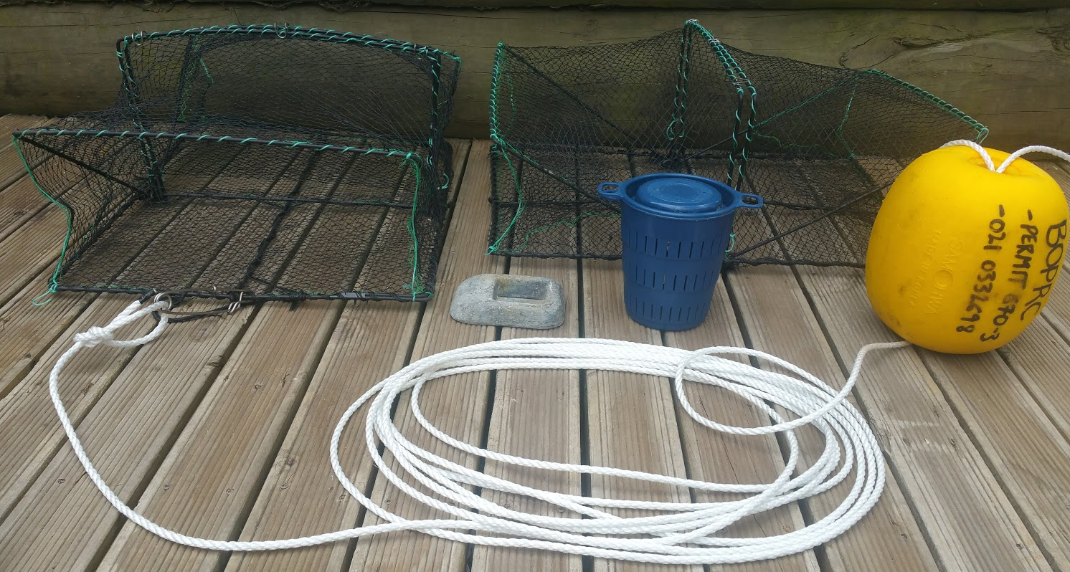
Figure 2: Traps used for sampling

Results overview 2019/2020 period

Over the survey period (05/11/19 – 05/02/20) a total of 723 traps were set targeting four general geographical locations resulting in a total of 44 crabs removed. See appendix for full dataset. The four locations designated for survey and their consequent results are summarised below;
- Southern harbour- Between Matapihi Rail bridge and the Maungatapu bridge area (246 Trap sets, 11 Charybdis removed)
- Central harbour- Omokoroa Peninsula and Te Puna estuary (299 Trap sets, 25 removed)
- Northern harbour- Bowentown, Tanners Point, Matakana, Ongare and Kauri Point. (90 Trap sets, 6 Charybdis removed)
- Ohiwa harbour- (88 Trap sets, 2 Charybdis removed)

A significant increase in numbers caught to trap effort was observed in all locations and a new southern range for the species was established at Ohiwa harbour.

No pattern in regard to depth was apparent with Charybis being caught in both shallow (1.2m) and deeper waters (6.1m) which represent the range of depths covered in this survey

Of the 44 individuals collected, 68% (30) were male (5 juveniles), 32% (14) were female. Of the 14 females, one was juvenile. 71% (10) were mature females in berry.

Carapace width ranged from 25mm (Male, West Omokoroa) to 95mm (Male, Southern Harbour) The largest average size per location was in the southern Harbour location (80.83mm) All juveniles were caught in the Central harbour location indicating a newer cohort in this area.

Trapping Location Maps
Pins represent trap pairs soaked. Red pins indicate Charybdis found

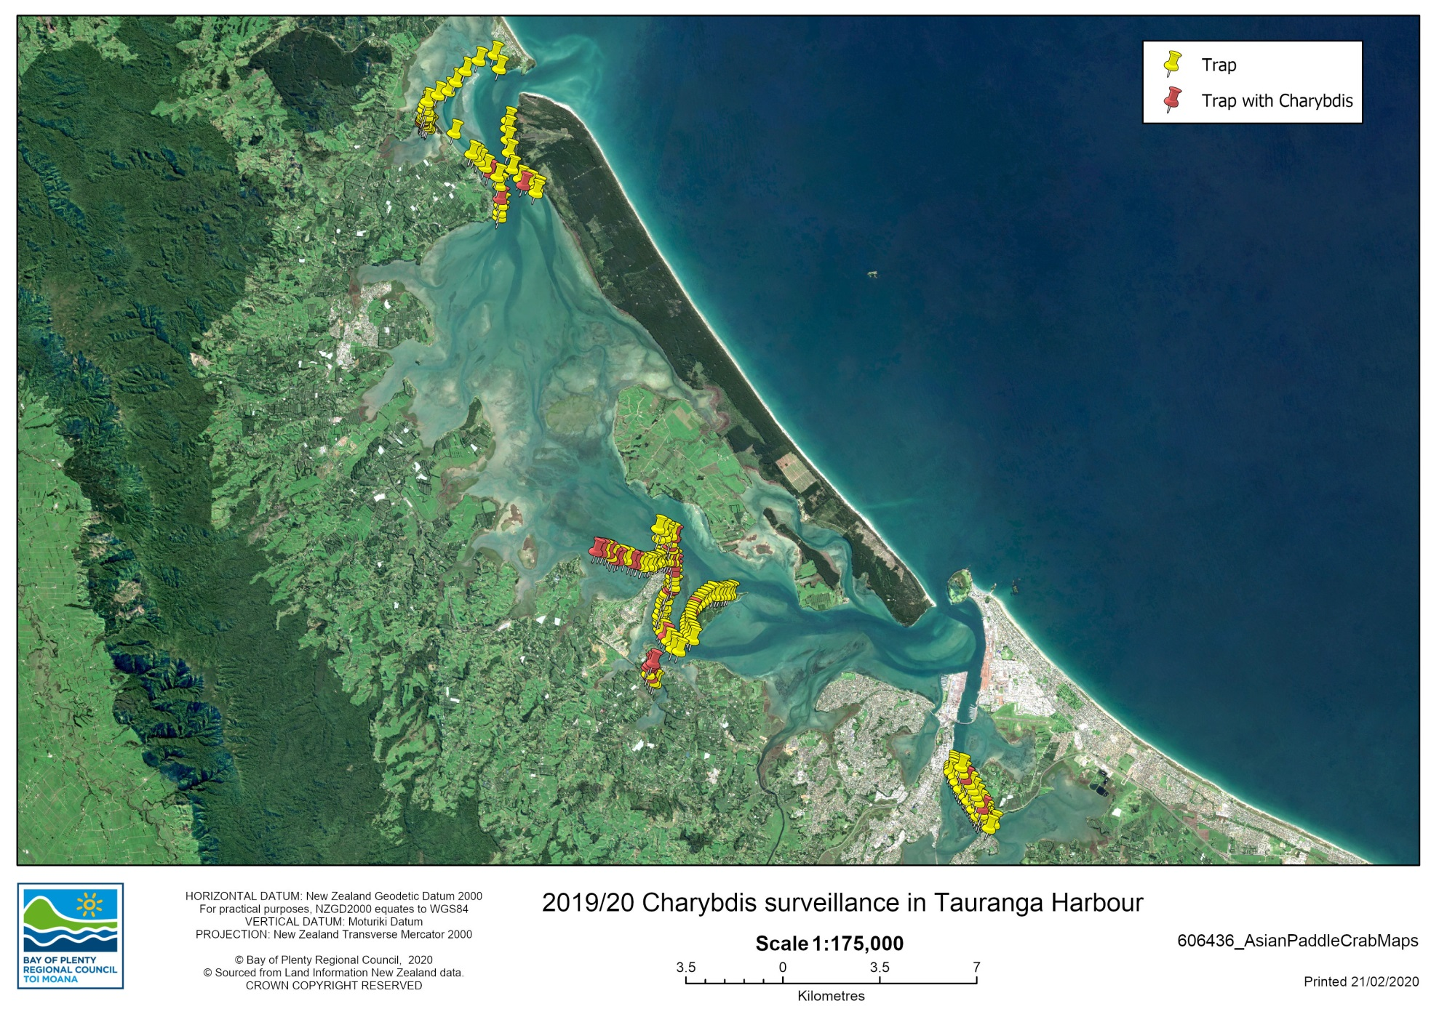
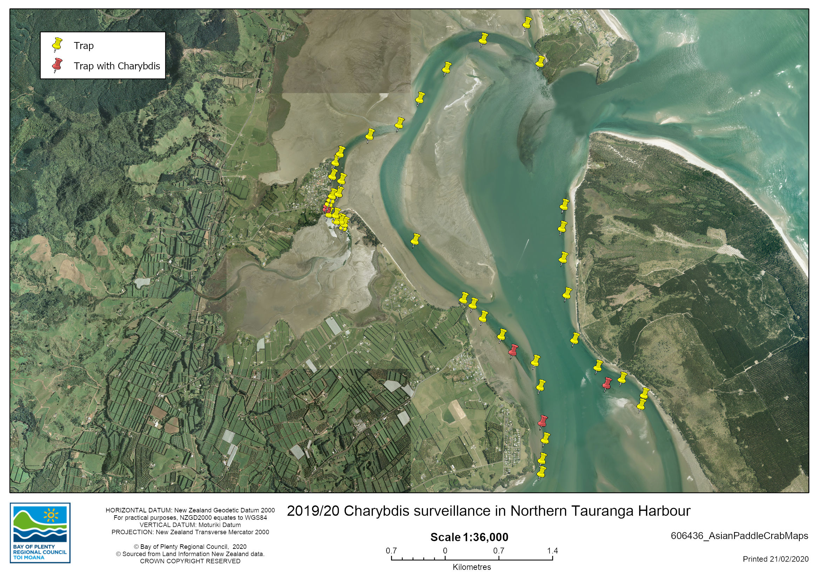
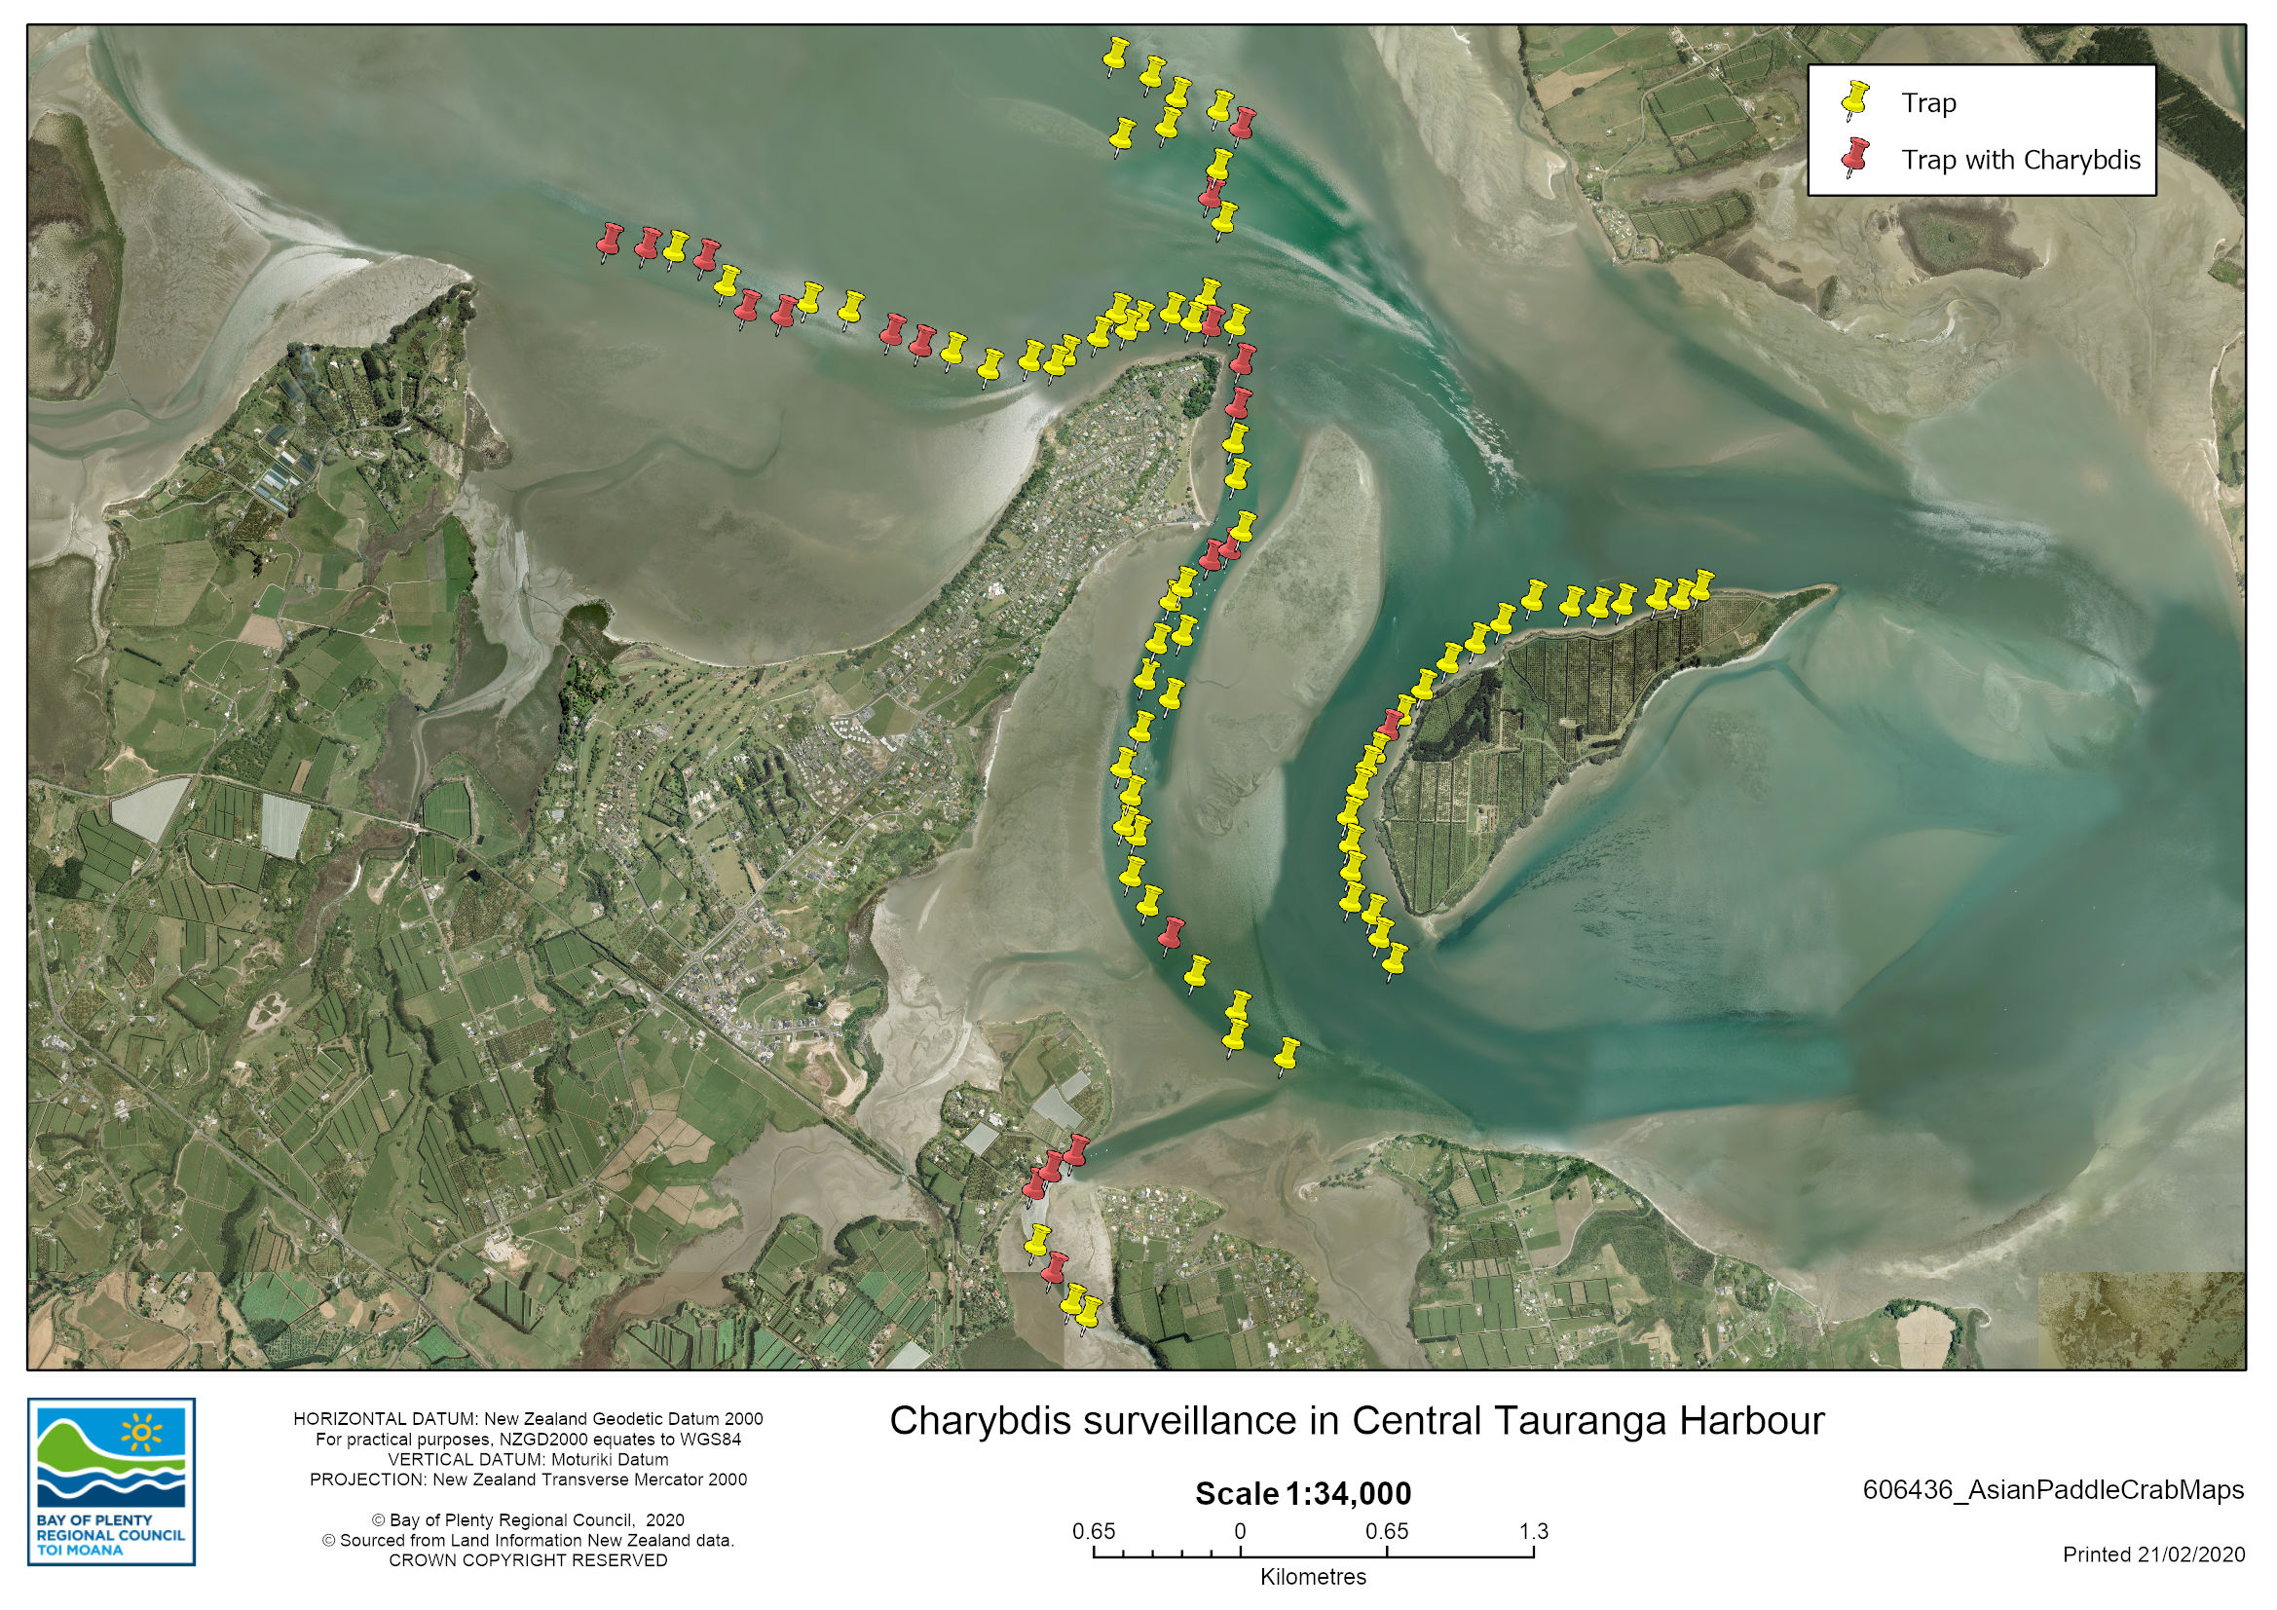
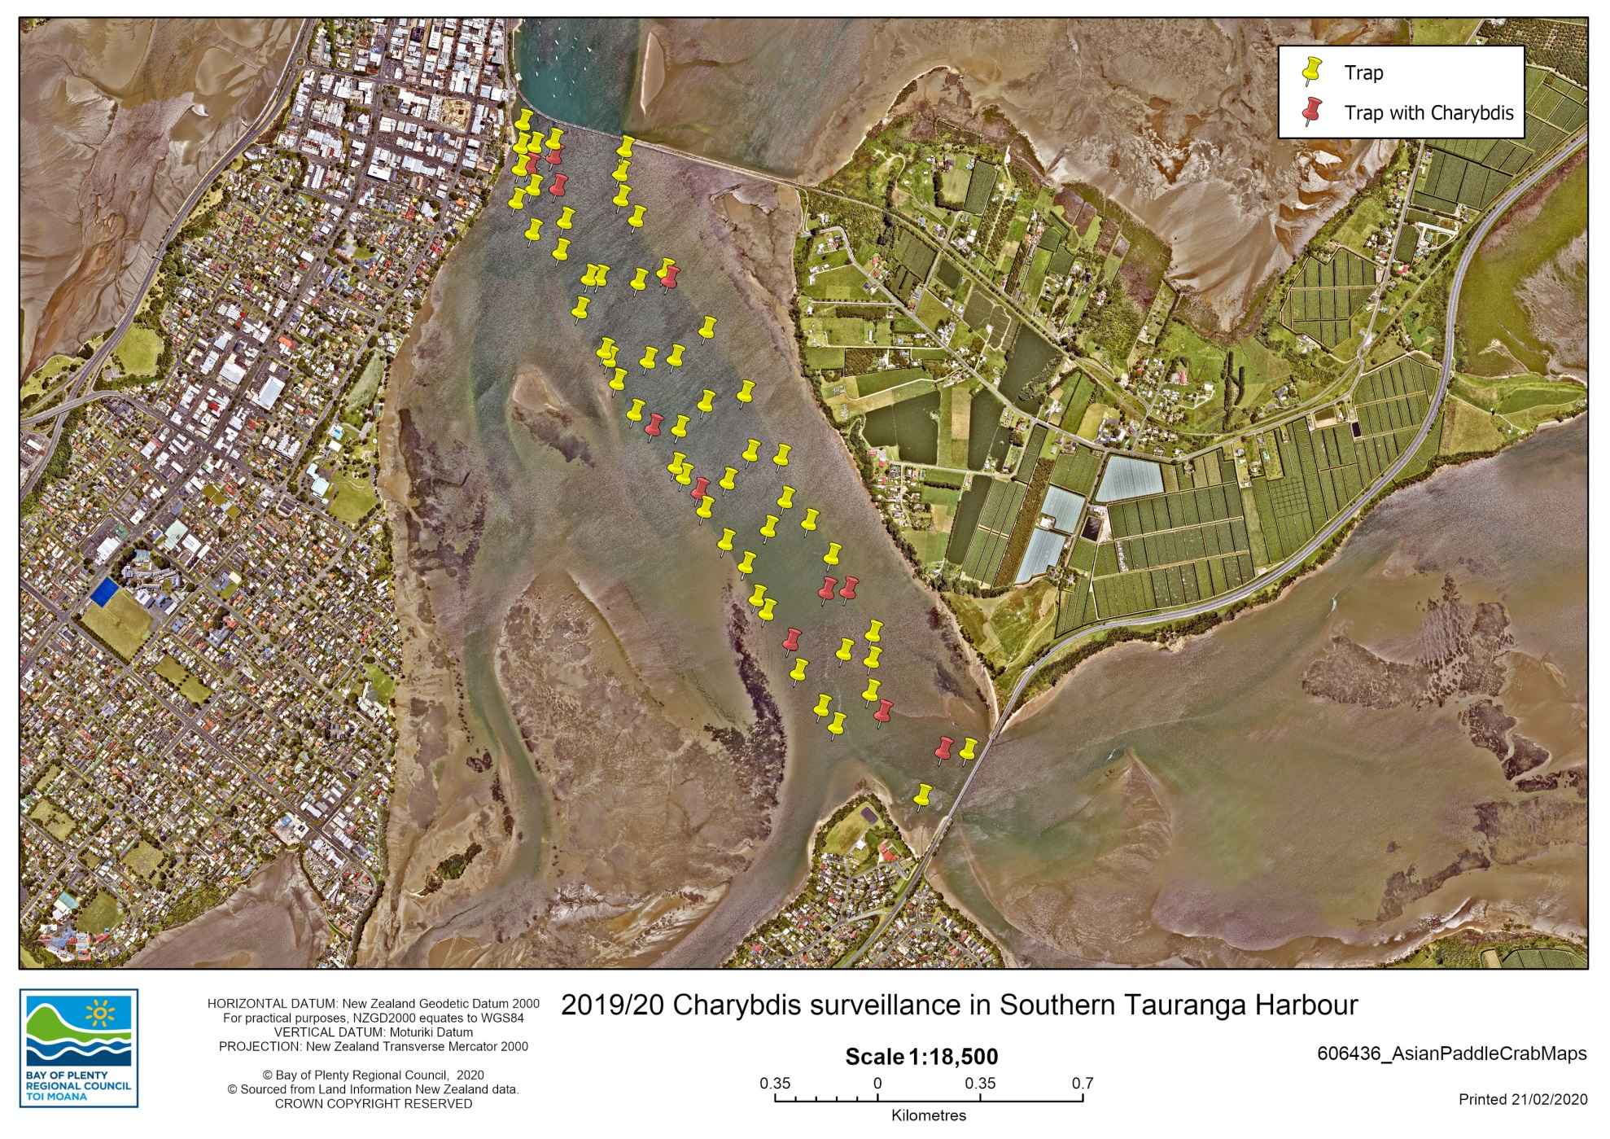
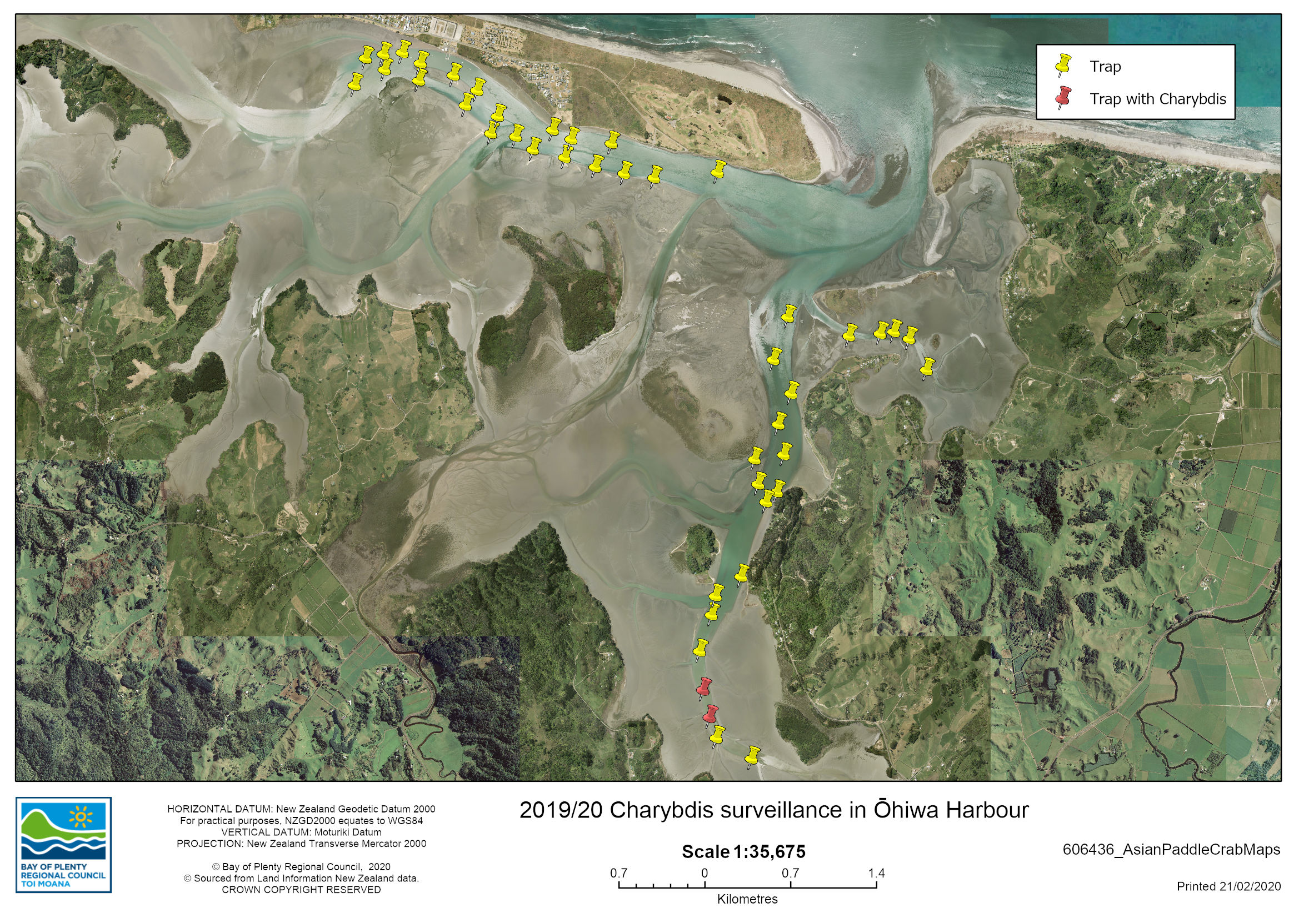

Discussion

The continued spread of Charybdis down the East coast of the North Island, as evident by the discovery in Ohiwa Harbour may indicate that the spread of Charybdis may be via larval dispersion “leap-frogging” between harbours rather than through infected vessel movement. This restricts the ability to contain the species using current vessel monitoring methods. It is unlikely that trapping alone will reduce the population to a manageable level in the BOP region given the extensive area of suitable habitat available, particularly in Tauranga Harbour. Charybdis are highly fecund species and eradication efforts historically worldwide have been unsuccessful.

Manaaki Te Awanui

Manaaki Te Awanui are exploring options for trialling matauranga Maori based trapping methods. The Bay of Plenty Regional Council have supplied Box traps to Kiamai Ellis as part of this trial work and are keen to support them as much as possible in this work. Manaaki Te Awanui were also looking into holding a Wanaga related to Charybdis.

References

Fowler, A.E., Gerner, N.V. & Sewell, M.A. (2011). Temperature and salinity tolerances of Stage 1 zoeae predict possible range expansion of an introduced portunid crab, Charybdis japonica, in New Zealand. Biological Invasions, 13, 691-699.
Fowler, A.E. and C.L. McLay (2013) Early stages of a New Zealand invasion by (A. Milne-Edwards, 1861) (Brachyura: Portunidae) from Asia: population demography. 224-234.
Gust, N. & Inglis, G.J. (2006). Adaptive Multi-scale Sampling to Determine an Invasive Crab’s Habitat Usage and Range in New Zealand. Biological Invasions, 8, 339-353.
Hong-Yu, L., Lu-Qing, P. & Debin, Z. (2008). Effects of Salinity on Biogenic Amines, Hemolymph Osmotic Pressure, and Activity of Gill’s Na+/K+-ATPase in Charybdis japonica (Crustacea, Decapoda). Journal of the World Aquaculture Society, 39, 812-820.
Kim, K.B., (2001). Growth and Reproduction of Charybdis japonica (A. Milne! Edwards) (Decapoda: Portunidae) in Korean Waters, Ph.D. Thesis, Department of Marine Biology, Graduate School, Pukyong National University, Pusan, Korea.
Milne-Edwards, A. (1861) Etudes zoologiques sur les Crustacés récents de la famille des Portuniens. Archives du Muséum d'Histoire naturelle, Paris 10, 309–430, pls 28–38.
Osborne, T., (1987). Life history and population biology of the paddle crab, Ovalipes catharus. Ph.D. thesis. University of Canterbury, Christchurch, New Zealand.
Townsend, M., Lohrer, A.M., Rodil, I.F. & Chiaroni, L.D. (2015). The targeting of large-sized benthic macrofauna by an invasive portunid predator: evidence from a caging study. Biological Invasions, 17, 231-244.
Wear, R. G., (1988). Paddle crab fishery has potential in NZ. Catch 15, 11.
Webber, R. (2001). Space invaders, crabs that turn up in New Zealand unannounced. Seafood New Zealand November 2001: 80-84.
Wong, N. A., Sewell, M. A., (2015). The reproductive ecology of the invasive Asian paddle crab, Charybdis japonica (Brachyura: Portunidae), in northeastern New Zealand. Invertebrate Biology 134(4), 303-317.
Wong, N., Tooman, L., Sewell, M., Lavery, S., (2016). The population genetics and origin of invasion of the invasive Asian paddle crab, Charybdis japonica (A. Milne-Edwards, 1861) (Brachyura: Portunidae) in northeastern New Zealand. Marine Biology 163(6), 1-13.
Yatsuzuka, K. (1952). The metamorphosis and growth of the larva of Charybdis japonica A. Mine Edward. Bull. Japanese Soc. Sci. Fish., 17, 17-22.

Appendix

