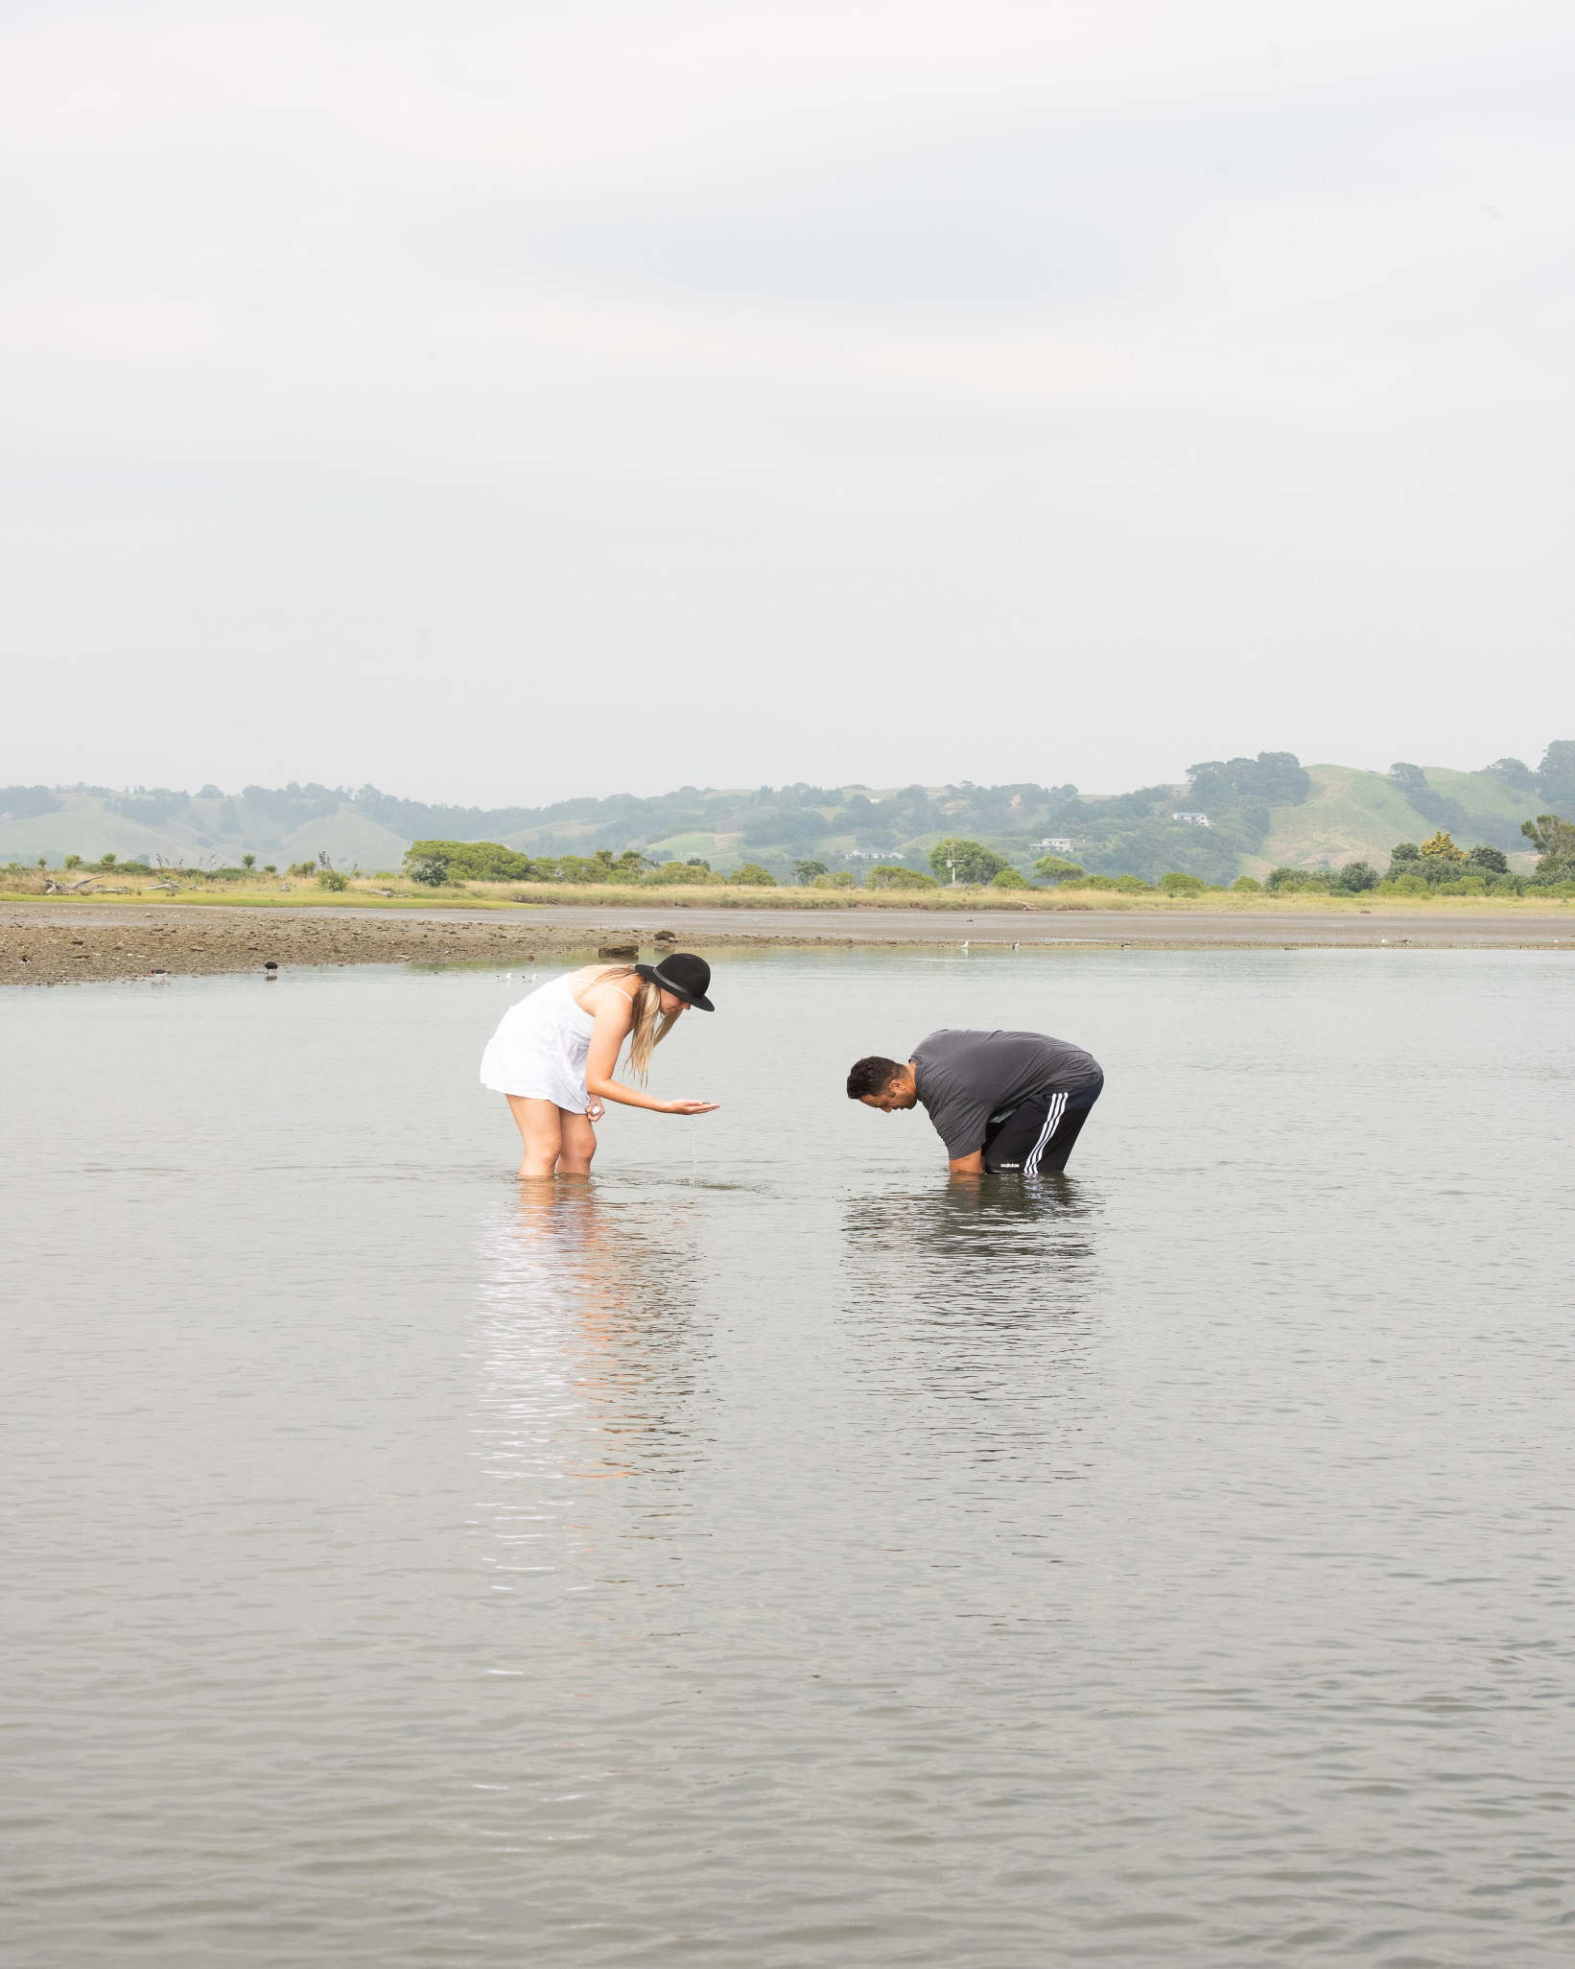

He Toka Tū Moana – Toi Moana Environmental Scholarship

Application Form 2020

Applicant Details
First Name(s): _________________________________________________________
Family Name(s): _________________________________________________________
Date of Birth: _________________________________________________________
Current Address: _____________________________________________________________
Mailing Address: _____________________________________________________________
Phone: Day: _______________ _________________Night:___________________________
Email: ______________________________________________________________________

Brief Proposal
In one page or less tell us who you are (include your whakapapa or connection to the Bay of Plenty and any past or current community involvements), what you are studying, how your study aligns with the enhancement of our taiao (environment) and why you’ve applied for the He Toka Tū Moana – Toi Moana Environmental Scholarship.

_____________________________________________________________________ _____________________________________________________________________ _____________________________________________________________________ _____________________________________________________________________ _____________________________________________________________________ _____________________________________________________________________ _____________________________________________________________________ _____________________________________________________________________ _____________________________________________________________________ _____________________________________________________________________

Character Reference (optional)
Please have referee complete here or, attach a separate document with the required details.
I confirm that I have known______________________________________for____years.
I recommend that this applicant be awarded the He Toka Tumoana Scholarship for the following reasons:

Signature: ___________________________________Date:
Name: __________________________________________________________________
Relationship to applicant (eg. tutor, employer, coach, kaumātua, etc.): _______________________
Phone number:_______________________________________________________________

Conditions
- Successful scholarship recipients are expected to attend Toi Moana Bay of Plenty Regional Council Komiti Māori upon invitation to formally receive award.
- Scholarship recipients agree that the Toi Moana Bay of Plenty Regional Council may include details of the recipient holder for promotional purposes.
- Applicants will be notified of outcome via email no later than Friday 12 June 2020
- Applicants consent to the Council contacting the named referee
- All applications must be submitted no later than 4pm 22 May 2020. Late scholarship submissions will not be accepted
- In accordance with the Privacy Act, all the information provided in this application will be used in the assessment of an applicant for a scholarship.
I ______________________________ have read and understood the above conditions and declare that all information provided is full and true to the best of my knowledge.

Signature:_________________________________________ Date:_______________

Checklist
Please ensure the following support documents are attached with your completed application:
☐ Curriculum vitae (CV) – Strictly two pages or less
☐ Proof of enrolment (or intention to enrol) in study, training and or research programme
☐ Proof of NZ residency – valid form of identification
☐ A completed character reference letter (optional)

Applications close on 22 May 2020 at 4pm
Complete online application form or download and send to one of the following:

Email: Michelle.Hingston@boprc.govt.nz

Post: He Toka Tu Moana – Environmental Scholarship Fund
Bay of Plenty Regional Council
P.O Box 364, Whakatāne

Deliver to a Toi Moana – Bay of Plenty Regional Council office:
Tauranga - 87 First Avenue
Mount Maunganui - 6 Rata Street
Whakatane - 5 Quay Street
Rotorua - 1125 Arawa Street

