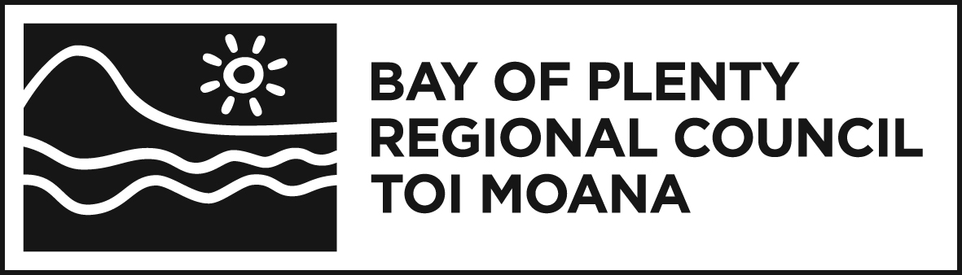
MEMORANDUM

To: | Namouta Poutasi
 | General Manager, Strategy and Science
From: | Julie Bevan | Date: 17 December 2019
 | Policy and Planning Manager
File Ref: | A3452582
Subject: | 2019 Progress Report on Bay of Plenty Regional Council’s Staged Programme for Implementing the National Policy Statement for Freshwater Management 2014 (as amended 2017)

- Introduction
The National Policy Statement for Freshwater Management 2014 (as amended in 2017) (NPSFM) requires Bay of Plenty Regional Council (Council) to publicly report, in every year, on the extent to which Council has implemented its staged NPSFM implementation programme. This is reported below, will be included on Bay of Plenty Regional Council’s website, and the Ministry for the Environment will be notified.
- Background
In December 2018, Council adopted an amended staged NPSFM implementation programme as shown in Figure 1. This is publicly available on the Bay of Plenty Regional Council website.

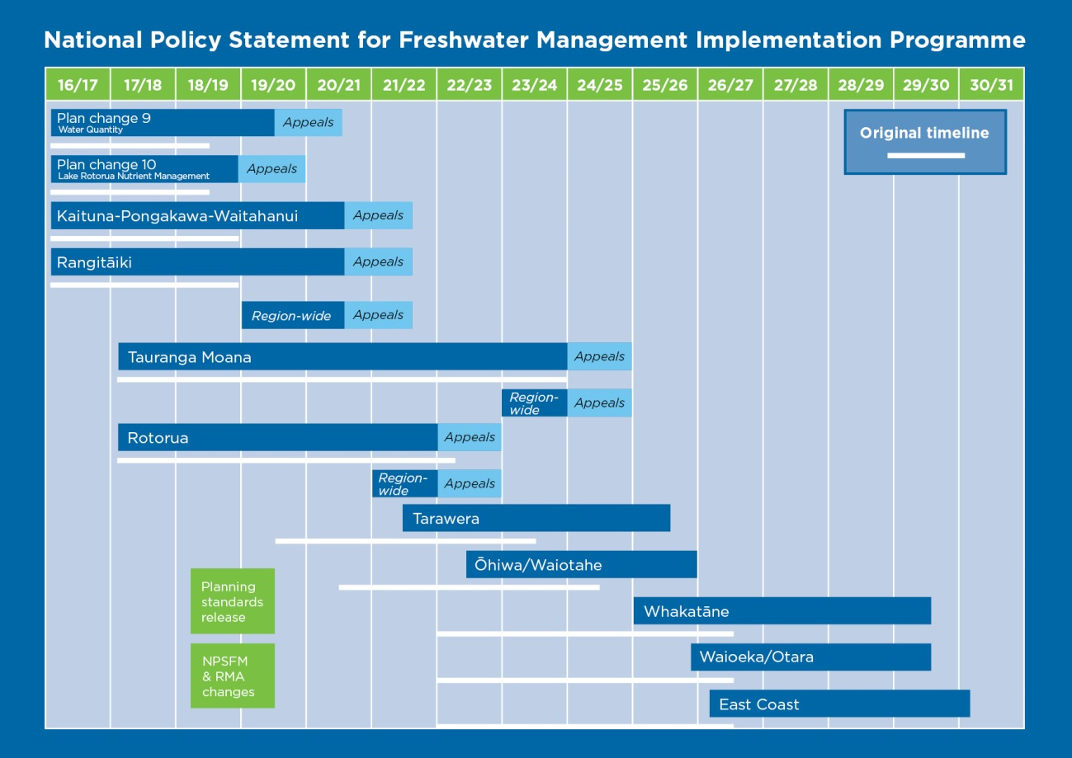
Figure 1: Bay of Plenty Regional Council’s NPSFM implementation timetable
- Pending changes to the NPSFM
Central government intends to gazette a new NPSFM in July 2020. By this time some initial amendments to the RMA may also be enacted. In response, it is likely that Council will need to adopt a new NPSFM implementation programme. The Strategy and Policy Committee will discuss preliminary planning about these changes early in 2020.
- Implementation Progress in 2019
The following table provides a summary of progress relative to the publicly notified programme. Green highlight indicates implementation is on track. Orange indicates delays.
Task/stage | Progress | Scheduling implication
Region Wide Water Quantity Plan Change (Proposed Plan Change 9)
Environment Court Appeals | Environment Court mediation held 4, 5 and 16 December 2019. Further mediation scheduled 13-14 December. | On track to resolve appeals before mid-2021.
Lake Rotorua Nutrient Management (Proposed Plan Change 10)
Environment Court Appeals | Court led mediation is proceeding. Council will report to Court in February 2020. Second phase of hearings yet to be scheduled. | On track to resolve appeals by mid-2020
Implementation | Land owners are progressing nutrient management plans and reductions.
Kaituna-Pongakawa-Waitahanui and Rangitāiki Water Management Areas (Pre-draft Plan Change 12)
Pre-draft plan change work | Working draft values, narrative and measurable objectives prepared. Issues identified.  Groundwater modelling complete.  Good practice and potential future scenarios assessed.  Sources/causes and management options analysis progressing.  Ongoing engagement with community groups, and co-governance fora continues.
Pre-draft plan change work | Surface water quantity methodology confirmed. Data being collated. Community Group engagement early 2020.  Surface water quality modelling delays as further data and sensitivity testing required. | Anticipate resolving and completing prior to June 2020 (6 month delay compared to schedule)
Draft plan change and engagement | Drafting discussion documents for public engagement.  Plan drafting to be initiated shortly.  Community and iwi/hapū engagement will then progress. | Draft plan change engagement may occur prior to June 2020, subject to decisions about changes to the implementation programme in response to NPSFM 2020
Proposed plan change | Not yet initiated. | This may occur in late 2020, subject to changes needed, and decisions about implementation programme changes, in response to NPSFM 2020. One option may be to hold off notification until 2023 and to deliver one plan change for the whole region.
Rotorua and Tauranga Water Management Areas
Preliminary data gathering and project setup. | Well progressed. | Subject to decisions about changes to the implementation programme in response to NPSFM 2020.
Action plans as required under operative RNRP | Action plans and the lakes management program are well advanced. Gaps analysis work completed. This work will inform future plan changes.
Region wide
Developing meaningful relationships and engagement with Maori | Discussions with iwi representatives continue to advance in Rangitāiki and in Kaituna-Pongakawa-Waitahanui. However, several iwi have clearly expressed expectations that Council will demonstrate more clearly how it intends to involve iwi in freshwater management planning going forward. | An updated relationships and engagement plan is being developed for 2020 onwards.
Groundwater accounts | Groundwater accounts were automated in 2018. | Streamlines future processes and discussions around groundwater.
Groundwater and surface water data | Data improvements continue. | Significantly improved confidence in accounts for the region.
Surface water quantity accounts | This work is progressing well with preliminary scripts built. | Provides new analytical capabilities that substantially reduce manual calculations. Time and cost savings for future WMAs. Will benefit consents and industry.
Metering | New systems and standards now in place with continually improving records. | With time, will provide a more robust dataset for policy analysis.
Giving effect to National Planning Standards | All changes to the operative RPS and RNRP that can be made without a plan change. | Complete by mid-2020
Primary contact / recreational bathing sites | Primary Contact site inventory and map being prepared. | Complete by mid-2020
Outstanding Freshwater Bodies | Methodology to be progressed in 2020 for the whole region. | Outstanding Freshwater Bodies based on ecological values will be identified by mid-2020. Other values will be progressively added.

Prepared by Nicki Green, Principal Advisor
and James Low, Water Policy Manager

