

**Tauranga Harbour Navigational Safety Management System**

Report Number: 14NZ310

Issue: 1

February 2015

Bay of Plenty Regional Council

5 Quay Street

PO Box 364

Whakatāne 3158

NEW ZEALAND

*Prepared by: Marico Marine NZ Ltd for Bay of Plenty Regional Council*

Document information

Bay of Plenty Regional Council

Port and Harbour Navigational Safety Management System

Prepared for: Bay of Plenty Regional Council

6 Rata Street

Mt Maunganui

Tauranga

Checked by: Gianis Priovolos

Marico Marine NZ

11th Floor

156 Willis Street

Wellington, 6011

(04) 917 4959

|  |  |  |  |  |  |  |
| --- | --- | --- | --- | --- | --- | --- |
| **Document record** | | | | | **Approval** | |
| **Rev** | **Date** | **Description** | **By** | **CHK** | **HBMR** | **Sign** |
| HBR_001 Rev A | 2009 | Development of Draft to Preliminary Issue 1  Document BOPRC HB1 001 | S Kopp J Riding | J Riding | CM | C Magazinovic |
| HBR_02  Issue 1 | 2015 | Development of 2015 Issue  1 A | J Riding | GP | PB | P Buell |
| Issue 1 | 2016 | Annual review.  Risk assessment migrated from Navman II to Quantate and documents updated an filed in objective | P Buell  C Isherwood | PB | PB | P Buell |
|  |  |  |  |  |  |  |
|  |  |  |  |  |  |  |
|  |  |  |  |  |  |  |
|  |  |  |  |  |  |  |
|  |  |  |  |  |  |  |
|  |  |  |  |  |  |  |

Components of the Navigational Safety Management System

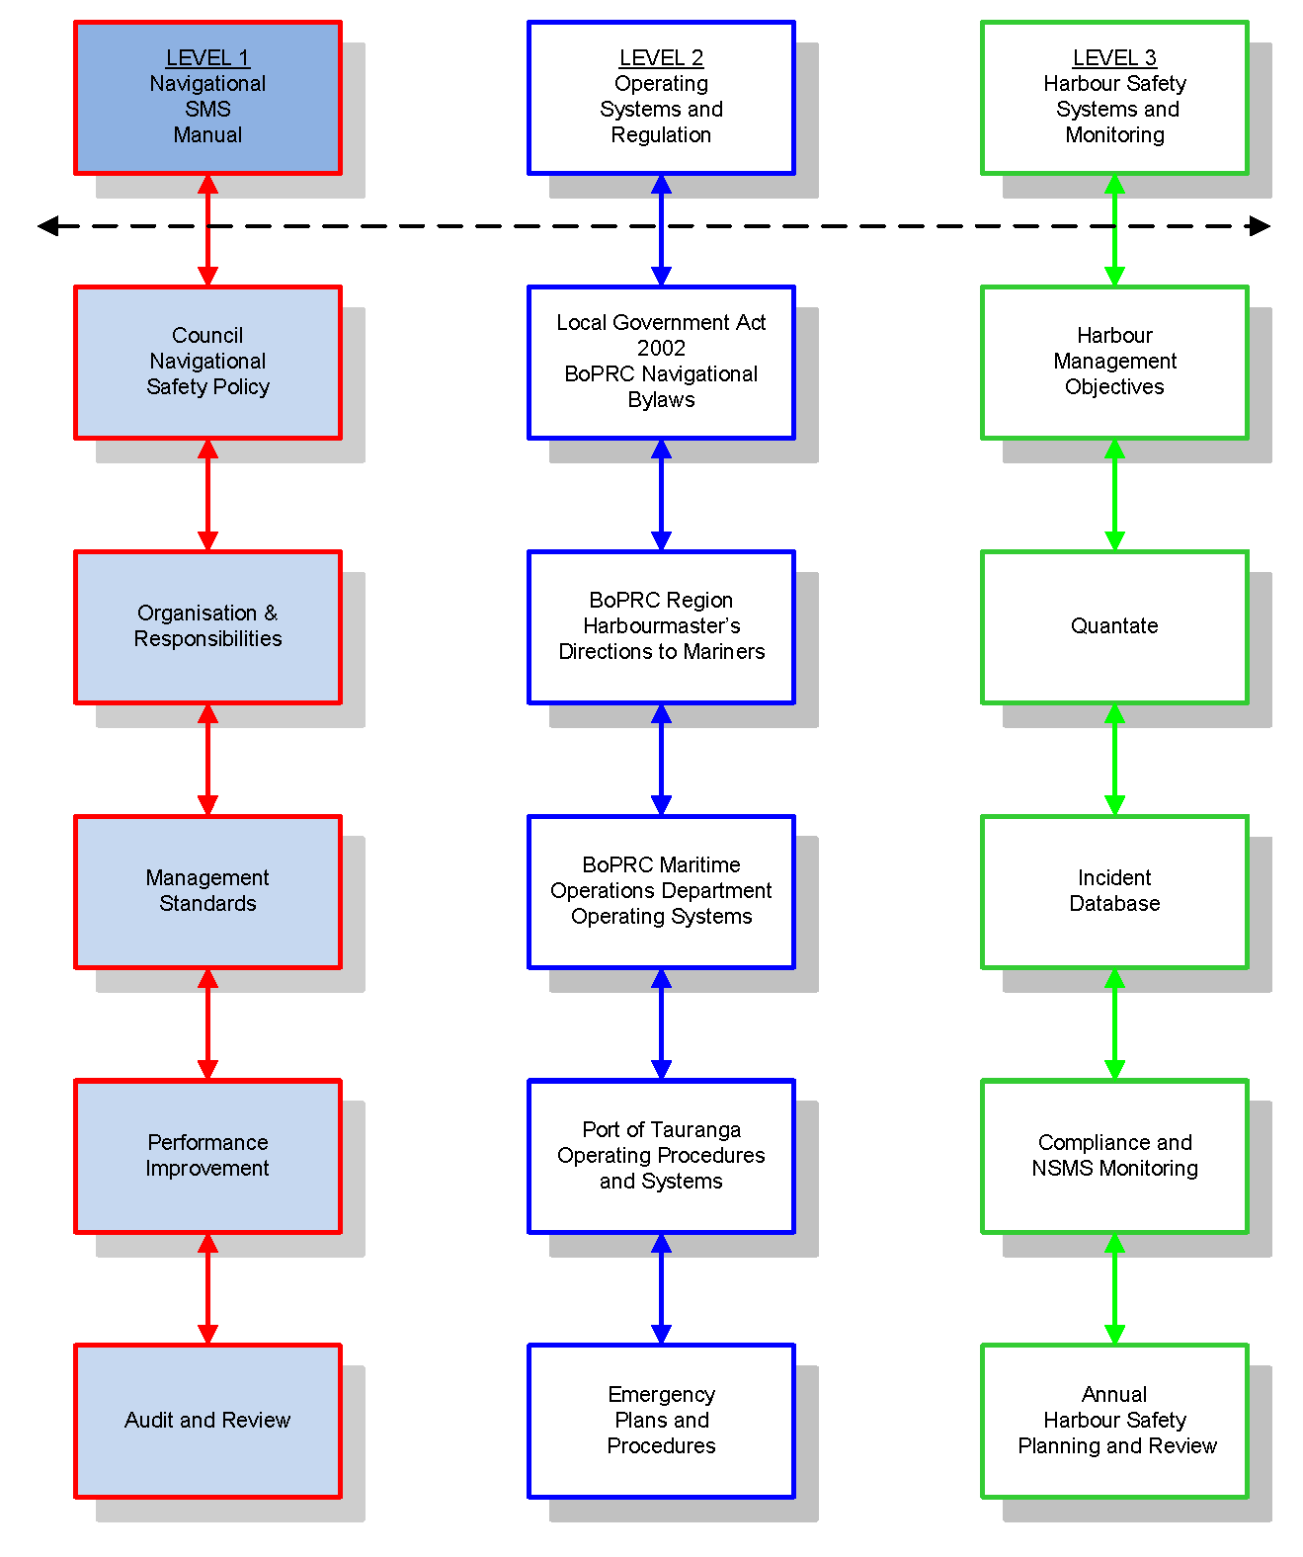Figure 1 below, shows the general structure of the Bay of Plenty Regional Council Harbour Safety Management System, which is designed in three complementary levels. The shaded boxes refer to this manual.

Figure 1 Diagram showing the structure and components of the Bay of Plenty Harbour Safety Management System.

Contents

Document information i

Components of the Navigational Safety Management System iii

Part 1: Introduction 1

1.1 Compliance and Designated Person 1

1.2 BOPRC Port and harbour arrangements 1

1.3 Navigational Safety Management System principles 2

1.4 Port and Harbour Marine Safety Code requirements 3

1.5 System components 3

Part 2: Navigational Safety Policy 5

2.1 Introduction 5

2.2 Commitment Statement - Navigational Safety Management System 5

2.3 Purpose of policies 5

2.4 Policy development and communication 6

2.5 General Port and Harbour Marine Safety Code Policy 6

2.6 Navigational Safety Policy and supporting marine policies 6

Part 3: Organisation 13

3.1 BOPRC functional structure for the management of navigational safety 13

3.2 Key responsibilities – navigational safety 15

Part 4: Relationships with port operators 17

4.1 Port of Tauranga Limited 17

4.2 Policy relationships – Bay of Plenty Regional Council and Port of Tauranga 17

4.3 Management of conflict of interest 18

4.4 Pilotage and towage – Port of Tauranga 20

Part 5: Implementation of Safety Management 21

5.1 Navigational Safety Plan 21

5.2 Annual Plan revision 21

Part 6: Navigational SMS data 23

6.1 Safety Management Archive – Quantate 23

6.2 Incident database 23

Part 7: Key risk management systems 25

7.1 Documentary risk controls 25

7.2 Physical risk controls 25

Part 8: Performance improvement 29

8.1 Introduction 29

8.2 Document control 29

8.3 Navigational SMS review processes 29

8.4 Risk assessment standards 30

Part 9: Training 33

9.1 Competence assurance 33

9.2 Marine training 33

9.3 Safety management training 34

9.4 Training and competence records 34

Part 10: Incident investigation 35

10.1 Definitions 35

10.2 Responsibility for investigation 35

Appendix 1 – NSMS Document Management 39

Appendix 2 – Incident Response 40

Appendix 3 – Civil Defence/HM Response To Warnings or Events 43

Appendix 4 – Incidents and Events Table 46

Appendix 5 – Meeting Agenda 49

1. Introduction

Under powers provided under the Maritime Transport Act, Bay of Plenty Regional Council (BOPRC) has the role of Harbour Authority for Waterways and Harbour Areas within its jurisdiction. The limits of navigational jurisdiction for BOPRC are set by its Navigational Bylaws, which are reviewed from time to time. The present (2010) Navigational Bylaw jurisdiction extends out to the 12 mile international limit, which is consistent with the limits of the BOPRC Coastal Plan. The full extents of this navigational jurisdiction are referred to within this safety management plan where appropriate.

BOPRC bylaws are maintained and reviewed to be compatible with the Maritime rules of Maritime New Zealand.

Within these overall 12 mile limits, Pilotage Limits are established in the Maritime rules for the harbours within its jurisdiction, where pilotage is required. Harbour Limits, are gazetted. The Tauranga Harbour area is defined as Tauranga Harbour to the Harbour Limits at both the Tauranga Harbour entrance and Katikati entrance as per NZ 5411.

BOPRC has an obligation under the New Zealand Port and Harbour Marine Safety Code (the Code) to introduce a Navigational Safety Management System (NSMS) after conduction or reviewing a navigational risk assessment. The Code applies to pilotage waters, but its application can be increased as part of a Code Application assessment. This risk assessment has considered the waters of Tauranga Harbour and its approaches on the basis that the Code would apply to the extents of the harbour. The provisions of the Bay of Plenty Regional Council NSMS are set out in this manual.

This document describes the overall framework for harbour safety management and   
co-ordination of key harbour stakeholders participating in the delivery of this important safety function.

* 1. Compliance and Designated Person

The NSMS arrangements referred to in this manual comply with the New Zealand Port and Harbour Marine Safety Code (2004) and are subject to internal or external audit to satisfy the Designated Person (DP) of applicability.

The DP for Port and Harbour Marine Safety Issues is the appointed Bay of Plenty Regional Harbourmaster.

* 1. BOPRC Port and harbour arrangements

BOPRC, in its role as Harbour Authority for the waters of the Bay of Plenty region, has made formal NSMS interface arrangements with its largest port operator, Port of Tauranga Limited, where the Code directly applies[1]. In Tauranga Harbour, BOPRC and Port of Tauranga Ltd work together to implement the controls and procedures described by this NSMS Manual. Port of Tauranga Ltd will maintain its own NSMS interface in the form of procedure manuals for the Port of Tauranga systems contributing to navigational safety. The BOPRC NSMS (this document) describes the SMS interfaces with Port of Tauranga Ltd.

The BOPRC Regional Harbourmaster maintains the overview, in order to deliver integrated Navigational Safety within Bay of Plenty harbours of the Harbourmaster’s responsibility in executing the Council’s statutory function as a Harbour Authority.

* 1. Navigational Safety Management System principles

The BOPRC Navigational Safety Management System is designed to deliver the relevant requirements of the New Zealand Port and Harbour Marine Safety Code.

The Harbour Authority’s navigational safety policies define the organisation and arrangements that are planned to monitor, promote and proactively manage the conduct of navigation and associated marine activities so that safety of any navigational activity is enhanced. Port of Tauranga Ltd is a key contributor to the navigational safety of Tauranga Harbour and has its own systems to confirm that navigational safety policies are being delivered.

The NSMS is structured into three levels as is indicated in **Figure 1.** This manual represents Level One. The process of harbour regulatory management and operation forms Level Two and the planning and review systems form Level Three.

**Figure 2** shows the links between policy, the organisational structure and the administration of the Navigational Safety Management System.

Figure 2 Flowchart of the Navigational Safety Management System.

* 1. Port and Harbour Marine Safety Code requirements

The NSMS procedures and guidelines fulfil the requirements of the Port and Harbour Marine Safety Code including, but not limited to, the following:

* Making risk control the basis of all marine activities, procedures, bylaws and directions.
* Using risk assessment to identify the requirement for aids to navigation.
* Applying risk assessment to all proposed harbour developments affecting navigational safety.
* Subjecting new and potential hazards to risk assessment.
* Subjecting wrecks and abandoned vessels to risk assessment.
* Periodically reviewing the provision of safe anchorages.
* Maintaining systems to implement the findings of risk assessments.
* Identifying, designating and periodically reviewing safe pilot boarding and disembarking areas.
* Applying current pilot transfer arrangement standards.
* Reporting deficiencies on visiting vessels.
* Providing procedural advice for giving directions in relation to dangerous vessels or substances.
* Regulating the use of harbour craft and ensuring powers are sufficient to govern the mooring of vessels.
* Maintaining and developing a competence based training scheme, with continual professional development supporting delivery of all marine functions.
* Maintaining appropriate plans and procedures for emergency response and associated training/exercises.
* Using verification/audit systems.

The Maritime Operations Department will undertake a formal review every three years and will also review when an accident or incident highlights a need. Any changes to these documents will, where appropriate, be reflected into all other relevant manuals, to ensure it meets the requirements of the Port and Harbour Marine Safety Code.

* 1. System components

The NSMS focuses on the operational and administrative output of the Regional Council’s Harbourmaster’s department.

It includes the following components:

Navigational and marine policies

* Navigational Management Team.
* Navigational SMS Manual.
* Risk Assessment and Risk Control Measures.
* Hazard Management System – *Quantate 11.
* Incident Database.
* Rollin Annual Harbour Safety Plan.
* Staff involvement and consultation.
* Bay of Plenty Harbour Navigation User Groups (including Pilotage).
* Records and controls.
* Audit and review.

*Quantate is used throughout this document and refers to the brand name of the current hazard/risk management system in place. It can be considered to also refer to any system that might be used in future for the same purpose.

Risk control measures will fall into two broad categories. Some measures, particularly some of the physical components are planned for the future and will be introduced and implemented in a progressive manner.

* + 1. Documentary
* National Regulatory Framework.
* Regional Council Local Legislation.
* BOPRC Navigational Bylaw, 2010.
* Harbourmaster Empowerment.
* Accurate Charts and other Navigational Information.
* Operational manuals and guidelines.
* Operating procedures.
* Emergency plans and procedures.
* Harbour Notices to Mariners.
* Formalised training and assessment.
* Memorandum of Understanding – Port of Tauranga and BOPRC.
  + 1. Physical
* Radars.
* Tugs.
* VHF communication.
* Traffic Management System.
* Tide gauges.
* Wave measuring equipment.
* Aids to navigation.
* Anchorages and moorings.
* Emergency anchorages.
* Patrol craft.
* User consultation interfaces.

1. Navigational Safety Policy
   1. Introduction

The Navigational Safety Policy sets out the Regional Council’s intentions (in its accepted statutory role as Harbour Authority for Bay of Plenty Regional Council jurisdictional waters) and its commitment to navigational safety. It also describes the organisational responsibilities and arrangements established to ensure that the Policy is implemented. The Policy, with its supporting policies (Traffic Management, Pilotage, and Enforcement) contributes to operational objectives and states the Regional Council’s commitment to meet its statutory responsibilities. The fundamental objective of the Navigational Safety Management System is to demonstrate the consistent application of these Policies.

* 1. Commitment Statement - Navigational Safety Management System

BOPRC, as “Duty Holder” under the New Zealand Port and Harbour Marine Safety Code (PHMSC), is the body accepting responsibility for setting and monitoring the standards of navigational safety within its harbour waters and offshore jurisdictions as defined by the Navigational Safety Bylaw, 2010.

BOPRC has committed itself to comply with the requirements of the New Zealand Port and Harbour Marine Safety Code (Ref. PHMSC 1.4.3 a-d).

Furthermore, it is committed to ensuring that the appointed Harbourmaster is adequately resourced to exercise his or her statutory powers and functions towards navigational safety obligations (Ref. PHMSC 1.4.3 e).

One key purpose of this document is to show a link between:

* This Commitment Statement,
* The policies set by the Bay of Plenty regional councillors,
* The Maritime Operation’s management arrangements, controls and provisions that discharge those policies, and
* The links to the port company management arrangements and controls that meet the requirements of these policies.
  1. Purpose of policies

The primary purpose of the navigational safety policies is to transparently link objectives, agreed at the top of the Harbour Authority into guidance for those responsible for managing harbour safety. They also provide a reference point for a variety of operational decisions including the selection of resources and the design and implementation of safe working practices.

* 1. Policy development and communication

Navigational safety policies are developed by the Bay of Plenty Regional Council Marine Operations Section and are to be approved by Council. The policies have been communicated to staff, Port of Tauranga Ltd, harbour users and interested parties. Once these policies are operational they will be posted on the Council’s website and staff intranet. In addition, the Council is committed to working closely with harbour stakeholders to aid the development of the Navigational SMS, which will contribute to compliance with the Port and Harbour Marine Safety Code. Copies of all navigational safety and marine policies are freely available and there is a continuing process of briefing stakeholders and updating information with regard to navigational safety.

* 1. General Port and Harbour Marine Safety Code Policy

Bay of Plenty Regional Council has made a commitment to comply with the requirements of the NZ Port and Harbour Marine Safety Code. It aims to achieve this by:

* Regulating navigation in a way that safeguards Tauranga Pilotage waters, harbour users, stakeholders, the public and the environment,
* Ensuring that relevant navigational assets are managed safely and efficiently to recognised standards,
* Ensuring the provision of adequate resources (including staff training) to discharge its navigational safety obligations,
* Making available relevant navigational information to all jurisdictional water users,
* Working closely with key stakeholders to aid the development of a Navigational SMS,
* Publishing relevant parts of the Navigation SMS and Annual Harbour Safety Plan on the public website of the Council and the staff intranet and employing a continuous process of briefing and updating information with regard to navigational safety.
  1. Navigational Safety Policy and supporting marine policies

The Regional Council’s marine policies guiding the delivery of navigational safety management are recorded in this section. This document will be updated with current policy as it is approved by Council.

# Navigational Safety Policy

Bay of Plenty Regional Council has a primary responsibility to facilitate the safety of navigation within its jurisdiction. It also has responsibility to assist Maritime New Zealand to manage pilotage standards within compulsory pilotage limits for Port of Tauranga. To this end, it is Regional Council policy for the Maritime Operations Section to:

1. Establish, fund and maintain an effective Navigational Safety Management System, based on a continuing, formalised assessment and mitigation of risk in consultation with navigational users,
2. Review regularly the effectiveness of, and if necessary seek amendments to, its legal powers, bylaws and directions in respect of navigational safety,
3. Maintain formal policy towards the provision of maritime traffic monitoring throughout its waters and maintain an interface with both piloted and pilot exempt traffic,
4. Periodically review management of the navigation of vessels in waters within the Tauranga Harbour jurisdiction,
5. Maintain formal policy towards pilotage and ensure the Port of Tauranga periodically review the level, competence and availability of pilotage service in accordance with Maritime New Zealand requirements and vessel sizes,
6. Maintain formal policy towards enforcement within all jurisdictional waters, with particular reference to Tauranga’s Compulsory Pilotage waters,
7. Regularly review towage capability to determine that it remains appropriate to the levels of service required in Port of Tauranga,
8. Facilitate an appropriate patrol service for Bay of Plenty Regional Council jurisdictional waters proportionate to navigational use,
9. Facilitate or undertake such hydrographic surveys as are necessary for safe and efficient navigation,
10. Promulgate to users up-to-date, timely and accurate hydrographic information, where appropriate;
11. Maintain an overview of maintenance dredging within Tauranga pilotage area, as appropriate,
12. Assess and where necessary require removal of sunken, derelict, unseaworthy or abandoned vessels and other obstructions that are, or may become, an impediment to safe navigation within Tauranga pilotage area,
13. Facilitate and where necessary provide the necessary major aids to navigation and maintain a programme of review of channel markers within Tauranga pilotage area,
14. Make available relevant navigational information to all relevant users of Council waters,
15. Maintain regular liaison with navigational stakeholders and seek input as required on matters influencing navigational safety,
16. Provide professional advice in the resource consent process under the Resource Management Act, 1991, for any form of development affecting navigational safety within Tauranga Pilotage waters.

Council Approved

23 April 2009

# Traffic Management Policy

In order to provide for safe navigation within its area of jurisdiction, the Bay of Plenty Regional Council maintains knowledge of the traffic transiting its waters as defined by bylaws. Large vessels using the Port of Tauranga are managed by POTL via an MOU with the port company.

Overall, BOPRC has policy commitment to the management of vessel traffic as follows:

1. Throughout the BOPRC coastal jurisdiction, maintain a system of remote monitoring of transiting vessels over 500 gross tons and other craft fitted with AIS transponders.
2. For the navigable pilotage and harbour waters of Tauranga:
3. Develop, with the Port of Tauranga, the training and systems required to deliver traffic management appropriate to the needs of Tauranga Harbour, from the customer service centre, utilising the standards of IALA for equipment, training and qualification.
4. Provide a local PS.
5. Formalise the importance of the 24-hour Port of Tauranga Customer Service Centre to advise traffic of marine hazards within Tauranga Pilotage Limits.
6. Maintain a service level agreement (MOU) with the Port of Tauranga Limited to support provision of maritime traffic monitoring, this being undertaken by Port company personnel.
7. For river and local harbour entrances where navigational use occurs:
8. Develop and maintain an advisory service about bar conditions,
9. Provide advice to users about bar suitability as seasons change,
10. Maintain an advisory service about flood water conditions.

Council Approved

23 April 2009

Council Approved, April 2009

# Pilotage Policy

Bay of Plenty Regional Council has responsibilities for pilotage in association with Maritime New Zealand (MNZ). MNZ also lay down requirements under which Pilotage Exemption Certificates (PECs) are issued.

The Council’s policy in respect of pilotage is to:

* Ensure that the operation of the Tauranga pilotage service is compliant with national and international regulations and guidelines,
* Monitor to establish that there exists an appropriate level and competence of pilotage service in accordance with Maritime rules,
* Periodically review requirements and locations for pilot boarding areas,
* Administer the PEC monitoring system to ensure that all PEC applicants and holders fully meet the requirements laid down in Maritime rules,
* Maintain close liaison with Port of Tauranga with regard to the Pilotage Policy of that organisation, to ensure that the pilotage policies of the two organisations are mutually supportive.

Council Approved

23 April 2009

# Enforcement Policy

Bay of Plenty Regional Council is empowered to prosecute offenders for breaches of Bylaws made under the Local Government Act 2004, and will assist TAIC or MNZ in any investigation under the New Zealand Maritime Transport Act. In order to ensure compliance with the provisions of such statutes and Bylaws, particularly where navigational safety and protection of the environment are concerned, it is necessary that an effective enforcement regime be maintained and publicised to encourage compliance and deter non-compliance.

To this end, it is Council policy for the Maritime Operations Section to:

* Develop and maintain effective enforcement based on a continuing review of relevant legislation and the provision of appropriate training for its staff,
* Facilitate an appropriate patrol service for the Tauranga pilotage waters, with crews empowered where necessary to issue infringement notices by delegation,
* Maintain an appropriate surveillance regime to monitor compliance with, and detect breaches of the Navigation Bylaw and directions,
* Investigate maritime incidents or alleged breaches of the bylaw and directions at its discretion, in accordance with Council guidelines,
* Maintain appropriate records of all reported incidents and investigations undertaken,
* Where appropriate, work with and inform other relevant authorities of investigations;
* Respond to breaches of the bylaw and directions, in accordance with the   
  Bay of Plenty Regional Council Staff Delegations Manual.

Council Approved

23 April 2009

# Consultation Policy

The Port and Harbour Marine Safety Code emphasises the importance of effective consultation by relevant navigational stakeholders. This includes all those who work on or in the Bay of Plenty Regional Council’s jurisdictional waters or use the waters in some form, as well as those that represent them.

It is therefore Council policy that it shall publish matters of relevance to, and encourage comment and contribution from, all navigational stakeholders. In particular, the   
Regional Council shall:

1. Consult as early as is practicable with stakeholders when changes to legislation, bylaws and policy are being considered,
2. Include appropriate councillors and Council staff in the consultation process,
3. Maintain an effective consultation mechanism with stakeholders on navigational safety and other operational issues,
4. Maintain an effective consultation mechanism with other interests including iwi,
5. Include appropriate Bay of Plenty Regional Council stakeholders in the ongoing work to identify navigational hazards, assess the risk of such hazards and recommend appropriate control and mitigation measures, and
6. Make available harbour navigational and safety information, as well as planned developments to stakeholders.

Council Approved

23 April 2009

1. Organisation
   1. BOPRC functional structure for the management of navigational safety

The BOPRC Maritime Operations Department is structured as shown in **Figure 3,** below. There is a Regional Harbourmaster/Maritime Manager who has overall management responsibility for the department, with a Deputy Harbourmaster based in Tauranga, a deputy with responsibility for the Eastern District (based in Whakatane), and a deputy based in the Rotorua Lakes.

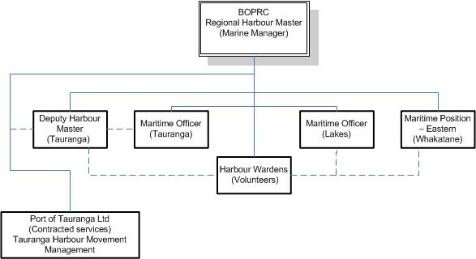

Figure 3 Structure of the Maritime Operations Department.

The wider organisational structure connecting the Maritime Operations Department to the Council Management System and the Council itself is shown in **Figure 3.** This links to both the main Council assembly and its Environment Committee.

The wider harbour regulatory structure is shown in **Figure 4.**

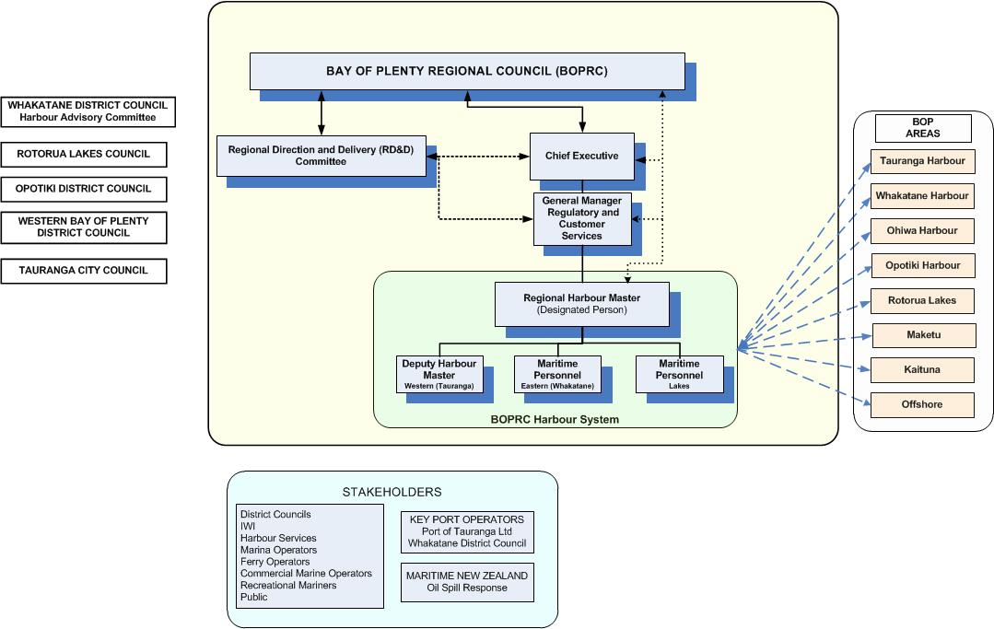

Figure 4 Harbour regulatory structure.

* 1. Key responsibilities – navigational safety
     1. The Council

In respect of navigational safety, BOPRC:

* Discharges the duties and exercises the powers given to it, both directly and by delegation in accordance with the Local Government Act, 2002, as amended,
* Discharges the function of Harbour Authority as defined in the New Zealand Port and Harbour Marine Safety Code (PHMSC) by ensuring compliance with the Code, and the safe management of navigation,
* Approves the strategy, policies, plans and budgets of the Maritime Operations Department, together with its strategic objectives,
* Reviews the performance of the BOPRC Maritime Operations Department against its strategic and operational objectives, plans and budgets.
  + 1. Harbourmaster

Harbourmasters are appointed from time to time by Council to discharge the statutory role of Harbourmaster in accordance with the Maritime Transport Act and the Code. They are responsible for delivering navigational safety policy, keeping the Chief Executive advised and Council informed. A key function of this role is to ensure that the NSMS fulfils the marine aspects of the Council’s statutory duties and relevant non-statutory obligations.

* + 1. Designated Person (DP)

In meeting its obligations under the Code, the Council has appointed a Designated Person (DP), the Regional Harbourmaster or the delegated Deputy Harbourmaster. The DP maintains a right of direct access to the Council and/or the Chief Executive, as appropriate. The role of the ‘Designated Person’ is to:

* Provide assurance to Council that it has an effective, appropriate and ongoing Navigational Safety Management System.
* Provide the Council with professional advice to ensure Council’s overall compliance with the requirements of the New Zealand Port and Harbour Marine Safety Code.
  + 1. Harbour stakeholders

Harbour stakeholders may provide input about specific issues to the Maritime Operations Department and will be convened by the Harbourmaster, when there is an issue to be considered. The make-up of these groups may change from time to time, dependant on the harbour stakeholder experience most able to contribute to the issue under consideration. A harbour stakeholder group may be formed by individual invitation or it may be formed from an existing Harbour Interest group, depending on the issue being considered. For example, an issue involving commercial vessels at Tauranga, a Harbour stakeholder group comprising Port Company representatives and shipping agents would be consulted, whereas a recreational issue would involve a harbour stakeholder group represented by either boating clubs or individuals with relevant navigational interest in the harbour.

1. Relationships with port operators
   1. Port of Tauranga Limited

Port of Tauranga Ltd (POTL) operates the commercial berths at Mount Maunganui, including the Sulphur Point container terminal, the tanker berth and the general purpose wharves. The Regional Council is a majority shareholder through its Council controlled organisation, and investment arm, subsidiary Quayside Holdings and is potentially able to provide considerable influence over the Port Company Operations. The Port Company is an independent entity, operated by a management structure in the interests of all its shareholders.

* 1. Policy relationships – Bay of Plenty Regional Council and Port of Tauranga

As the Port of Tauranga is by far the largest port operator in the region, it retains its own operational policies of relevance to this safety management system. There is a connection between the BOPRC Navigational Policies and those of the Port Company. This is both in terms of Governance as well as Navigational Safety Policy.

The relationship between both organisations is shown in Figure 5. This is further expanded in the POTL’s own Navigational Safety Management System Manual.



Figure 5 Relationship between Bay of Plenty Regional Council and Port of Tauranga Limited policies.

* 1. Management of conflict of interest

BOPRC recognises the importance of managing any potential conflict of interest between itself as majority shareholder through its subsidiary company Quayside Holdings and the independence of the Tauranga Port Company.

The Designated Person for navigational safety matters within the Port of Tauranga organisation is the Port Operations Manager.

The operational relationship between the organisations have been considered and recorded. Both explicit and implicit relational points of contacts are shown in **Figure 6,** which also shows key tasks relevant to the SMS and the supporting documentation.

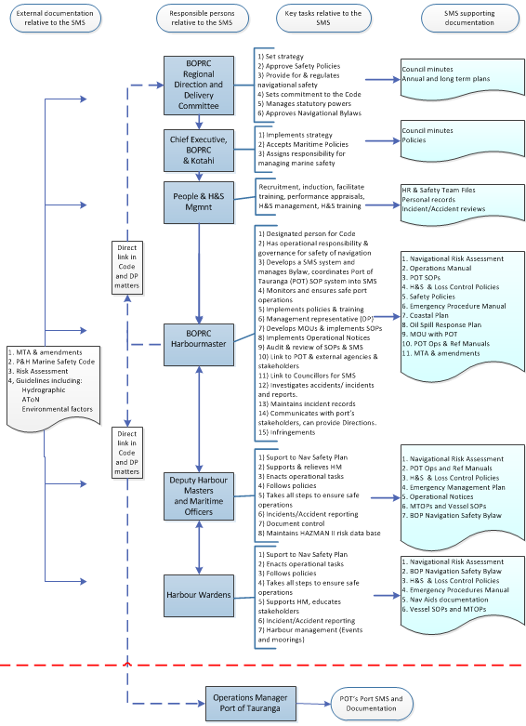

Figure 6 Operational relationships, points of contact and SMS key tasks (BOPRC Maritime Operations Department and Port of Tauranga Ltd).

* 1. Pilotage and towage – Port of Tauranga

The Port of Tauranga is the only port organisation in the BOPRC region providing authorised pilotage services. Pilots are trained and authorised in accordance with the requirements of Maritime Rule Part 90. The company is the entity responsible for the delivery of these services, including training. The Harbourmaster maintains an understanding of pilotage standards and capability.

Port of Tauranga Ltd retains responsibility to the BOPRC NSMS to maintain systems to safely assist vessels and craft visiting its wharves. The Harbourmaster is responsible for ensuring that pilotage procedures remain appropriate and to assist with their interface as a Level 2 component of this NSMS.

From time to time the Harbourmaster or his authorised representative will audit or appoint an independent auditor to monitor and/or review Pilotage Standards and the delivery of the pilotage and towage service.

1. Implementation of Safety Management
   1. Navigational Safety Plan

In association with its duties and responsibilities, the BOPRC Maritime Operations Section has an annual plan in accordance with the wider needs of the Council organisation. The overall purpose of the plan is to collate all actions requiring to be implemented and to set target completion dates.

The Tauranga Pilotage Safety Plan is reviewed annually to produce strategic objectives and budget for the year ahead and a plan for the year is recorded. These objectives seek to:

* Reduce risks to as low as is reasonably practicable.
* Ensure all reasonably practicable steps are taken to identify the hazards and risks arising from operational activities in the Bay of Plenty Pilotage waters.
* Ensure conformance with the navigational safety and marine policies, associated operating controls and applicable port and marine legislation and non-statutory obligations.
* Periodically review data gathered from audits, inspections, incidents and any concerns raised to evaluate and determine where improvements and changes need to be made.
* Implement employee competence training and Navigational SMS awareness programmes.
* Facilitate port user involvement in the maintenance of the Navigational SMS and the overall improvement in the provision of navigational safety.
* Communicate the Council’s ongoing efforts and achievements in facilitating navigational safety to relevant stakeholders.
* Review the effectiveness of and continually improve the Navigational SMS.
  1. Annual Plan revision

The Annual Safety Plans are reviewed and reissued prior to the commencement of the Council’s financial year. The review is undertaken to facilitate financial planning and development of Tauranga Harbour systems for the forthcoming financial year.

1. Navigational SMS data

For Tauranga Pilotage waters, the NSMS is informed by a navigational risk assessment.

* 1. Safety Management Archive – Quantate

The Quantate database contains details of identified hazards, together with summarised risk control measures employed to mitigate those hazards. Both hazards and risk control measures have a designated ‘owner’ and hazards are maintained within the system in ranked order, based on the outcome of the risk assessment process. This ranking structure will change with time as the hazards and risk controls continue to be reviewed, reassessed and rescored.

* 1. Incident database

The Quantate package also has an incident database. The responsibility to ensure that incident data is accurately recorded and remains current is allocated to the Deputy Harbourmaster (Tauranga).

1. Key risk management systems

The generic risk control measures employed by Bay of Plenty Regional Council can be categorised as follows:

* 1. Documentary risk controls
* Regulatory Framework – Includes the Navigation Bylaw, 2010 and Harbourmaster’s directions.
* MOU with the Port of Tauranga.
* The provision of tidal and other navigational information, navigation warnings and advice of conditions at berths.
* Departmental operational manuals and guidelines.
* Process or task specific operating procedures.
* Emergency plans and procedures.
* Notices to mariners – general navigational guidance and advice.
* Formalised training and assessment – See **Section 8** and the various departmental operational manuals.
  1. Physical risk controls
* AIS Receivers and AIS Virtual AToN Transmissions.
* Radars – radar coverage is currently available of Tauranga Harbour waters used for POTL operations, such as the Tauranga Harbour entrance and wharves. These are owned by POTL.
* VHF communication – a marine radio network covering VHF Channel 14 and Channel 16, providing effective harbour communications for shipping, harbour radio and all harbour users.
* VTS System – the POTL provide a VTS system installed compliant to IALA VTS standards. Its service is in accordance with the BOPRC and POTL MOU. It delivers a Local Port Service standard (LPS) under the IALA standards.
* Tide gauges – a system of tide gauges located within the harbour providing live tidal information.
* Aids to navigation – buoys, beacons, marks and lights etc. maintained by BOPRC and Port of Tauranga Ltd.
  + 1. Vessel traffic services

Vessel Traffic Services (VTS) are currently provided by the Customer Service Centre, operating from the port company’s management building. The Service Centre monitors and manages vessel traffic within the area of responsibility and adoption of IALA traffic management principals is ongoing. To do this effectively, the Council, with Port of Tauranga intends the VTS service to provide a continuous service within the limitations imposed by:

1. The level of training and qualification achieved by VTS personnel,
2. The level of service to be promulgated (presently LPS),
3. The availability and operability of VTS equipment.

The Tauranga LPS traffic management service will, under the MOU:

* Monitor by radar, AIS, VHF, CCTV and all other available means, all vessel traffic within the Tauranga Harbour limits associated with port operations. The service will include but not be limited to:

1. The recording of all known vessel traffic within the area covered by the POTL system,
2. The recording of personnel numbers on vessels required to participate in the vessel reporting system,
3. The recording of equipment deficiencies on vessels transiting the harbour.

* The use pf PEC privileges by vessel navigators.
* Introduce a Local Port Service while developing its capability to provide an information service. As an information service, provide VHF broadcasts of any known hazards to navigation which are temporary in nature and not covered in any local notices to mariners, also broadcasts of weather and tidal information on request. Swell conditions will be monitored and will be broadcast along with meteorological information. VTS will also provide broadcasts of known vessel traffic movements to reporting vessels.
* Provide assistance to the Police and RCC NZ in the event of emergencies or SAR events arising within the Harbour Authority’s area of jurisdiction and support to the On Scene Commander in the event of a pollution incident within Tauranga Harbour.
* Develop staff to <ultimately and if risk determines this is needed> deliver a Traffic Organisation Service (TOS) in chosen areas of port waters. Appropriate equipment will be installed and training to the IALA international standard[2] will be a long-term objective. The need for this will be kept under review.
* Compliance with the Harbourmaster’s Standing Orders, Standard Operating Procedures and any relevant legislation.

International IALA Guidelines approved by IMO, and any VTS standards developed by Maritime New Zealand will be used to keep under review the geographical extent in which the delivery of VTS is appropriate.

* + 1. Harbour patrol service

The Harbourmaster will maintain the ability to carry out harbour patrol services as required and support administrative follow-up to assist in the effective regulation and enforcement of navigational safety policy.

* + 1. Marine services – Harbourmaster System

The Harbourmaster has been designated with responsibility for the provision and maintenance of navigational beacons, buoys and lighthouses.

The Harbourmaster has a limited capability to remove wrecks and obstructions that are deemed to be hazards to navigation. Power to undertake this is found in the Local Government Act as well as Navigation Safety Bylaws.

* + 1. Port of Tauranga Ltd wharves

Port of Tauranga Ltd is responsible for the direct access to their wharves and formal arrangements will be in place so that berths are maintained in a condition appropriate to their use and safe access is maintained in order to follow the policies and principles of this NSMS Manual.

* + 1. Pilotage

Pilotage is supplied by Port of Tauranga Ltd. The Harbour Authority has policy for Port of Tauranga Ltd to provide the responsible interface for the deployment of Authorised Pilots to vessels. Pilots are required to report the movement of any vessel to the VTS.

* + 1. Towage

Towage is supplied by Port of Tauranga Ltd to vessels requesting tugs. Port of Tauranga Ltd maintains and regularly reviews an asset management plan to address potential future towage requirements.

The adequacy of towage is reviewed form time to time by the Harbourmaster in consultation with POTL.

* + 1. Emergency preparedness and response

The Council and POTL have established emergency response plans and procedures to address marine emergency incidents. Training exercises and seminars are programmed on an annual basis to familiarise and update staff on these emergency procedures and to exercise individual response actions. Appropriate staff training and emergency exercise records are maintained. See also Appendix 4

* + 1. Environmental management

The Council maintains effective procedures and control measures designed to ensure that the potential impact on the environment is fully considered when planning or approving commercial and recreational activities within the Port.

1. Performance improvement
   1. Introduction

Sections 9, 10 and 11 of this NSMS document describe how the system is reviewed and improved. These are important components of the NSMS.

* 1. Document control

The document approval procedure for the Navigational Safety Management System is managed by the Harbourmaster. SMS related documents as developed may be referred to an appropriate BOPRC Committee, after their development. All documents within the Navigational SMS are given a final sign-off approval by the Harbourmaster prior to issue.

A record of changes to this NSMS Manual is to be maintained on the front of this manual.

The BOPRC document is available in hard copy form in the Harbourmasters office, online at BOPRC website and held electronically on Objective (see document management).

* 1. Navigational SMS review processes

The identification and assessment of navigational hazards is central to the effective maintenance of the NSMS. The risks of the Bay of Plenty harbours are retained in the Quantate package. Quantate online software is used for continuing review of both new and existing hazards and their preventative control measures.

Reviewing identified hazards and risk control measures will involve the Council’s maritime staff and port stakeholders, as appropriate. It may also, on occasions, involve external specialist consultants.

A full review of harbour hazards and NSMS Manual is undertaken every five years, but individual hazards are reviewed in between this overall review, together with their risk control measures. The review of hazards and control measures are prompted by four circumstances:

1. Planned, periodic, formal review of established hazards and risk controls, initiated by the Quantate software,
2. Review of hazards and associated risk controls following an incident,
3. A reviewed hazard showing a significant rise in risk ranking, and
4. The identification and assessment of any potential hazards arising from changes to circumstances including the introduction of a new trade and/or marine operation.
   * 1. Periodic reviews - proactive

The SMS review schedules revision of individual hazards and their associated risk control measures. This is set up electronically within the Quantate software, with hazards ranked highly in relation to others being reviewed at shorter timespans than those ranking low on the list for any harbour.

This schedule ensures that all currently identified hazards are reviewed over a five year period, some more frequently than others. The individual periodicity of review is dependent upon the ranking of the hazard or the potential consequence of hazard realisation. The highest ranked hazards are reviewed six-monthly, the lowest four-yearly.

All hazards and risk control measures have been allocated an ‘Owner’, normally the Harbourmaster or his deputy, the port company, or a delegated specialist appointee. A hazard owner may be given a hazard to review but its risk control measures will always be the responsibility of the Harbourmaster (as an independent) to review or audit as necessary. The Harbourmaster will retain responsibility for allocating any entity undertaking the hazard review, which could be an external organisation. A review will be undertaken in consultation with staff members, Port of Tauranga Ltd and port stakeholders as appropriate.

* + 1. Post-incident reviews - reactive

Following a navigational incident, the Harbourmaster decides if investigative action is warranted and, where appropriate, liaises with Maritime New Zealand. He will also establish whether there is a need to review the relevant hazard in the Quantate software package and its associated control measures.

* + 1. New risk assessments

Whenever circumstances change to bring in activities outside the existing scope of the Navigational SMS, the Harbourmaster will, in full collaboration with the relevant stakeholders, initiate the requirement for a risk assessment of the intended operation. Such a risk assessment may be conducted directly by the Harbour Staff, stakeholders, or an independent.

* 1. Risk assessment standards
     1. Methodology

The general risk assessment process used is based on the standards published by Maritime New Zealand. This formal approach involves the following five sequential assessment stages, applied in appropriate depth:

* Data gathering and familiarisation:
  + *Review of the existing management structure, risk control arrangements, policies, procedures and operational functions.*
* Hazard identification:
  + *Identification of potential hazards and mapping of existing control measures.*
* Risk analysis:
  + *Consideration of the likelihood of identified hazardous incidents and their associated potential consequences, including prioritising of their risk factors.*
* Risk assessment:
  + *Comparison of risk factors with effectiveness of existing risk control arrangements, and subsequent determination of additional control measures.*
* Risk control:
  + *Judgement and endorsement of specific control measures to be implemented and managed through the Navigational SMS. Update of the Quantate record.*

* + 1. Risk level criteria

Risk Criteria are stated in each harbour risk assessment conducted. Criteria used are in accordance with the New Zealand Marine Risk Assessment guidelines as circulated by Maritime New Zealand. The resulting risk level from each identified hazard is determined by numerically comparing the potential severity of the consequences (against life, the environment, property and harbour stakeholders) and the likelihood of that hazard occurring.

Hazards are then ranked according to their numerically scored risk level. An objective of the hazard review process is to manage and improve the risk control measures associated with each hazard, thereby reducing risk.

2. Training

Training is part of the SMS process of performance improvement. This section of the NSMS document relates to BOPRC and its harbour regulation, although personnel employed in other organisations interfacing with BOPRC for harbour safety management may receive SMS training as appropriate.

* 1. Competence assurance

The competence assurance process is linked directly to personnel selection and recruitment procedures, relevant job descriptions and appropriate pre-determined recruitment selection criteria.

Typically, for organisations operating in BOPRC harbours, the process comprises four stages:

* + 1. Stage 1: Pre-job

A person shall not be permitted to undertake work until the entry-level criteria have been satisfied. Entry-level requirements are normally defined within the relevant job description and vacancy notice.

* + 1. Stage 2: Induction training

All new staff, including any temporary personnel, will receive appropriate induction training. This will take the form of general induction training common to all new staff, followed by departmental induction training and operational briefings as appropriate. Relevant departmental managers are required to record that induction training has been completed.

* + 1. Stage 3: Supervision and on-the-job training (OJT)

Once a person has been selected as suitable to fulfil a specific job function, that person will be placed under the supervision of a competent person, who will recommend when the person is considered competent. Alternatively, in certain cases, this period of supervision may take the form of On the Job Training, following which a formal assessment of competence is conducted.

* + 1. Stage 4: Competence

A person may be considered competent once he/she has completed all necessary induction training and has been assessed either by his/her supervisor, or by formal assessment on completion of OJT.

The principles of competence assurance are followed when recommending authorisation of a Pilot Exemption Certificate.

* 1. Marine training

Training is a key element within the NSMS. In order to ensure that personnel are properly trained, the principles of job analysis and training design are followed. In particular, the person responsible for marine training will:

* Identify operational and safety training needs,
* Establish a skills matrix of competency levels required for key tasks,
* Plan how training requirements are to be met and when,
* Establish a process to appraise the effectiveness of training.
  1. Safety management training

It is intended that all marine staff shall attend a Navigational Safety Management induction briefing to ensure that they are fully aware of the provisions of the NSMS, and of specific roles and responsibilities assigned to them within this programme. The topics to be covered shall include:

* Overview of relevant Council bylaws and general or harbourmaster’s directions,
* Review of the Navigational Safety Policy,
* Outline of management and operating procedures and their provisions,
* Principles of individual accountability and responsibilities,
* Formal and informal procedural controls in place,
* Outline of response to emergencies and contingencies,
* Health and safety.
  1. Training and competence records

All training and instruction provided to BOPRC Maritime Operations Department Staff will be duly recorded and retained in a secure file. Port of Tauranga Limited will retain their own records.

2. Incident investigation

The Investigation of incidents is an important method of learning, as well as providing the feedback needed to modify and improve the NSMS.

* 1. Definitions
     1. Incident

In relation to the NSMS an Incident is defined as:

‘Any unplanned event which causes, or is liable to cause, an undesirable outcome.’

The above definition encompasses:

1. injury or death to one or more persons,
2. damage to property (i.e. vessels, port infrastructure or aids to navigation),
3. damage to the environment,
4. damage to port business (i.e. financial loss or damage to Bay of Plenty Regional Council or the Port of Tauranga’s reputation), or
5. non-compliance with a statute or regulation.
   * 1. Near miss

Note that the inclusion of ‘liable to cause’ brings near misses into the definition of incident for the purposes of the SMS.

Examples of those to be considered include:

1. Situations where a vessel or craft needs to take unconventional avoiding action.
2. A vessel passing another so close as to create a risk of collision or interaction.
3. A vessel passing so close to shoal water as to create a risk of grounding.
4. A vessel or craft passing so close to a structure as to create a risk of contact.
   1. Responsibility for investigation

The Harbourmaster is responsible to BOPRC for the investigation of navigational incidents in BOPRC harbour and offshore waters, both from the NSMS perspective (i.e. the cause/circumstance of the incident) and in the regulatory sense (whether there has been a breach of Council or other bylaws or regulations). The Harbourmaster may request an independent investigation of an incident.

It should be noted that the Harbourmaster has no formal powers of investigation, and if circumstances show there is a need for such powers, a request for assistance is made to Maritime New Zealand.

Where circumstances warrant, Maritime New Zealand may become the lead investigation agency, or an investigation may be undertaken by the Transport Accident Investigation Commission (TAIC). In such cases, the BOPRC Maritime Operations Department will take a provisional view of any failings of the NSMS and act upon them. A full appraisal of the final outcome of any external investigation (following the publication of any reports or the conclusion of any investigation, inquiry or prosecution) will subsequently be undertaken and any remaining issues considered at that time.

**Appendices**

Appendix 1 – NSMS Document Management

|  |  |
| --- | --- |
| **Document** | **Objective Reference** |
| Safety Management Systems/Port & Harbour Safety Codes | qA1141 |
| Risk Assessments | qA1142 |
| [Port of Tauranga Safety Management Systems](https://objective.envbop.net/id:A2049644/document/versions/latest) | A2049644 |
| [Port of Tauranga Launchmaster Training](https://objective.envbop.net/id:A2049649/document/versions/latest) | A2049649 |
| [Port of Tauranga Vessel Manual Arataki](https://objective.envbop.net/id:A2049651/document/versions/latest) | A2049651 |
| [Port of Tauranga Deckhand Training Manual](https://objective.envbop.net/id:A2049664/document/versions/latest) | A2049664 |
| [Port of Tauranga Vessel Manual Te Awanui](https://objective.envbop.net/id:A2049666/document/versions/latest) | A2049666 |
| [Port of Tauranga Tugmaster Training Manual](https://objective.envbop.net/id:A2049667/document/versions/latest) | A2049667 |
| [Port of Tauranga Vessel Manual Te Matua](https://objective.envbop.net/id:A2049668/document/versions/latest) | A2049668 |
| [Port of Tauranga Vessel Manual Sir Robert](https://objective.envbop.net/id:A2049669/document/versions/latest) | A2049669 |
| [Port of Tauranga Vessel Manual Kaimai](https://objective.envbop.net/id:A2049672/document/versions/latest) | A2049672 |
| [Port of Tauranga Pilots Standard Operating Procedures](https://objective.envbop.net/id:A2049673/document/versions/latest) | A2049673 |
| [Port of Tauranga Pilot Training Manual](https://objective.envbop.net/id:A2049674/document/versions/latest) | A2049674 |
| [BOPRC Tauranga Harbour Hazard List](https://objective.envbop.net/id:A1910995/document/versions/latest) | A1910995 |
| [BOPRC MTOP](https://objective.envbop.net/id:A1455986/document/versions/latest) | A1455986 |
| BOPRC Incidents and Accidents | qA1144 |
| [Memorandum of understanding between POTL & BOPRC Harbourmaster](https://whkobjapp01.envbop.net/id:A1789880?A2101381) | A2101381 |

The most current versions of PoT publications are held at the Customer Service Centre at Port Of Tauranga.

Appendix 2 – Incident Response







Appendix 3 – Civil Defence/HM Response To Warnings or Events







Appendix 4 – Incidents and Events Table

| Incident/event | Immediate questions | Contacts | Immediate actions | Considerations and further actions |
| --- | --- | --- | --- | --- |
| Death in harbour | Advise to contact Police. | Police  MNZ | Contact Police. | * Navigation safety issue. * Consider Exclusion Zone * Support as requested |
| Injury | Extent of injury. | MNZ and or  Work Safe | Deal with injuries  Contact MNZ.  Contact Work Safe  Contact BOPRC Heath, Safety & Wellness advisor | * Navigation safety issues. * Copy of report to RHM. |
| Grounding  Collision  Contact with other vessel  Wharf contact  Vessel fire  Marine oil spill  Chemical spill  Sewerage spill | Injuries to pers on board.  Vessel damage.  Environmental damage. | ROSC  MSI – Secure paperwork  P & I – costs for removal  PoT CSC | BOPRC Pollution Hotline  Consider informing RCCNZ.  Controller of scene as per coordinated incident.  Management system (CIMS).  Receive report.  Send to MNZ.  Marine Manager.  Coastguard unit.  Oil Spill in accordance with Tier 2 | * Weather conditions and forecasting. * State of tide. * Proximity to other dangers. * Nature of cargo vessel. * Oil on vessel. * Anything immobilised on vessel. * Availability of tugs. * Extra resources. * Exclusion zone. * Cease vessel movements/close Port. |
| Tsunami | WARNING  Ministry of Civil Defence and Emergency Management will at once advise the Harbourmaster through BOPRC Duty Officer or RCCNZ.  Receive information regarding likely extent of damage.  Earthquake  Ascertain extent of damage. | Advise:  Call Centre  PoT CSC  Port Security/Duty Pilot – informs all vessels in the harbour and at berth of the tsunami warning and requires masters to set a continuous radio watch. | Tsunami  RHM takes full control of all shipping operations in accordance with Annual NZ Notices to Mariners No 11. RHM to move to a safe position to control the response.  Tsunami and earthquake  Set up control centre.  Liaise with Port Operations Manager/duty pilot and other stakeholders and local operators.  Commence logs.  Provide regular situation reports. | * Consider stopping bunkering operations and cargo operations; prepare ships to depart the port as required. * Additional assistance from relieving HMs/DHM/BOPRC/admin staff. * Maintain contact with Civil Defence, monitor radio communications and other sources of communications and other sources of information. * Issuing HM directions. * Shifting vessels. * Closing ports. * Issuing navigation warnings. * Stopping cargo operations. * Mobilising engines. * Tugs on standby / Sail * Crew on standby / Sail * Laid up vessels. * Extra lines. * Other resources needed. * Arrange for updated soundings of channels. * Consider Evacuation |
| Air crash | Details of incident. | Port Security  Police  RCCNZ  Coastguard | In charge as per CIMS. | * Consider stopping vessel movements. * Set exclusion zone. |
| Bylaw infringement | Details of incident.  Attempt to find owner (possibly via car/trailer). | RHM/contracted Enforcement Officer. | RHM/contracted Enforcement Officer to respond if available. | * As per event/incident procedure. |
| Dead animal/fish | Details of location. | Pollution Prevention Officer  Contractor  DOC | Attempt to find owner.  Organise retrieval via contractor/owner.  Advise DOC for whales/mammals. | * Navigation safety issues |
| Vessel adrift  Sinking  Derelict/wreck  Wrecks | Details of complaint. | Contractor  PoT CSC  Rescue agency as appropriate. | Attempt to find owner.  Dispose of wreck.  Recover costs. | * MTA 1994 Section 33. |
| Aid to navigation outage | Details of outage. | PoT CSC AtoNs  BOPRC / Contractor | NtoM required if safe navigation affected. | * MNZ to be advised if required. |
| Navigation hazards/ obstructions | Details of Hazard Danger to shipping. | Contractor  Pilots | Assess hazard.  Arrange contractor to respond. | * Only remove significant hazard in main shipping channel. * Immediate removal possible. * Mark obstruction – issue NtoM. |
| Signage | Details of complaint/ information. | Local contracted/voluntary enforcement officer. | Advise local/voluntary enforcement officer. | * Arrange repair/replacement. |

Appendix 5 – Meeting Agenda

** **

**PORT & HARBOUR MARINE SAFETY MEETING AGENDA**

**Attendees: Peter Buell, Phil Julian**

**Guests:**

**Date: Time:**

**Venue:**

**______________________________________________________________**

**AGENDA**

1. **Updates -** 
   1. Port
   2. Harbour
2. **Incidents & Action Review -**
3. **Risk Review (5 of) -**
4. **Other Business -**

**__________________________________________________________**

1. The POTL and BOPRC have an MOU agreement of December 2014, which lays out the roles and obligations of each party to the MOU.
2. IALA V103